Unit 2: Cell Structure and Function

Topic | Learning Objective(s)
2.1  Cell Structure:  Subcellular Components | SYI-1.D Describe the structure and/ or function of subcellular components and organelles.
2.2  Cell Structure and Function | SYI-1.E Explain how subcellular components and organelles contribute to the function of the cell.
 | SYI-1.F Describe the structural features of a cell that allow organisms to capture, store, and use energy
2.3  Cell Size | ENE-1.B Explain the effect of surface area-to-volume ratios on the exchange of materials between cells or organisms and the environment.
 | ENE-1.C Explain how specialized structures and strategies are used for the efficient exchange of molecules to the environment.
2.4  Plasma Membranes | ENE-2.A Describe the roles of each of the components of the cell membrane in maintaining the internal environment of the cell.
 | ENE-2.B Describe the Fluid Mosaic Model of cell membranes.
2.5  Membrane Permeability | ENE-2.C Explain how the structure of biological membranes influences selective permeability
 | ENE-2.D Describe the role of the cell wall in maintaining cell structure and function.
2.6  Membrane Transport | ENE-2.E Describe the mechanisms that organisms use to maintain solute and water balance.
 | ENE-2.F Describe the mechanisms that organisms use to transport large molecules across the plasma membrane.
2.7  Facilitated Diffusion | ENE-2.G Explain how the structure of a molecule affects its ability to pass through the plasma membrane.
2.8  Tonicity and Osmoregulation | ENE-2.H Explain how concentration gradients affect the movement of molecules across membranes.
 | ENE-2.I Explain how osmoregulatory mechanisms contribute to the health and survival of organisms.
2.9  Mechanisms of Transport | ENE-2.J Describe the processes that allow ions and other molecules to move across membranes.
2.10  Cell Compartmentalization | ENE-2.K Describe the membrane-bound structures of the eukaryotic cell.
 | ENE-2.L Explain how internal membranes and membrane-bound organelles contribute to compartmentalization of eukaryotic cell functions.
2.11  Origins of Cell Compartmentalization | EVO-1.A Describe similarities and/or differences in compartmentalization between prokaryotic and eukaryotic cells.
 | EVO-1.B Describe the relationship between the functions of endosymbiotic organelles and their free-living ancestral counterparts.

Multiple Choice Practice
- Simple cuboidal epithelial cells line the ducts of certain human exocrine glands. Various materials are transported into or out of the cells by diffusion. (The formula for the surface area of a cube is 6 x S², and the formula for the volume of a cube is S³, where S = the length of a side of the cube.) Which of the following cube-shaped cells would be most efficient in removing waste by diffusion?

  - 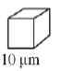
  - 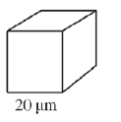
  - 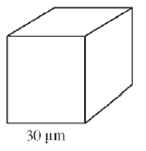
  - 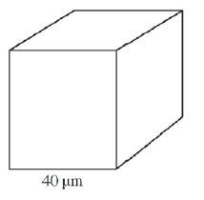

- A pathogenic bacterium has been engulfed by a phagocytic cell as part of the nonspecific (innate) immune response. Which of the following illustrations best represents the response?

  - 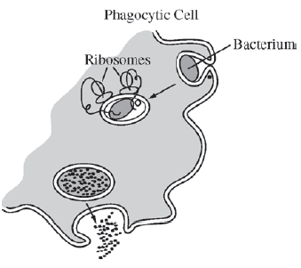
  - 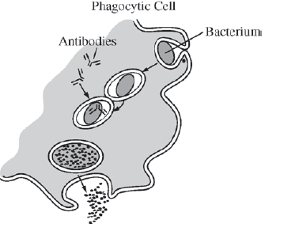
  - 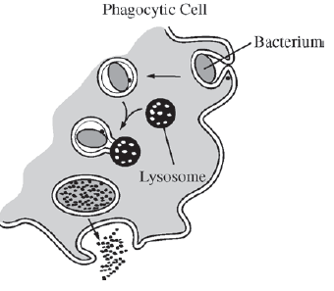
  - 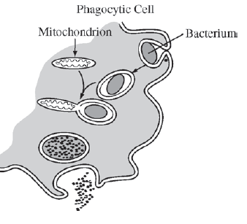

- If ATP breakdown (hydrolysis) is inhibited, which of the following types of movement across cell membranes is also inhibited?
  - Movement of oxygen into a cell
  - Movement of water through aquaporins
  - Passage of a solute against its concentration gradient
  - Facilitated diffusion of a permeable substance

- A human kidney filters about 200 liters of blood each day. Approximately two liters of liquid and nutrient waste are excreted as urine. The remaining fluid and dissolved substances are reabsorbed and continue to circulate throughout the body. Antidiuretic hormone (ADH) is secreted in response to reduced plasma volume. ADH targets the collecting ducts in the kidney, stimulating the insertion of aquaporins into their plasma membranes and an increased reabsorption of water.

If ADH secretion is inhibited, which of the following would initially result?
  - The number of aquaporins would increase in response to the inhibition of ADH.
  - The person would decrease oral water intake to compensate for the inhibition of ADH.
  - Blood filtration would increase to compensate for the lack of aquaporins.
  - The person would produce greater amounts of dilute urine.

- Paramecia are unicellular protists that have contractile vacuoles to remove excess intracellular water. In an experimental investigation, paramecia were placed in salt solutions of increasing osmolarity. The rate at which the contractile vacuole contracted to pump out excess water was determined and plotted against osmolarity of the solutions, as shown in the graph. Which of the following is the correct explanation for the data?
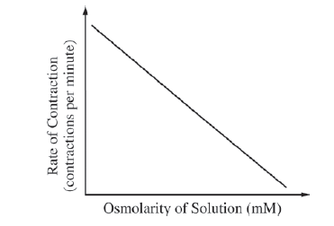
  - At higher osmolarity, lower rates of contraction are required because more salt diffuses into the paramecia.
  - The contraction rate increases as the osmolarity decreases because the amount of water entering the paramecia by osmosis increases.
  - The contractile vacuole is less efficient in solutions of high osmolarity because of the reduced amount of ATP produced from cellular respiration.
  - In an isosmotic salt solution, there is no diffusion of water into or out of the paramecia, so the contraction rate is zero.

- A common laboratory investigation involves putting a solution of starch and glucose into a dialysis bag and suspending the bag in a beaker of water, as shown in the figure below.
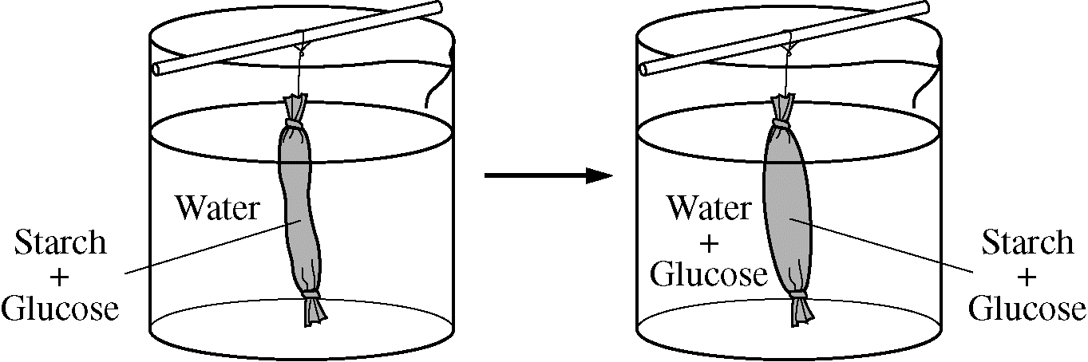
The investigation is aimed at understanding how molecular size affects movement through a membrane.

Which of the following best represents the amount of starch, water, and glucose in the dialysis bag over the course of the investigation?

  - 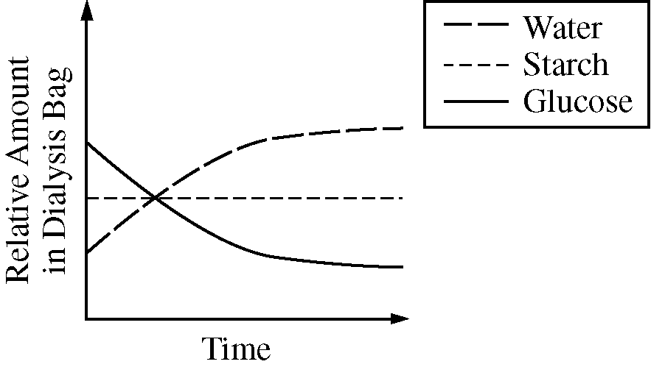
  - 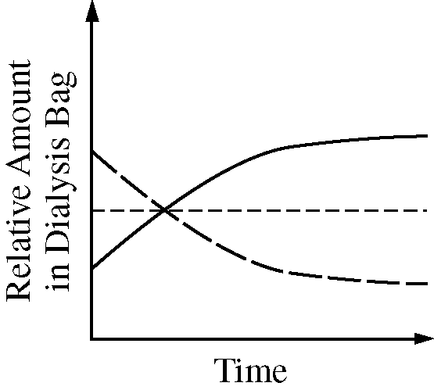
  - 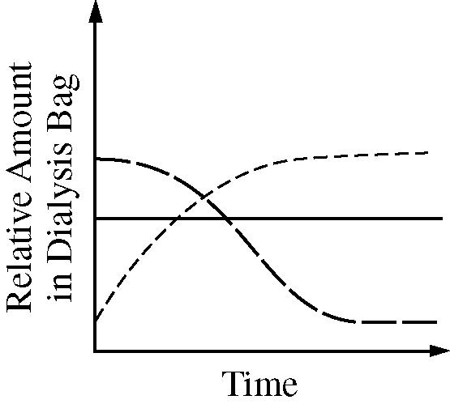
  - 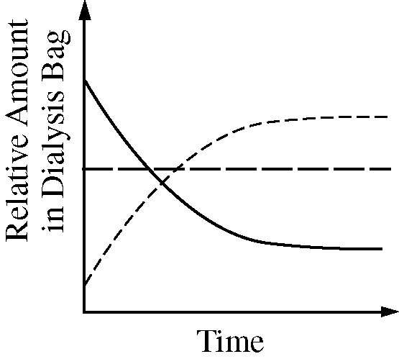

- A student used a microscope to observe a wet-mount slide of red onion epidermal cells that were suspended in a 1% NaCl solution. The student then added a 15% NaCL solution to the slide and observed the changes that occurred. The student’s observations are represented in Figure 1.
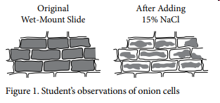
Which of the following most directly explains the changes in the cells?
- The degradation of DNA in the nuclei of the cells
- The lysis of chloroplasts in the cells
- The movement of water from the central vacuoles of the cells into the solution
- The movement of NaCl from the solution into the cytoplasm of the cells

Multiple Choice Key
Question | Correct Answer | Unit/Topic | Source
1 | A. | 2.3 | 2012  CED #2
2 | C. | 2.6 | 2012  CED #5
3 | C. Passage of a solute against its concentration gradient | 2.7 | 2013 #3
4 | D. The person would produce greater amounts of dilute urine. | 2.7 | 2012  CED #30
5 | B. The contraction rate increases as the osmolarity decreases because the amount of water entering the paramecia by osmosis increases. | 2.8 | 2012  CED #12
6 | A. | 2.8 | 2013 #19
7 | C. The movement of water from the central vacuoles of the cells into the solution | 2.8 | 2020  CED #10

Multiple Choice Explanations
Q |  | Explanation:
1 | A | You should be able to look at this question to know that the smallest cube will have the largest surface area to volume ratio making it the most efficient at removing waste by diffusion. If you need to do the calculations, compare by using a 1x1x1 cube. Surface Area = 6 and Volume = 1, so SA/V = 6  This option is correct. It demonstrates the ability to calculate surface area-to-volume ratios and predict their effects on a cell’s ability to exchange materials with its environment. The cell shown in A has the greatest surface area-to-volume ratio at 0.6:1. (CollegeBoard)
 | B | You should be able to look at this question to know that the smallest cube (A) will have the largest surface area to volume ratio making it the most efficient at removing waste by diffusion. If you need to do the calculations, compare by using a 2x2x2 cube. Surface Area = 24 and Volume = 8, so SA/V = 3  This option is incorrect. That cell does not have the greatest surface area-to-volume ratio at 0.3:1. (CollegeBoard)
 | C | You should be able to look at this question to know that the smallest cube (A) will have the largest surface area to volume ratio making it the most efficient at removing waste by diffusion. If you need to do the calculations, compare by using a 3x3x3 cube. Surface Area = 54 and Volume = 27, so SA/V = 2  This option is incorrect. That cell does not have the greatest surface area-to-volume ratio at 0.2:1. (CollegeBoard)
 | D | You should be able to look at this question to know that the smallest cube (A) will have the largest surface area to volume ratio making it the most efficient at removing waste by diffusion. If you need to do the calculations, compare by using a 4x4x4 cube. Surface Area = 96 and Volume = 64, so SA/V = 1.5  This option is incorrect. That cell does not have the greatest surface area-to-volume ratio at 0.1:1. (CollegeBoard)
2 | A | Ribosomes have a function to synthesize proteins. The hydrolytic enzymes that will be responsible for hydrolysis of an engulfed bacteria would be synthesized by membrane ribosomes on the rough ER then modified by the Golgi prior to be used in phagocytosis.  This option is incorrect. Ribosomes do not play a direct role in phagocytosis, although they are organelles that carry out protein synthesis. (CollegeBoard)
 | B | Antibodies are released by plasma cells as a signal for macrophages to engulf. This diagram shows the antibodies inside of the cell being used for digestion.  This option is incorrect. Antibodies do not play a role in phagocytosis, a nonspecific immune response. Antibodies are involved in specific immune responses in the presence of specific antigens. Antibodies do not act intracellularly either. (CollegeBoard)
 | C | Lysosomes have hydrolytic enzymes responsible for digestion. Recall, after phagocytosis – the food vacuole formed will fuse with a lysosome for digestion.  This option is correct. It demonstrates an understanding to interpret representations that describe a nonspecific immune response. In phagocytosis, a cell engulfs a bacterium by wrapping pseudopodia around it and packaging it within a membrane-enclosed vacuole. The bacterium is digested after the vacuole fuses with a lysosome containing hydrolytic enzymes. Digested particles can be exported out of the cell by exocytosis. (CollegeBoard)
 | D | Mitochondria is the site of cellular respiration. This process will not result in digestion of materials.  This option is incorrect. Mitochondria do not play a direct role in cellular digestion. Mitochondria are the sites of cellular respiration, the metabolic process that generates ATP from organic molecules in the presence of oxygen. (CollegeBoard)
3 | A | Oxygen does not require a transport protein since it is small and nonpolar. The ATP breakdown is referring to an active transport situation which uses ATP and a transport protein.
 | B | Water requires a transport protein to move large amounts across the membrane. This statement does not demonstrate that it will be going against its concentration gradient to require ATP.
 | C | Active transport involves the usage of a transport protein to move a material against its concentration gradient.
 | D | Facilitated transport is a type of passive transport and does not require ATP.
4 | A | ADH stimulates the insertion of aquaporins (increasing the number of aquaporins), but this statement says the ADH is inhibited which means the ADH is unable to do its job. There will not an increase of aquaporins.  This option is incorrect. ADH stimulates the production of aquaporins. Inhibition of ADH would result in fewer aquaporins. (CollegeBoard)
 | B | ADH stimulates the insertion of aquaporins (increasing the number of aquaporins) which would result in additional water being re-absorbed decreasing the need to consume oral water intake. But if ADH is inhibited, the water isn’t reabsorbed thus the person would need to increase their oral water intake to off balance the loss of water.  This option is incorrect because inhibition of ADH causes more water to be excreted from the body, thus triggering thirst rather than decreasing it (CollegeBoard)
 | C | ADH stimulates the insertion of aquaporins (increasing the number of aquaporins) so since the ADH is inhibited there will not be aquaporins in the membrane to reabsorb the water. This statement refers to blood filtration to increase which is not affected by the ADH as this step precedes the aquaporins.  This option is incorrect because filtration of the blood in the kidney is independent of ADH. (CollegeBoard)
 | D | ADH stimulates the insertion of aquaporins which reabsorbs the water back into the blood stream. Without the transport protein to move water back into the blood, the excess water remains in the urine making dilute urine.  This option is correct because it links the signal (ADH) with the response (reabsorption of water). Because ADH increases reabsorption of water, its lack would result in less water reabsorbed, more excreted, and thus a more dilute urine. (CollegeBoard)
5 | A | Recall that ions required specific transport proteins to move across the membrane. There is no information about those transport proteins, so we are looking just at the water movement across the membrane. As the osmolarity increases, there is more salt in the solution which results in less water diffusing into the paramecium so there is less contractions to pump that excess water back out.  This option is incorrect because the paramecium’s plasma membrane is not permeable to charged ions, so no salt will enter. If salt could enter the paramecium, then water would follow by osmosis and actually result in increasing contractions of the contractile vacuole. (CollegeBoard)
 | B | The more hypotonic the solution is to the paramecium, the higher the amount of water entering the cell. As the solution gets less hypotonic to the paramecium, the amount of water entering will decrease. When the paramecium is in low osmolarity, there is a high rate of contraction because there is a large amount of water entering. When the paramecium is in high osmolarity, there is a low rate of contraction because there is a small amount of water entering.  This option is correct. The lower the concentration of solute, the larger the gradient between the paramecium and the solution. When the paramecium is hypertonic to the low concentration solution, water will enter the paramecium by osmosis. If the paramecium does not pump excess water back out, it will burst. As the solution gradient decreases, less water will enter, and, therefore, there will be a decreased need to pump excess water out (CollegeBoard)
 | C | There is no information that refers to the ATP and whether there would be a lack of ATP. The higher amount of osmolarity leads to a decrease in contraction as there is less water entering the paramecium to be pumped out.  This option is incorrect because the external concentration of salt has no direct relationship with internal ATP production by cellular respiration. As long as the paramecium’s internal environment is not altered, then cellular respiration should be unaffected, and therefore the contractile vacuole will have sufficient energy. (CollegeBoard)
 | D | An isotonic solution refers to an equal amount of water entering and leaving the cell. This answer choice states that no water movement would take place which does not refer to an isotonic solution.  This option is incorrect because even at isosmotic concentrations water still diffuses, but in dynamic equilibrium (CollegeBoard)
6 | A | Use the diagram and determine whether the graph fits. The dotted line is the starch, the starch begins in the bag and remains in the bag (no change in the amount in the bag). The dashed line is the water, the bag begins deflated but appears to be more inflated after representing water movement into the bag (increase in the amount in the bag). The solid line is the glucose, the glucose begins in the bag and is found in the bag and the solution after (decrease in the amount in the bag).
 | B | Use the diagram and determine whether the graph fits. The dotted line is the starch, the starch begins in the bag and remains in the bag (no change in the amount in the bag). The dashed line is the water, the bag begins deflated but appears to be more inflated after representing water movement into the bag (increase in the amount in the bag), but this graph shows a decrease. The solid line is the glucose, the glucose begins in the bag and is found in the bag and the solution after (decrease in the amount in the bag), but this graph shows an increase.
 | C | Use the diagram and determine the graph fits. The dotted line is the starch, the starch begins in the bag and remains in the bag (no change in the amount in the bag) but this graph shows an increase. The dashed line is the water, the bag begins deflated but appears to be more inflated after representing water movement into the bag (increase in the amount in the bag) but this graph shows a decrease. The solid line is the glucose, the glucose begins in the bag and is found in the bag and the solution after (decrease in the amount in the bag) but this graph shows no change.
 | D | Use the diagram and determine whether the graph fits. The dotted line is the starch, the starch begins in the bag and remains in the bag (no change in the amount in the bag), but this graph shows an increase. The dashed line is the water, the bag begins deflated but appears to be more inflated after representing water movement into the bag (increase in the amount in the bag), but this graph shows no change. The solid line is the glucose, the glucose begins in the bag and is found in the bag and the solution after (decrease in the amount in the bag), but this graph shows a decrease.
7 | A | The nucleus is traditionally depicted as a circle in the center of the cell. This diagram is not showing the nucleus so there is no information to justify a degrading of DNA. You can see the cell wall in the figure and see the cell getting smaller, which refers to a loss of water due to a hypertonic solution.
 | B | The chloroplasts are not depicted in these cells and thus there is no information to justify a lysis of chloroplasts.
 | C | As the concentration of the NaCl (table salt) increases outside the cell, the solution becomes more hypertonic to the cell resulting in a loss of water which causes plasmolysis (plasma membrane pulls away from the cell wall). This water is stored in the central vacuole.
 | D | NaCl is an ionic compound resulting in a positively charged Na and a negatively charged Cl. These ions require specific transport proteins to move across the membrane. In addition, if NaCl entered the cell there would not demonstrate the loss of volume demonstrated in the diagram.

