Unit 3: Cellular Energetics

Topic | Learning Objective(s)
3.1  Enzyme Structure | ENE-1.D Describe the properties of enzymes.
3.2  Enzyme Catalysis | ENE-1.E Explain how enzymes affect the rate of biological reactions.
3.3  Environmental Impacts on Enzyme Function | ENE-1.F Explain how changes to the structure of an enzyme may affect its function.
 | ENE-1.G Explain how the cellular environment affects enzyme activity
3.4  Cellular Energy | ENE-1.H Describe the role of energy in living organisms.
3.5  Photosynthesis | ENE-1.I Describe the photosynthetic processes that allow organisms to capture and store energy.
 | ENE-1.J Explain how cells capture energy from light and transfer it to biological molecules for storage and use
3.6  Cellular Respiration | ENE-1.K Describe the processes that allow organisms to use energy stored in biological macromolecules.
 | ENE-1.L Explain how cells obtain energy from biological macromolecules in order to power cellular functions.
3.7  Fitness | SYI-3.A Explain the connection between variation in the number and types of molecules within cells to the ability of the organism to survive and/or reproduce in different environments.

Free Response Practice
2022 #3
Fireflies emit light when the enzyme luciferase catalyzes a reaction in which its substrate, D-luciferin, reacts to form oxyluciferin and other products (Figure 1). In order to determine the optimal temperature for this enzyme, scientists added ATP to a solution containing D-luciferin, luciferase, and other substances needed for the reaction. They then measured the amount of light emitted during the first three seconds of the reaction when it was carried out at different temperatures.

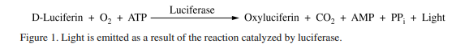

(a) Describe a characteristic of the luciferase enzyme that allows it to catalyze the reaction.

(b) Identify the dependent variable in the experiment.

(c) State the null hypothesis for the experiment.

(d) A student claims that, as temperature increases, there will be an increase in the amount of light given off by the reaction in the first three seconds. Support the student’s claim.

2021 #3
Researchers hypothesize that the plant compound resveratrol improves mitochondrial function. To test this hypothesis, researchers dissolve resveratrol in dimethyl sulfoxide (DMSO). The solution readily passes through cell membranes. They add resveratrol solution to mammalian muscle cells growing in a nutrient-rich solution (culture medium) that contains glucose. They measure ATP production at several time points after the addition of the resveratrol solution and find an increase in ATP production by the muscle cells.

(a) Describe the primary advantage for a mammalian muscle cell in using aerobic respiration over fermentation.

(b) Identify an appropriate negative control for this experiment that would allow the researchers to conclude that ATP is produced in response to the resveratrol treatment.

(c) Predict the effect on short-term ATP production when resveratrol-treated mammalian muscle cells are grown in a culture medium that lacks glucose or other sugars.

(d) The researchers find that resveratrol stimulates the production of components of the electron transport chain. The researchers claim that treatment with resveratrol will also increase oxygen consumption by the cells if glucose is not limiting. Justify this claim.

2017 #5
Microcystis aeruginosis is a freshwater photosynthetic cyanobacterium. When temperatures increase and nutrients are readily available in its pond habitat, M. aeruginosis undergoes rapid cell division and forms an extremely large, visible mass of cells called an algal bloom. M. aeruginosis has a short life span and is decomposed by aerobic bacteria and fungi. Identify the metabolic pathway and the organism that is primarily responsible for the change in oxygen level in the pond between time I and II AND between times III and IV.
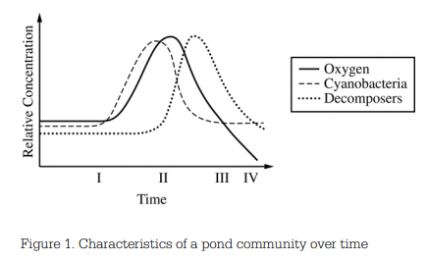

2017 #7
Many species of bacteria grow in the mouths of animals and can form biofilms on teeth (plaque). Within plaque, the outer layers contain high levels of oxygen and the layers closest to the tooth contain low levels of oxygen. The surface of the tooth is covered in a hard layer of enamel, which can be dissolved under acidic conditions. When the enamel breaks down, the bacteria in plaque can extract nutrients from the tooth and cause cavities.
Certain types of bacteria (e.g. Streptococcus mutans) thrive in the innermost anaerobic layers of the plaque and are associated with cavities. Other types of bacteria (Streptococcus sanguinis) compete with S. mutans but are unable to thrive in acidic environments.

(a) Identify the biochemical pathway S. mutans uses for metabolizing sugar and describe how the pathway contributes to the low pH in the inner layers of plaque.

(b) Normal tooth brushing effectively removes much of the plaque from the flat surfaces of teeth, but cannot reach the surfaces between teeth. Many commercial toothpastes contain alkaline components, which raise the pH of the mouth. Predict how the population sizes of S. mutans AND S. sanguinis in the bacterial community in the plaque between the teeth are likely to change when these toothpastes are used.

2013 #2
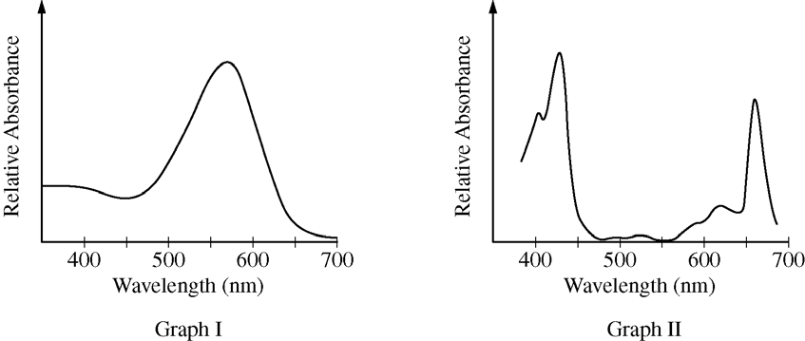

Color | Wavelength (nm)
Violet | 380 – 450
Blue | 450 – 475
Cyan | 475 – 495
Green | 495 – 570
Yellow | 570 – 590
Orange | 590 – 620
Red | 620 - 750

An absorption spectrum indicates the relative amount of light absorbed across a range of wavelengths. The graphs above represent the absorption spectra of individual pigments isolated from two different organisms. One of the pigments is chlorophyll a, commonly found in green plants. The other pigment is bacteriorhodopsin, commonly found in purple photosynthetic bacteria. The table above shows the approximate ranges of wavelengths of different colors in the visible light spectrum.

(a) Identify the pigment (chlorophyll a or bacteriorhodopsin) used to generate the absorption spectrum in each of the graphs above. Explain and justify your answer.

(b) In an experiment, identical organisms containing the pigment from Graph II as the predominant light-capturing pigment are separated into three groups. The organisms in each group are illuminated with light of a single wavelength (650 nm for the first group, 550 nm for the second group, and 430 nm for the third group). The three light sources are of equal intensity, and all organisms are illuminated for equal lengths of time. Predict the relative rate of photosynthesis in each of the three groups. Justify your predictions.

(c) Bacteriorhodopsin has been found in aquatic organisms whose ancestors existed before the ancestors of plants evolved in the same environment. Propose a possible evolutionary history of plants that could have resulted in a predominant photosynthetic system that uses only some of the colors of the visible light spectrum.

Free Response Scoring Guidelines
2022 #3
Part | Scoring Guidelines | Topic
(a) |  | 3.1
(b)
(c)
(d) |  | 3.3

2021 #3
Part | Scoring Guidelines | Topic
(a) | 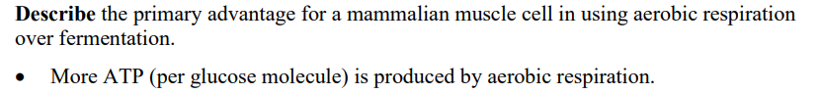 | 3.6
(b) | 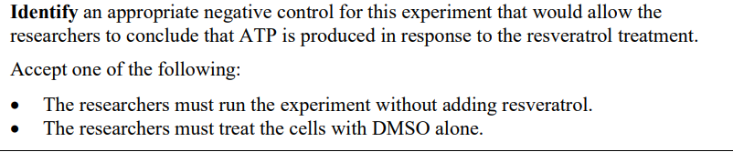 | 3.6
(c) | 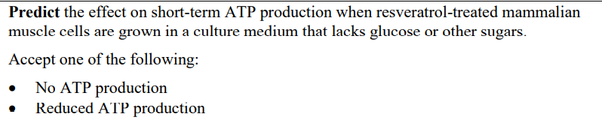 | 3.6
(d) | 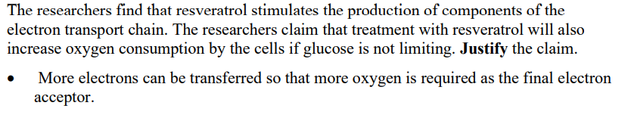 | 3.6

2017 #5
Part | Scoring Guidelines | Topic
 | 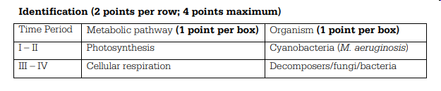 | 3.5  3.6

2017 #7
Part | Scoring Guidelines | Topic
(a) |  | 3.6
(b) |  | 3.6

2013 #2
Part | Scoring Guidelines | Topic
(a) | 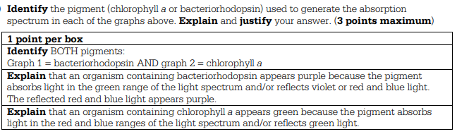 | 3.5
(b) | 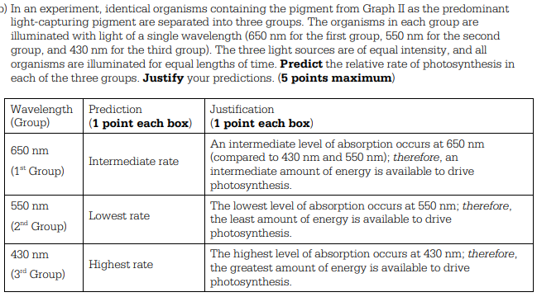 | 3.5
(c) | 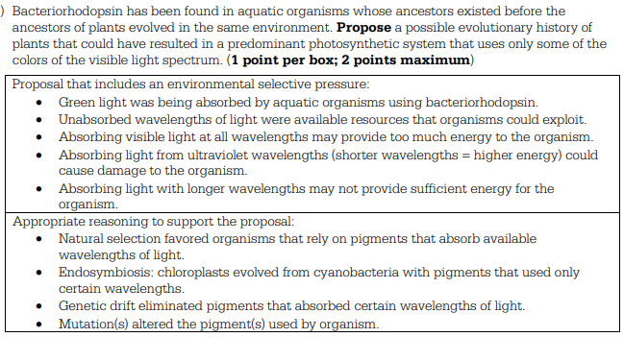 | 3.7

