Unit 4: Cell Communication and Cell Cycle

Topic | Learning Objective(s)
4.1  Cell Communication | IST-3.A Describe the ways that cells can communicate with one another.
 | IST-3.B Explain how cells communicate with one another over short and long distances.
4.2  Introduction to Signal Transduction | IST-3.C Describe the components of a signal transduction pathway.
 | IST-3.D Describe the role of components of a signal transduction pathway in producing a cellular response.
4.3  Signal Transduction | IST-3.E Describe the role of the environment in eliciting a cellular response.
 | IST-3.F Describe the different types of cellular responses elicited by a signal transduction pathway.
4.4  Changes in Signal Transduction Pathways | IST-3.G Explain how a change in the structure of any signaling molecule affects the activity of the signaling pathway
4.5  Feedback | ENE-3.A Describe positive and/ or negative feedback mechanisms.
 | ENE-3.B Explain how negative feedback helps to maintain homeostasis
 | ENE-3.C Explain how positive feedback affects homeostasis.
4.6  Cell Cycle | IST-1.B Describe the events that occur in the cell cycle.
 | IST-1.C Explain how mitosis results in the transmission of chromosomes from one generation to the next.
4.7  Regulation of Cell Cycle | IST-1.D Describe the role of checkpoints in regulating the cell cycle.
 | IST-1.E Describe the effects of disruptions to the cell cycle on the cell or organism.

Multiple Choice Practice
- Anabaena is a simple multicellular photosynthetic cyanobacterium. In the absence of fixed nitrogen, certain newly developing cells along a filament express genes that code for nitrogen-fixing enzymes and become non- photosynthetic heterocysts. The specialization is advantageous because some nitrogen-fixing enzymes function best in the absence of oxygen. Heterocysts do not carry out photosynthesis but instead provide adjacent cells with fixed nitrogen, in exchange receiving fixed carbon and reduced energy carriers.
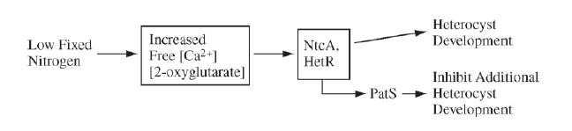
As shown in the diagram above, when there is low fixed nitrogen in the environment, an increase in the concentration of free calcium ions and 2-oxyglutarate stimulates the expression of genes that produce two transcription factors (NtcA and HetR) that promote the expression of genes responsible for heterocyst development. HetR also causes production of a signal, PatS, that prevents adjacent cells from developing as heterocysts.

Based on your understanding of the ways in which signal transmission mediates cell function, which of the following predictions is most consistent with the information given above?
  - In an environment with low fixed nitrogen, treating the Anabaena cells with a calcium-binding compound should prevent heterocyst differentiation.
  - A strain that overexpresses the patS gene should develop many more heterocysts in a low fixed nitrogen environment.
  - In an environment with abundant fixed nitrogen, free calcium levels should be high in all cells so that no heterocysts develop.
  - In environments with abundant fixed nitrogen, loss of the hetR gene should induce heterocyst development.
- The diagram below shows a developing worm embryo at the four-cell stage. Experiments have shown that when cell 3 divides, the anterior daughter cell gives rise to muscle and gonads and the posterior daughter cell gives rise to the intestine. However, if the cells of the embryo are separated from one another early during the four-cell stage, no intestine will form. Other experiments have shown that if cell 3 and cell 4 are recombined after the initial separation, the posterior daughter cell of cell 3 will once again give rise to normal intestine.
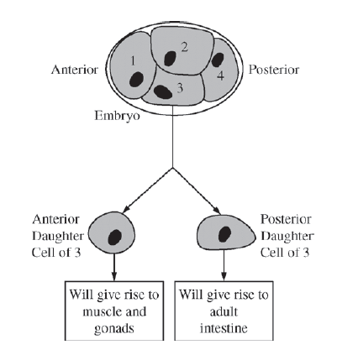
Which of the following is the most plausible explanation for these findings?
  - A cell surface protein on cell 4 signals cell 3 to induce formation of the worm’s intestine.
  - The plasma membrane of cell 4 interacts with the plasma membrane of the posterior portion of cell 3, causing invaginations that become microvilli.
  - Cell 3 passes an electrical signal to cell 4, which induces differentiation in cell 4.
  - Cell 4 transfers genetic material to cell 3, which directs the development of intestinal cells.

- The vertebrate forelimb initially develops in the embryo as a solid mass of tissue. As development progresses, the solid mass near the end of the forelimb is remodeled into individual digits. Which of the following best explains the role of apoptosis in remodeling of the forelimb?
  - Apoptosis replaces old cells with new ones that are less likely to contain mutations.
  - Apoptosis involves the regulated activation of proteins in specific cells of the developing forelimb that leads to the death of those cells.
  - Apoptosis involves the destruction of extra cells in the developing forelimb, which provides nutrients for phagocytic cells.
  - Apoptosis in the developing forelimb triggers the differentiation of cells whose fate was not already determined.

- The figure below shows a model of a ligand precursor being cleaved to produce an active ligand that binds to a specific receptor. Which of the following is most likely to reduce the binding of the active ligand to its receptor?
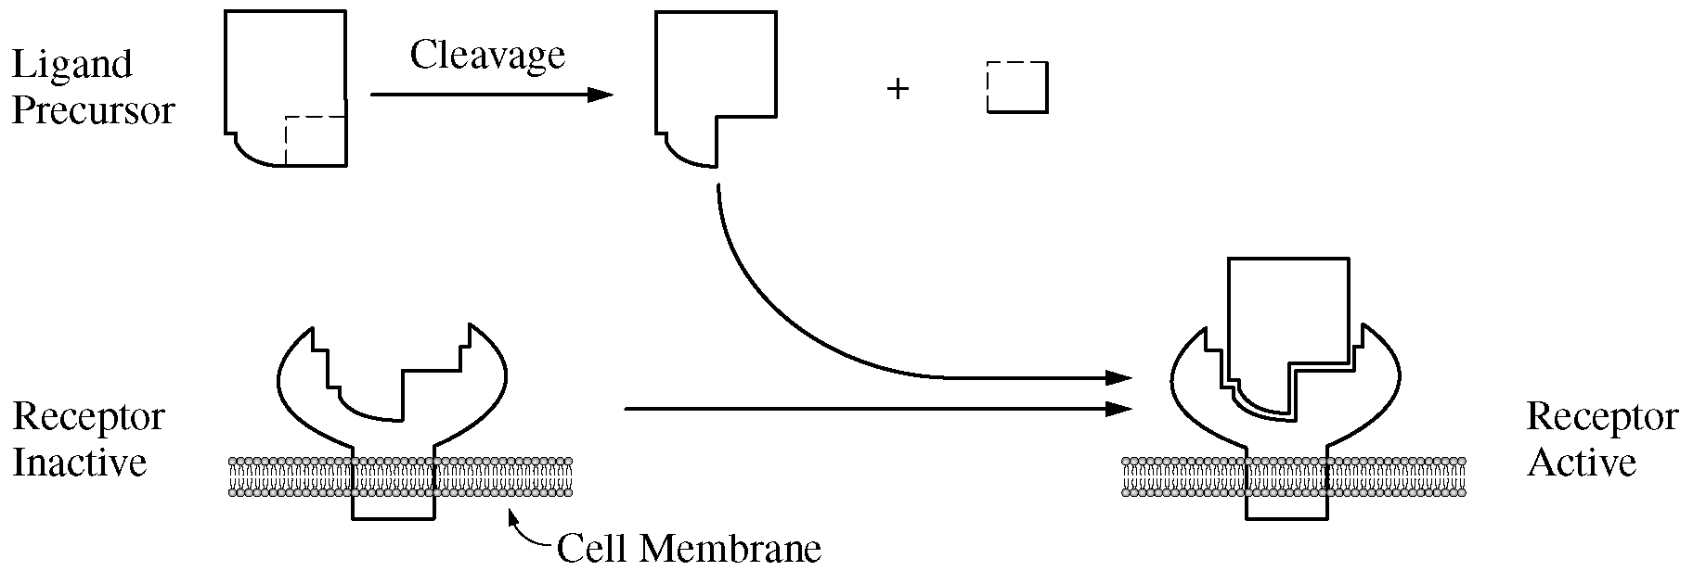
  - A change in the cytoskeletal attachment of transmembrane proteins
  - The presence of a large amount of the precursor form of the ligand
  - An increase in the ratio of the number of unsaturated to the number of saturated fatty acid tails of the membrane lipids
  - A mutation in the receptor gene that causes a substitution of a charged amino acid for a nonpolar amino acid in the ligand binding site of the receptor

- Insulin is a protein hormone that is secreted in response to elevated blood glucose levels. When insulin binds to its receptors on liver cells, the activated receptors stimulate phosphorylation cascades that cause the translocation of glucose transporters to the plasma membrane.

Based on the information provided, which of the following best describes the role of insulin in this liver cell signal transduction pathway?
  - It acts as a ligand.
  - It acts as a receptor.
  - It acts as a secondary messenger.
  - It acts as a protein kinase.

- The endocrine system incorporates feedback mechanisms that maintain homeostasis. Which of the following demonstrates negative feedback by the endocrine system?
  - During labor, the fetus exerts pressure on the uterine wall, inducing the production of oxytocin, which stimulates uterine wall contraction. The contractions cause the fetus to further push on the wall, increasing the production of oxytocin.
  - After a meal, blood glucose levels become elevated, stimulating beta cells of the pancreas to release insulin into the blood. Excess glucose is then converted to glycogen in the liver, reducing blood glucose levels.
  - At high elevation, atmospheric oxygen is more scarce. In response to signals that oxygen is low, the brain decreases an individual’s rate of respiration to compensate for the difference.
  - A transcription factor binds to the regulatory region of a gene, blocking the binding of another transcription factor required for expression.

- The diagram below illustrates feedback control as exerted by the hormone thyroxine. Following surgical removal of the thyroid gland, the level of TSH in the blood will increase. Which of the following best explains this increase?

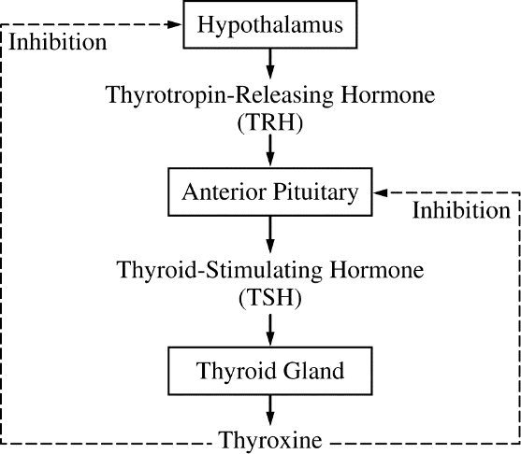

  - Residual blood thyroxine, from prior to thyroid gland removal, will bind to cells in the anterior pituitary, signaling more TSH secretion.
  - Thyroxine will remain bound to thyroxine receptors on various body cells, and these body cells will secrete additional hormones that stimulate the anterior pituitary to secrete TSH.
  - Thyroxine that was stored in the anterior pituitary prior to thyroid gland removal will signal more TSH secretion.
  - A decrease in thyroxine levels means a loss of inhibition to the hypothalamus and anterior pituitary, leading to increased TSH secretion.

- Antidiuretic hormone (ADH) is important in maintaining homeostasis in mammals. ADH is released from the hypothalamus in response to high tissue osmolarity. In response to ADH, the collecting duct and distal tubule in the kidney become more permeable to water, which increases water reabsorption into the capillaries. The amount of hormone released is controlled by a negative feedback loop. Based on the model presented, which of the following statements expresses the proper relationship between osmolarity, ADH release, and urine production?
  - As tissue osmolarity rises, more ADH is released, causing less water to be excreted as urine.
  - As tissue osmolarity rises, less ADH is released, causing less water to be excreted as urine.
  - As tissue osmolarity rises, more ADH is released, causing more water to be excreted as urine.
  - As tissue osmolarity rises, less ADH is released, causing more water to be excreted as urine.

Use the following information to answer question 9:

Platelets are fragments of larger cells and normally circulate in the blood without adhering to blood vessel walls. When the wall of a blood vessel is damaged, collagen fibers in the wall are exposed to the interior of the blood vessel. The exposed fibers and chemicals released from the endothelial cells that line the blood vessel attract platelets, which start to form a plug and release other chemicals (Figure 1).

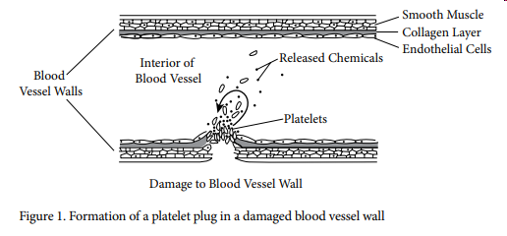

- Which of the following best explains the feedback mechanism illustrated in Figure 1?
  - This is an example of positive feedback, because the few platelets that initially bind attract more platelets to the damaged area.
  - This is an example of positive feedback, because it results from the interactions among collagen, endothelial cells, and platelets.
  - This is an example of negative feedback, because a large clump of platelets can block the blood vessel and prevent blood flow through it.
  - This is an example of negative feedback, because the accumulation of platelets returns the open blood vessel wall to a closed state.

Use the following information to answer question 10:
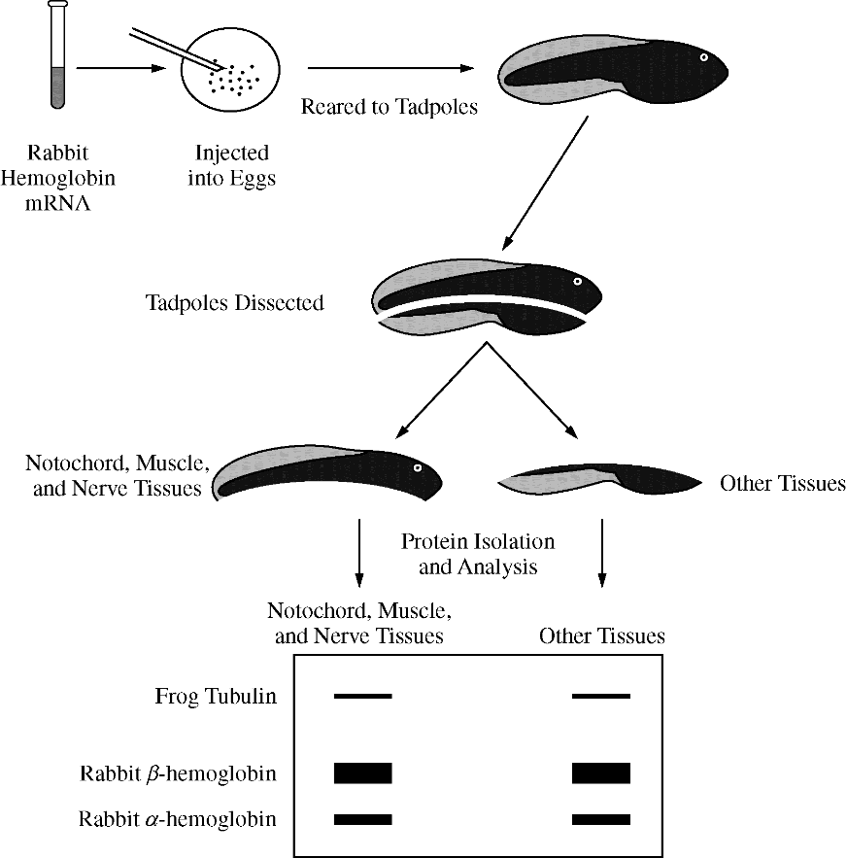
In a classic experiment from the 1970s investigating gene expression, a solution containing equal amounts of rabbit a-hemoglobin mRNA and b-hemoglobin mRNA, which encode subunits of a protein found in red blood cells, was injected into newly fertilized frog eggs. The injected mRNA was not degraded during the course of the experiment. Tadpoles that developed from the injected eggs were dissected into two fragments, one containing predominantly the notochord, muscle tissue, and nerve tissue and the other containing predominantly the other tissue types.

Equal amounts of total protein were analyzed after separation by electrophoresis to identify the relative amounts of the different proteins present in each sample. The thickness of the bands indicates the relative amounts of rabbit a-hemoglobin, rabbit b-hemoglobin, and frog tubulin (a cytoskeletal protein that is expressed at relatively constant levels in all tissues) present in each tadpole sample. The experimental protocol and results are summarized in the figure below.

- Which of the following is the best justification for why the rabbit hemoglobin proteins were found throughout the tadpole?
- Rabbit mRNA is composed of nucleotides that are more stable than those in frog mRNA.
- Rabbit hemoglobin is synthesized more efficiently than frog hemoglobin in frog cells.
- After differentiation, the rabbit hemoglobin proteins move through the circulatory system of the tadpole to every cell.
- The mRNA injected into the newly fertilized frog eggs is distributed in the cytoplasm of every daughter cell during cell division.

- If chemical signals in the cytoplasm control the progression of a cell to the M phase of the cell cycle, then fusion of a cell in G₁ with a cell in early M phase would most likely result in the
- replication of chromosomes only in the G₁ cell
- exiting of both cells from the cell cycle and into the G₀ phase
- condensation of chromatin in preparation of nuclear division in both cells
- transfer of organelles from the G₁ cell to the cell in the M phase

Multiple Choice Key
Question | Correct Answer | Unit/Topic | Source
1 | A. In an environment with low fixed nitrogen, treating the Anabaena cells with a calcium-binding compound should prevent heterocyst differentiation. | 4.1 | 2012  CED #38
2 | A. A cell surface protein on cell 4 signals cell 3 to induce formation of the worm’s intestine. | 4.1 | 2012  CED #31
3 | B. Apoptosis involves the regulated activation of proteins in specific cells of the developing forelimb that leads to the death of those cells. | 4.2 | 2013 #16
4 | D. A mutation in the receptor gene that causes a substitution of a charged amino acid for a nonpolar amino acid in the ligand binding site of the receptor | 4.2 | 2013 #46
5 | A. It acts as a ligand. | 4.2 | 2020  CED #1
6 | B. After a meal, blood glucose levels become elevated, stimulating beta cells of the pancre-as to release insulin into the blood. Excess glucose is then converted to glycogen in the liver, reducing blood glucose levels. | 4.5 | 2012  CED #17
7 | D. A decrease in thyroxine levels means a loss of inhibition to the hypothalamus and anterior pituitary, leading to increased TSH secretion. | 4.5 | 2013 #39
8 | A. As tissue osmolarity rises, more ADH is released, causing less water to be excreted as urine. | 4.5 | 2013 #52
9 | A. This is an example of positive feedback, because the few platelets that initially bind attract more platelets to the damaged area. | 4.5 | 2020  CED #14
10 | D. The mRNA injected into the newly fertilized frog eggs is distributed in the cytoplasm of every daughter cell during cell division. | 4.6 | 2013 #29
11 | C. condensation of chromatin in preparation of nuclear division in both cells | 4.6 | 2013 #35

Multiple Choice Explanations
Q |  | Explanation:
1 | A | As shown in the figure (and described in the prompt), if there is a low fixed nitrogen then there will be an increase in calcium which stimulates expression of genes that are responsible for heterocyst development. If there is a calcium-binding compound, the increase in calcium will be inhibited which inhibits the expression of the genes which inhibits heterocyst development.  This option is correct because free calcium is needed for heterocyst formation. Binding the calcium will prevent cyst formation. This answer demonstrates that the student is able to refine representations to illustrate how interactions between external stimuli and gene expression result in specialization of cells. (CollegeBoard)
 | B | As shown in the figure, PatS inhibits additional heterocyst development. If the PatS is overexpressed, there will be additional inhibition of the heterocyst development.  This option is incorrect because the patS gene inhibits heterocyst formation, so fewer would be produced. (CollegeBoard)
 | C | As shown in the figure, the abundant fixed nitrogen does not cause the pathway. With an abundant fixed nitrogen level, there will not be an increased amount of calcium so there will also not be heterocyst development.  This option is incorrect because in an environment with abundant fixed nitrogen, heterocysts are not an advantage to the organism in that the anaerobic nitrogen-fixing enzymes are not needed. (CollegeBoard)
 | D | As shown in the figure, the abundant fixed nitrogen does not cause the pathway. There will not be HetR activated which will not activate the heterocyst development.  This option is incorrect because loss of the hetR gene would prevent, not induce, heterocyst formation (CollegeBoard)
2 | A | There is a signaling molecule on the surface of cell 4. When cell 4 is not in contact with cell 3, it is unable to activate the pathway. When the cells are put back into contact, the signal transduction pathway leads to the formation of the intestines.  This option is correct. The stem of the question indicates that cell 4 and cell 3 must be touching in order for cell 3 to induce formation of the intestine. This is the mechanism by which the correct timing of this developmental event occurs. (CollegeBoard)
 | B | Invagination is due to a signaling molecule that leads to the signal transduction pathway resulting in the invagination. The plasma membrane alone will not provide that signaling molecule.  This option is incorrect because there is no indication that microvilli are formed. (CollegeBoard)
 | C | Based on the prompt, cell 3 must be in contact with cell 4 in order for the posterior daughter cell to give rise to the intestines.  This option is incorrect because there is no evidence of an electrical signal (CollegeBoard)
 | D | All cells of an organism are genetically identical except the gametes. Cell 4 will not transfer genetic information that cell 3 didn’t already have.  This option is incorrect because there is no indication that genetic material is transferred from cell 4 to cell 3, resulting in the development of intestinal cells (CollegeBoard)
3 | A | Apoptosis is programmed cell death. The cells are not going through this process to replace old cells.
 | B | Apoptosis is programmed cell death. This is due to a signaling transduction pathway leading to the cell digesting from the inside out. Initially, the forelimb is a solid mass of tissue, but after apoptosis there are spaces between the fingers to complete the formation of the forelimb.
 | C | Apoptosis is programmed cell death. Although the cell is broken down from the inside out then engulfed by macrophages, the goal is not to provide nutrients to the phagocytic cells.
 | D | Apoptosis is programmed cell death. It does not cause differentiation.
4 | A | The active site for the receptor would be on the extracellular region of the cell versus if there is a change in the cytoskeletal attachment of the protein. These are two different regions of the protein and thus the change has little effect on the protein.
 | B | In order for the ligand to bind, it must be cleaved. If there is a large amount of the precursor. This means there could be a decrease in the binding to the active site.
 | C | The number of unsaturated fatty acids to fatty acids will allow the membrane to maintain fluidity.
 | D | If there is a substitution with an amino acid that has a drastically different polarity, the protein will not fold correctly which leads to a difference in the binding of the ligand precursor and the enzyme’s active site.
5 | A | A ligand is a signaling molecule. This signaling molecule will bind to a receptor to initiate the signal transduction pathway. This is described in the prompt as “insulin binds to its receptors on the liver cells, the activated receptors stimulate phosphorylation cascades that cause the translocation of glucose transporters to the plasma membrane”.
 | B | A receptor is the location where the ligand or signaling molecule binds. The prompt states that insulin binds to its receptor, so insulin can’t be the receptor.
 | C | The secondary messenger is found intracellular and is a component of the signal transduction pathway. After the primary messenger binds to the receptor then initiates the phosphorylation cascade, the secondary messenger acts as a small molecule intracellular to continue the transduction.
 | D | Protein kinase is a component of the phosphorylation cascade. It has the role of phosphorylating a protein.
6 | A | This describes positive feedback. The release of oxytocin causes contractions that increase the production of oxytocin. The product activates the pathway to lead to more production.  This option is incorrect. The onset of labor is an example of a positive feedback mechanism, not a negative feedback mechanism. (CollegeBoard)
 | B | This describes negative feedback. The insulin is released in response to a high level of glucose binding to the liver to decrease the glucose level. This maintains homeostasis.  This option is correct. The decrease of blood glucose levels as a result of insulin production is an example of how the endocrine system is involved in negative feedback, allowing organisms to maintain their internal environments. (CollegeBoard)
 | C | Oxygen levels are scarce. The answer choice describes that in response, there will be a decrease in respiration which cause less oxygen to be respirated. Organisms need oxygen which should cause an increase in respiration to increase amount of air consumed to increase the oxygen amount respirated.  This option is incorrect. Respiration rates would increase, not decrease, in response to low oxygen levels. (CollegeBoard)
 | D | Transcription binds to a regulatory region of a gene inhibiting the synthesis of the transcription factor. This is an example of negative feedback. The product will inhibit the process to produce more product.  This option is incorrect. Transcription factors are not part of the endocrine system. (CollegeBoard)
7 | A | If there is residual thyroxine and it binds to the anterior pituitary, the anterior pituitary is inhibited and will not release the TSH.
 | B | This is not shown in the diagram. You need to use the diagram to answer the question.
 | C | If thyroxine binds to the anterior pituitary, the thyroxine inhibits the anterior pituitary so TSH will not be released.
 | D | The thyroxine will inhibit the anterior pituitary from releasing TSH. In the absence of the thyroxine, there is no inhibitor so the anterior pituitary will continue releasing TSH leading to an increased production.
8 | A | According to the prompt, ADH is released in response to high osmolarity. The ADH increases water reabsorption decreasing the amount of liquid in the filtrate (which becomes the urine). This aligns perfectly with this answer choice: As tissue osmolarity rises, more ADH is released (true) causing less water to be excreted (true).
 | B | As tissue osmolarity rises, less ADH is released (false). The prompt states the ADH is released in response to high osmolarity.
 | C | As tissue osmolarity rises, more ADH is released (true) causing more water to be excreted (false). The prompt states ADH increases water absorption. If there is an increase in water reabsorption, there will be less water excreted.
 | D | As tissue osmolarity rises, less ADH is released (false). The prompt states the ADH is released in response to high osmolarity.
9 | A | As seen in the figure, the platelets have a circular pathway. This shows that the platelets are simulating an increase in platelets to the area. This is an example of positive feedback as the product (platelets arriving at the damaged blood vessel) stimulates additional product (more platelets attracted to the area).
 | B | The released chemicals appear to come from another part of the vessel not the damaged site which does not show positive feedback.
 | C | By blocking the blood vessel with the platelets decreases the blood loss, but this does not describe negative feedback. The blood does not inhibit a pathway nor does the platelet.
 | D | By inhibiting the loss of blood, the open wall returns back to a closed wall. This is just a restoration versus a homeostatic balance.
10 | A | The mRNA remains in ONE cell. True that the more stable, the more protein could be produced from it. The question is asking why the protein is found throughout the tadpole.
 | B | The protein synthesis is in ONE cell. True that if the rabbit hemoglobin is synthesized more efficiently there would be more, but the question asks why the proteins are throughout the tadpole.
 | C | If proteins are traveling in the bloodstream, the proteins would come in contact with all of the cells. Proteins are polar and would most likely not be distributed throughout the tadpole in this fashion.
 | D | Due to cell division, all of the cells would be identical. If the mRNA was injected into the eggs, the cytoplasm would be distributed to all of the resulting cells during the cleavage step (rapid cell division).
11 | A | Replication of chromosomes occurs during the S phase of interphase. This process takes place after G₁, but the signaling molecules in the cytoplasm would promote the cell through M phase.
 | B | There are signaling molecules in the cytoplasm would promote the cell through the M phase prior to entering the G₀ phase.
 | C | During the M phase, the chromosomes are condensed, aligned on the metaphase plate, then separated to opposite poles. If the signals are in the cytoplasm, then when the G₁ cell fused with the M cell, the signaling molecules will bind in the G₁ cell promoting cell division.
 | D | There is no reason for the organelles to be transferred from one cell to another. This question is looking at the signaling molecules in division to determine how they would affect another cell.

