Unit 6: Gene Expression and Regulation

Topic | Learning Objective(s)
6.1  DNA and RNA Structure | IST-1.K Describe the structures involved in passing hereditary information from one generation to the next.
 | IST-1.L Describe the characteristics of DNA that allow it to be used as the hereditary material
6.2  Replication | IST-1.M Describe the mechanisms by which genetic information is copied for transmission between generations.
6.3  Transcription and RNA Processing | IST-1.N Describe the mechanisms by which genetic information flows from DNA to RNA to protein.
6.4  Translation | IST-1.O Explain how the phenotype of an organism is determined by its genotype
6.5  Regulation of Gene Expression | IST-2.A Describe the types of interactions that regulate gene expression.
 | IST-2.B Explain how the location of regulatory sequences relates to their function.
6.6  Gene Expression and Cell Specialization | IST-2.C Explain how the binding of transcription factors to promoter regions affects gene expression and/or the phenotype of the organism.
 | IST-2.D Explain the connection between the regulation of gene expression and phenotypic differences in cells and organisms.
6.7  Mutations | IST-2.E Describe the various types of mutation
 | IST-4.A Explain how changes in genotype may result in changes in phenotype.
 | IST-4.B Explain how alterations in DNA sequences contribute to variation that can be subject to natural selection.
6.8  Biotechnology | IST-1.P Explain the use of genetic engineering techniques in analyzing or manipulating DNA.

Multiple Choice Practice
- When DNA replicates, each strand of the original DNA molecule is used as a template for the synthesis of a second, complementary strand. Which of the following figures most accurately illustrates enzyme-mediated synthesis of new DNA at a replication fork?

  - 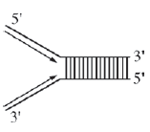
  - 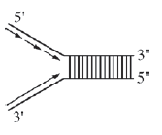
  - 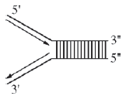
  - 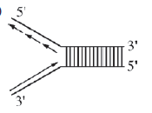

- The human TPM1 gene encodes members of the tropomyosin family of cytoskeletal proteins. Which of the following best explains how different proteins can be made in different cell types from the one TPM1 gene?
  - Different introns are selectively converted to exons.
  - Different exons are retained or spliced out of the primary transcript.
  - The GTP cap is selectively added to and activates different exons.
  - Different portions of the primary transcript remain bound to the template DNA.

- The first diagram below shows the levels of mRNA from two different genes (bicoid and caudal) at different positions along the anterior-posterior axis of a Drosophila egg immediately before fertilization. The second diagram shows the levels of the two corresponding proteins along the anterior-posterior axis shortly after fertilization.

Which of the following conclusions is best supported by the data?
  - Bicoid protein inhibits translation of caudal mRNA.
  - Bicoid protein stabilizes caudal mRNA.
  - Translation of bicoid mRNA produces caudal protein.
  - Caudal protein stimulates development of anterior structures.

Use the following information to answer questions 4 & 5:

The following figures display data collected while studying a family, some members of which have sickle-cell disease—a rare genetic disorder caused by a mutation in the hemoglobin beta gene (HBB). There are at least two alleles of the HBB gene: the HbA allele encodes wild-type hemoglobin and the HbS allele encodes the sickle-cell form of hemoglobin. Genetic testing provided insight into the inheritance pattern for sickle-cell disease.
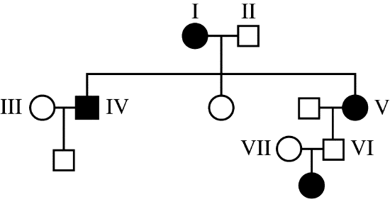
Figure 1. Pedigree of a family with affected individuals. Squares represent males, circles represent females, shaded symbols represent individuals with sickle-cell disease.

5' CTG ACT CCT GAG GAG AAG TCT 3' Non-template Strand
3' GAC TGA GGA CTC CTC TTC AGA 5' Template Strand
Figure 2. A portion of the DNA sequence from the wild-type hemoglobin allele (HbA) that codes for normal hemoglobin.

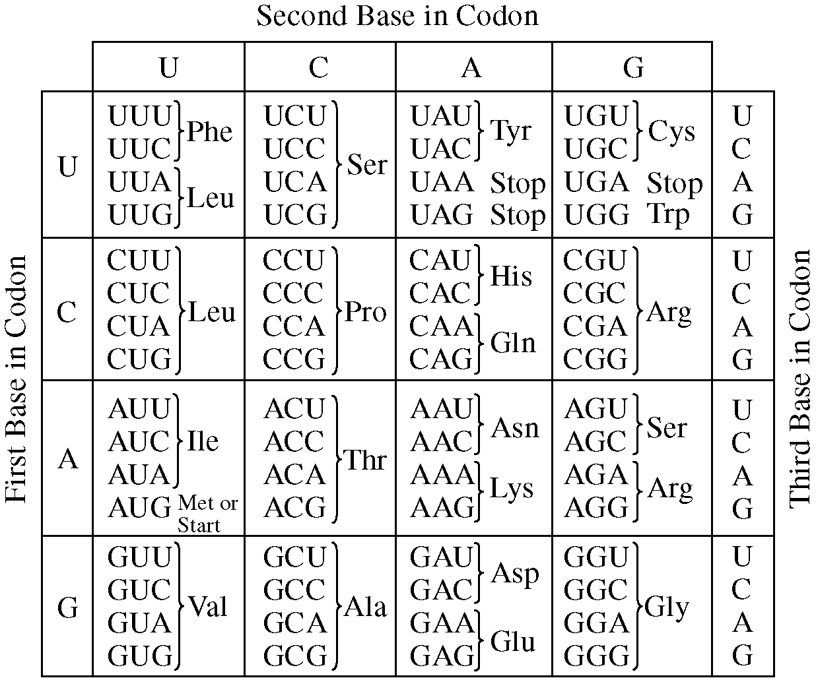
Figure 3. Codon table showing nucleotide sequences for each amino acid.

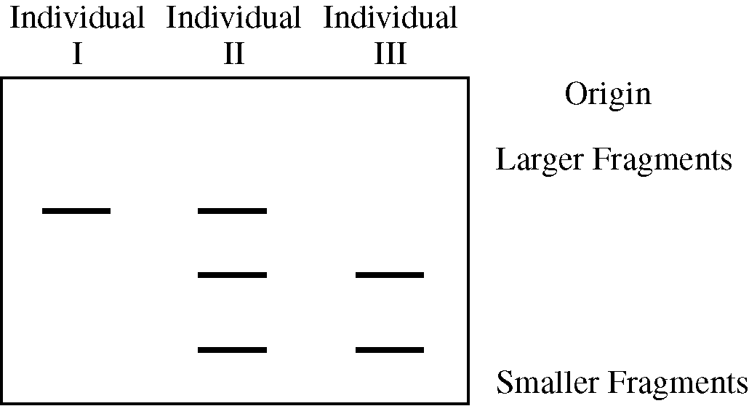
Figure 4. Image of a gel following electrophoretic separation of DNA fragments of the HBB gene from three individuals in the pedigree in Figure 1.

- The HbS allele, which causes sickle-cell disease, results from a mutation in the DNA sequence shown in Figure 2 that produces a valine (val) in the place of a glutamic acid (glu) residue in the hemoglobin protein. Which of the following mRNA sequences is derived from the HbS allele?
  - 5' GAC TGA GGA CTC CTC TTC AGA 3'
  - 5' UCU GAA GAG GAA UCC UCA GUC 3'
  - 5' AGA CTT CTC CTC AGG AGT CAG 3'
  - 5' CUG ACU CCU GUG GAG AAG UCU 3'

- The restriction endonuclease Mst II recognizes the sequence 5' CCT(N)AG (where N = any nucleotide) and cuts DNA at that site, producing separate fragments. Which of the following best explains the banding patterns exhibited in Figure 4?
  - The HbA DNA contains a recognition site for the Mst II restriction enzyme.
  - The HbA/HbS DNA contains three recognition sites for the Mst II restriction endonuclease.
  - Individual I has only one copy of the hemoglobin gene; therefore there is only one band on the gel.
  - The HbS/HbA DNA contains three different alleles for sickle-cell disease.
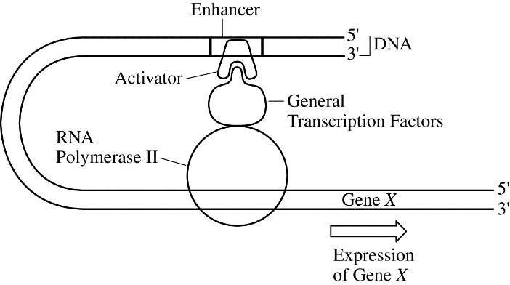
- The figure to the right depicts the DNA-protein complex that is assembled at the transcriptional start site of gene X when the expression of gene X is activated in liver cells. Previous studies have shown that gene X is never expressed in nerve cells. Based on the diagram, which of the following most likely contributes to the specific expression pattern of gene X?
  - Expression of gene X produces large amounts of tRNA but undetectable amounts of mRNA.
  - The general transcription factors inhibit the activation of gene X in liver cells by blocking the activator from binding to RNA polymerase II.
  - The activator is a sequence-specific DNA-binding protein that is present in some tissues but not in other tissues.
  - The enhancer is a unique DNA segment that is added to the nuclear DNA of some cells of an organism during the process of mitotic cell division but not other cells.

- Lactose digestion in E. coli begins with its hydrolysis by the enzyme b-galactosidase. The gene encoding b-galactosidase, lacZ, is part of a coordinately regulated operon containing other genes required for lactose utilization.

Which of the following figures correctly depicts the interactions at the lac operon when lactose is NOT being utilized? (The legend below defines the shapes of the molecules illustrated in the options.)

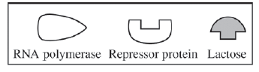
  - 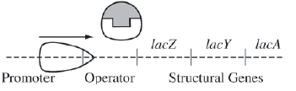
  - 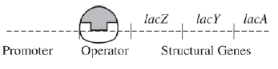
  - 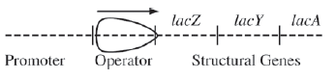
  - 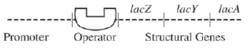

- Mutations in the MYO6 and POU4F3 genes have been associated with a form of hereditary hearing loss in humans. Researchers studying the genes have proposed that POU4F3 encodes a transcription factor that influences the regulation of MYO6.

Which of the following questions will best help guide the researchers toward a direct test of their proposal?
  - Have mutations in other genes also been associated with hearing loss?
  - In what types of cells are the mutant forms of the POU4F3 gene expressed?
  - Are mutations in the MYO6 and POU4F3 genes also found in mice?
  - Do mutations in the POU4F3 gene affect MYO6 mRNA levels in cells?

- Sickle-cell anemia results from a point mutation in the HBB gene. The mutation results in the replacement of an amino acid that has a hydrophilic R-group with an amino acid that has a hydrophobic R-group on the exterior of the hemoglobin protein. Such a mutation would most likely result in altered
  - properties of the molecule as a result of abnormal interactions between adjacent hemoglobin molecules
  - DNA structure as a result of abnormal hydrogen bonding between nitrogenous bases
  - fatty acid structure as a result of changes in ionic interactions between adjacent fatty acid chains
  - protein secondary structure as a result of abnormal hydrophobic interactions between R-groups in the backbone of the protein

- Cystic fibrosis is a recessively inherited disorder that results from a mutation in the gene encoding CFTR chloride ion channels located on the surface of many epithelial cells. As shown in the figure, the mutation prevents the normal movement of chloride ions from the cytosol of the cell to the extracellular fluid. As a consequence of the mutation, the mucus layer that is normally present on the surface of the cells becomes exceptionally dehydrated and viscous.
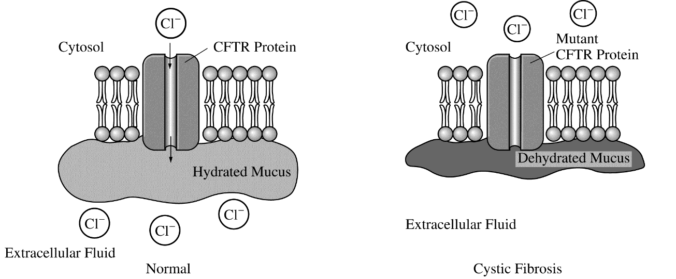
An answer to which of the following questions would provide the most information about the association between the CFTR mutation and the viscous mucus?
  - Is the mucus also secreted from the cells through the CFTR proteins?
  - How does the disrupted chloride movement affect the movement of sodium ions and water by the cell?
  - How does the mutation alter the structure of the CFTR proteins?
  - What is the change in nucleotide sequence that results in the CFTR mutation?

- The processes illustrated in the models depicted below all result in which of the following?
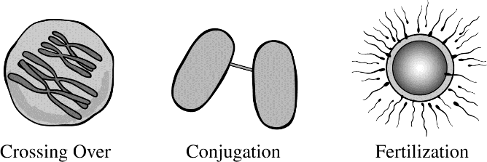
  - Transcription
  - An increase in genetic variation
  - An increase in the chromosome number
  - Horizontal gene transfer

- A new mutation that arose in one copy of gene X in a somatic cell resulted in the formation of a tumor. Which of the following pieces of evidence best describes how the new mutation directly caused the tumor?
  - Protein X normally stimulates cell division, and the mutation created an overactive version of protein X.
  - Protein X normally activates a growth hormone receptor, and the mutation decreased the stability of protein X.
  - Protein X normally prevents passage through the cell cycle, and the mutation created an overactive version of protein X.
  - Protein X normally regulates gene expression, and the mutation created an underactive version of protein X that blocked the cell cycle.

Use the following information for questions 13-17:

In a transformation experiment, a sample of E. coli bacteria was mixed with a plasmid containing the gene for resistance to the antibiotic ampicillin (amp^{r}). Plasmid was not added to a second sample. Samples were plated on nutrient agar plates, some of which were supplemented with the antibiotic ampicillin. The results of E. coli growth are summarized below. The shaded area represents extensive growth of bacteria; dots represent individual colonies of bacteria.
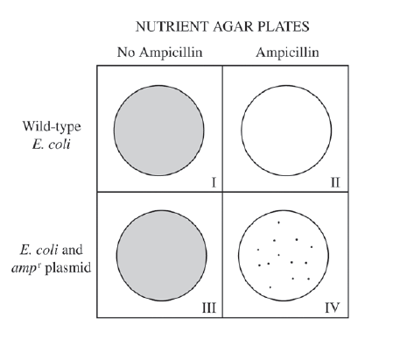
- Plates that have only ampicillin-resistant bacteria growing include which of the following?

  - I only
  - III only
  - IV only
  - I and II

- Which of the following best explains why there is no growth on plate II?
  - The initial E. coli culture was not ampicillin- resistant.
  - The transformation procedure killed the bacteria.
  - Nutrient agar inhibits E. coli growth.
  - The bacteria on the plate were transformed.

- Plates I and III were included in the experimental design in order to
  - demonstrate that the E. coli cultures were viable
  - demonstrate that the plasmid can lose its amp^{r} gene
  - demonstrate that the plasmid is needed for E. coli growth
  - prepare the E. coli for transformation

- Which of the following statements best explains why there are fewer colonies on plate IV than on plate III?
  - Plate IV is the positive control.
  - Not all E. coli cells are successfully transformed.
  - The bacteria on plate III did not mutate.
  - The plasmid inhibits E. coli growth.

- In a second experiment, the plasmid contained the gene for human insulin as well as the amp^{r} gene. Which of the following plates would have the highest percentage of bacteria that are expected to produce insulin?
  - I only
  - III only
  - IV only
  - I and III

Use the following information for questions 18-20:

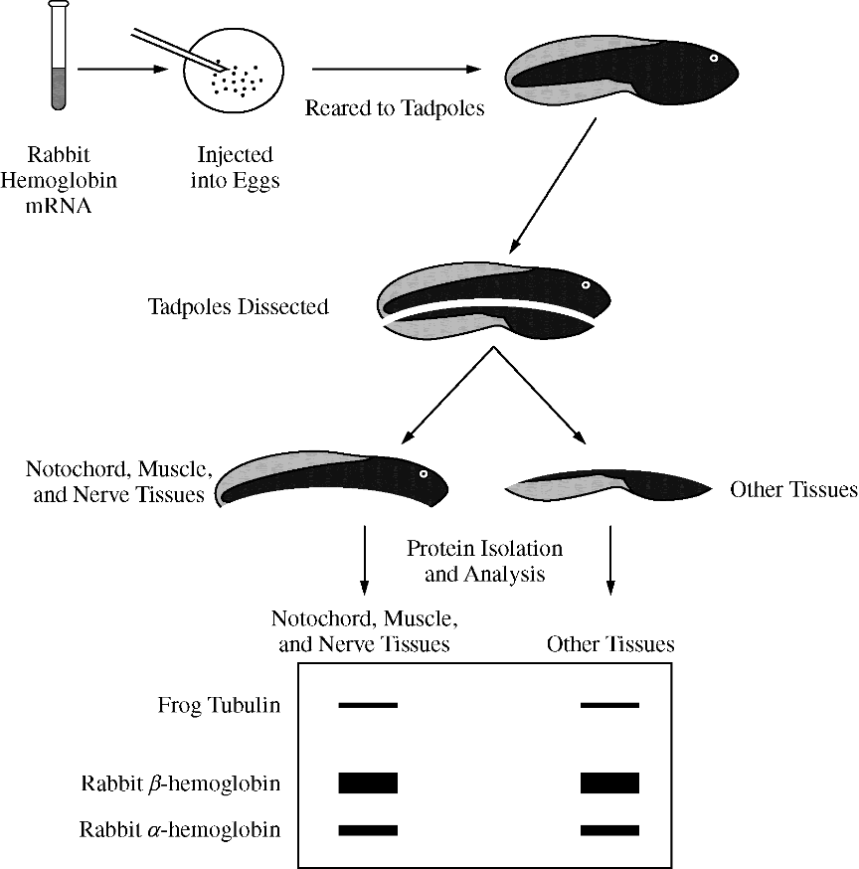
In a classic experiment from the 1970s investigating gene expression, a solution containing equal amounts of rabbit a-hemoglobin mRNA and b-hemoglobin mRNA, which encode subunits of a protein found in red blood cells, was injected into newly fertilized frog eggs. The injected mRNA was not degraded during the course of the experiment. Tadpoles that developed from the injected eggs were dissected into two fragments, one containing predominantly the notochord, muscle tissue, and nerve tissue and the other containing predominantly the other tissue types.

Equal amounts of total protein were analyzed after separation by electrophoresis to identify the relative amounts of the different proteins present in each sample. The thickness of the bands indicates the relative amounts of rabbit α-hemoglobin, rabbit β-hemoglobin, and frog tubulin (a cytoskeletal protein that is expressed at relatively constant levels in all tissues) present in each tadpole sample. The experimental protocol and results are summarized in the figure below.
- The electrophoresis results best support which of the following conclusions?
  - Cell specialization during development results in some cells losing the ability to synthesize proteins.
  - Cells from different tissues share a common ability to use genetic material from a foreign source to produce protein.
  - In comparison with other cells, nerve cells have a superior ability to produce cytoskeletal proteins.
  - Muscle cells produce more β-hemoglobin than do cells from the other tissues in a tadpole.

- Which of the following conclusions is most consistent with the results of the experiment?
  - Rabbit mRNA is composed of nucleotides that are absent from frog mRNA.
  - A larger volume of blood circulates through a rabbit than through a frog.
  - The subunits of hemoglobin differ in size, shape, or charge.
  - Synthesis of β-hemoglobin occurs at a faster rate in muscle cells than in other body cells.

- Given that equal amounts of the different mRNAs were injected into fertilized frog eggs, which of the following conclusions is most consistent with the electrophoresis results?
  - β-hemoglobin mRNA is translated more efficiently than is α-hemoglobin mRNA.
  - α-hemoglobin is present only in cells where β-hemoglobin is absent.
  - α-hemoglobin mRNA is more stable than β-hemoglobin mRNA.
  - Tubulin inhibits translation of hemoglobin mRNA.

Multiple Choice Key
Question | Correct Answer | Unit/Topic | Source
1 | D. | 6.2 | 2012 CED #3
2 | B. Different exons are retained or spliced out of the primary transcript. | 6.3 | 2020 CED #11
3 | A. Bicoid protein inhibits translation of caudal mRNA. | 6.3 | 2012 CED #19
4 | D. 5' CUG ACU CCU GUG GAG AAG UCU 3' | 6.3 | 2013 #49
5 | A. The HbA DNA contains a recognition site for the Mst II restriction enzyme. | 6.8 | 2013 #50
6 | C. The activator is a sequence-specific DNA-binding protein that is present in some tissues but not in other tissues. | 6.5 | 2013 #38
7 | D. | 6.5 | 2012 CED #7
8 | D. Do mutations in the POU4F3 gene affect MYO6 mRNA levels in cells? | 6.6 | 2020 CED #3
9 | A. properties of the molecule as a result of abnormal interactions between adjacent hemoglobin molecules | 6.7 | 2012 CED #20
10 | B. How does the disrupted chloride movement affect the movement of sodium ions and water by the cell? | 6.7 | 2013 #26
11 | B. An increase in genetic variation | 6.7 | 2013 #15
12 | A. Protein X normally stimulates cell division, and the mutation created an overactive version of protein X. | 6.7 | 2013 #25
13 | C. IV only | 6.8 | 2012 CED #24
14 | A. The initial E. coli culture was not ampicillin- resistant. | 6.8 | 2012 CED #25
15 | A. demonstrate that the E. coli cultures were viable | 6.8 | 2012 CED #26
16 | B. Not all E. coli cells are successfully transformed. | 6.8 | 2012 CED #27
17 | C. IV only | 6.8 | 2012 CED #28
18 | B. Cells from different tissues share a common ability to use genetic material from a foreign source to produce protein. | 6.8 | 2013 #26
19 | C. The subunits of hemoglobin differ in size, shape, or charge. | 6.8 | 2013 #30
20 | A. β-hemoglobin mRNA is translated more efficiently than is α-hemoglobin mRNA. | 6.4 | 2013 #31

Multiple Choice Explanations
Q |  | Explanation:
1 | A | The top strand here is read 5’ to 3’ and being made 3’ to 5’ which is opposite of the directionality of DNA replication.  This option is incorrect. The figure shows both template strands of DNA being replicated continuously in a parallel direction. No “lagging” strand with Okazaki fragments is identified. DNA polymerase’s structure does not allow it to add nucleotides in the 5' direction. (CollegeBoard)
 | B | The top strand here is read 5’ to 3’ and being made 3’ to 5’ which is opposite of the directionality of DNA replication.  This option is incorrect. The figure incorrectly shows Okazaki fragments on the “leading” strand and both new strands being assembled in a parallel direction. DNA polymerase’s structure does not allow it to add nucleotides in the 5' direction. (CollegeBoard)
 | C | The top strand here is read 5’ to 3’ and the bottom strand is read 5’ to 3’ so both strands are being made 3’ to 5’ which is opposite of the directionality of DNA replication.  This option is incorrect. The figure incorrectly shows both strands being replicated continuously, and no Okazaki fragments on the lagging strand are identified. The new strands are shown being assembled in the 3'-to-5' direction, but the limitations of DNA polymerase only allow assembly in the 5'-to-3' direction. (CollegeBoard)
 | D | DNA reads 3’ to 5’ and DNA is made 5’ to 3’. In addition, there are two “types” of strands. The leading strand (bottom) is synthesized continuously towards the replication fork and the lagging strand is synthesized discontinuously away from the replication fork.  This option is correct. It demonstrates an understanding of the structure of DNA and the process of replication. The two strands of the DNA molecule run antiparallel to each other; the 5' end of one strand pairs with the 3' end of the other strand. Replication is semi-conservative, with each strand serving as the template for the creation of new complementary strands. Helicase unzips the DNA molecules between the hydrogen bonds connecting the two strands. DNA polymerase “reads” each template strand in the 3'-to-5' direction and assembles the growing DNA chain in a 5'-to-3' direction. The “leading” strand is produced continuously, but on the “lagging” strand, Okazaki fragments are produced and are connected by ligase to produce the daughter molecule.
2 | A | Introns are non-coding regions of the DNA.
 | B | The exons are the coding regions of the DNA. If the same exons were spliced then same polypeptide would be formed.
 | C | The 5’ (GTP) cap allows for the mRNA to exit the nucleus and it aids in the binding of the ribosome to the 5’ end of the mRNA for translation.
 | D | The primary transcript needs to be read as mRNA in order to be a template for the polypeptide synthesis.
3 | A | If you look at the second figure, you will see the slow decrease of bicoid is complemented by the slow increase of caudal. This shows that there is a negative relationship between the two whereas the bicoid inhibits the synthesis of the caudal protein.  This option is correct. The second indicatesthat, after fertilization, the concentration of the bicoid protein decreases asthe concentration of the caudal protein increases. Inhibition of the translation of caudal protein by bicoid protein is a logical hypothesis about the interaction of these two proteins and supports the concept that both the coordination and timing of these two proteins are necessary for the normal development in a Drosophila egg. (CollegeBoard)
 | B | If the bicoid stabilized the caudal, the bicoid will have a similar trend (both high or both low)  This option is incorrect. There is no indication that the bicoid protein stabilizes caudal DNA. The first graph shows the relative concentrations of mRNA for the two proteins; the second shows the relative concentration of the proteins.
 | C | As the bicoid mRNA decreases, the caudal mRNA remains at high concentrations. (CollegeBoard)  This option is incorrect. There are not enough data to support that translation of bicoid mRNA produces caudal protein. (CollegeBoard)
 | D | According to the figure, caudal protein has a higher concentration in the posterior demonstrating that it stimulates the development of the posterior structures.  This option is incorrect. The second graph shows that caudal protein stimulates the development of posterior structures, not anterior structures, as indicated in the graph. (CollegeBoard)
4 | A | DNA is read 3’ to 5’. This answer choice uses the non-template strand to base pair for the mRNA.
 | B | DNA is read 3’ to 5’. This answer choice uses the template strand (correct) but reads in the wrong direction. In addition, this does not follow the antiparallel directionality of DNA.
 | C | This answer choice uses the non-template strand to base pair for the mRNA.
 | D | The template strand is read (3’ to 5’): 3' GAC TGA GGA CTC CTC TTC AGA 5'  To make mRNA, base pair: 5’ CUG ACU CCU GAG GAG AAG UCU 3’  GAG codes for Glu while GUG codes for Val
5 | A | Based on the pedigree, Individual I is HbS HbS, individual II is HbA HbS, and individual HbA HbA. Based on the gel electrophoresis, there is ONE restriction site since there are two fragments.
 | B | Individual II is HbA/HbS. It has TWO restriction sites since there are three fragments.
 | C | The one band represents that there were no restriction sites for the restriction enzyme to cut the DNA into smaller fragments.
 | D | HbS/HbA has two alleles – HbA and HbS. The three fragments is due to the restriction enzyme having two restriction sites.
6 | A | This does not compare the liver cells to other cells.
 | B | If the activation is inhibited in liver cells, then the liver cell would not synthesize the protein. Based on the prompt, the liver cells express the gene while nerve cells do not.
 | C | As seen in the figure, the activator binds to the enhancer region causing the DNA to bend to create a secure binding region for RNA polymerase. If this activator does not bind to the enhancer, the DNA would not bend over and there would be a decrease in transcription and thus a decrease in translation. Each cell has different activators which explains why it is expressed in liver cells and not in nerve cells.
 | D | DNA is identical in all cells. This region would be found in the DNA of liver cells and DNA in nerve cells.
7 | A | When lactose is present, it binds with the repressor protein to deactivate it. Since the repressor does not bind to the operator, the operon is on. This will synthesize the proteins needed to break down lactose.  This option is incorrect because lactose has bonded with the repressor protein, resulting in its release from the operator. This will allow RNA polymerase to transcribe the lac operon because the molecular barrier no longer exists. (CollegeBoard)
 | B | If lactose is bound to the repressor, the repressor is no longer bound to the operator.  This option is incorrect because if lactose did bind with the repressor protein, then it would result in a conformational change and the repressor protein would no longer bind to the operator portion of the operon. No transcription would occur. (CollegeBoard)
 | C | The prompt states that lactose is NOT being utilized. The lac operon is an inducible operon, so the repressor should be bound to the operator.  This option is incorrect because with no repressor in place, the operon would be turned on, and the genes would be transcribed (CollegeBoard)
 | D | The prompt states that lactose is NOT being utilized, which means that the lactose is not binding the repressor. Since the lactose is not being to the repressor, the repressor binds to the operator inhibiting the binding of RNA polymerase which inhibits the transcription of the structural genes.  This option is correct because the lac operon is an inducible operon, which means that the regulatory system is turned off until lactose or its analog turns it on. The mechanism for preventing its transcription is the binding of a repressor protein to the operator region (CollegeBoard)
8 | A | The other genes are not what is being studied by the researchers.
 | B | If we are investigating hearing loss, determining the mutations in other cells does not provide a solution to the investigated problem.
 | C | The researchers are studying the affect in humans, so it is not necessary to determine the mutations in mice.
 | D | According to the prompt, “researchers… proposed that POU4F3 encodes a transcription factor that influences the regulation of MYO6”. If this were true, a mutation in POU4F3 would encode a defective transcription factor which could affect the transcription of MYO6. If MYO6 is reduced, there could be a hearing loss and since it’s found in the DNA (mutation), the trait can be inherited.
9 | A | The missense mutation (one amino acid is substituted for another amino acid) causes a hydrophilic amino acid to be substituted with a hydrophobic amino acid. The prompt states this is located on the exterior of the protein. This would result in a confirmational shape change which will affect the function of the protein by “resulting in abnormal interactions”.  This option is correct. The mutation results in the replacement of an amino acid, which alters the properties of the R-group both structurally and functionally; thus, the interactions between adjacent hemoglobin molecules would also be altered. In this case, hemoglobin molecules would tend to stick together as a result of hydrophobic interactions between amino acids on the surface. (CollegeBoard)
 | B | The hydrogen bonding of the DNA is not affected by this mutation. The point mutation would replace both nitrogenous bases.  This option is incorrect. A point mutation, which causes the replacement of an amino acid with another amino acid, has already occurred in the DNA. The replacement of one amino acid would not alter the hydrogen bonding between nitrogenous bases in the structure of DNA. (CollegeBoard)
 | C | Proteins do not have a fatty acid. The phospholipids and fats have 2 and 3 fatty acids, respectively.  This option is incorrect. A point mutation, which causes the replacement of a hydrophilic amino acid R-group with another amino acid that has a hydrophobic R-group, would not alter a fatty acid. (CollegeBoard)
 | D | The secondary structure is a result of hydrogen bonding between the polypeptide backbone versus the missense mutation affects the R groups of the amino acids (which is tertiary structure)  This option is incorrect. A mutation is not likely to alter the secondary structure of a protein. The secondary structure of proteins is due to hydrogen bonding between the carboxyl and amine residues in the chain, not interactions between R-groups (CollegeBoard)
10 | A | Based on the image, it does not appear that the mucus moves across the membrane. The different appears to be in the hydrated vs dehydrated mucus outside the cell.
 | B | Cystic fibrosis affects the chloride channels. When the chloride is moved across the membrane, the mucus is hydrated (water follows the ions) while when the chloride does not cross the membrane, the mucus is dehydrated. The researchers need to investigate how the disrupted chloride movement affects the sodium ions and water.
 | C | This question will provide more information about why the chloride is unable to cross the membrane, but it does not provide information about the mucus.
 | D | This question will provide more information about the mutation (and possibly why the chloride is unable to cross the membrane), but it does not provide information about the mucus.
11 | A | Transcription is reading DNA to synthesize a mRNA molecule.
 | B | Crossing over increases genetic variation. Conjugation increases genetic variation. Fertilization increases genetic variation.
 | C | Crossing over involves exchanging genetic information, so there is no increase in chromosome number.
 | D | Horizontal gene transfer is the process where genetic information is shared between organisms without mating. This is demonstrated during the process of conjugation, but not crossing over or fertilization.
12 | A | If protein X stimulates cell division and protein X is overactive, protein X will continue to stimulate cell division excessively. This increase in cell division will result in a tumor (mass of cells).
 | B | If protein X activates a growth hormone receptor, it will be responsible for increased cell division BUT if the mutation decreases the stability, then there will be a decrease in cell division as the protein does not activate the receptor.
 | C | If protein X inhibits cell division and protein X is overactive, it will continue to inhibit cell division resulting in less cell division.
 | D | If protein X regulates gene expression and an underactive version of protein x, the cell cycle will be blocked resulting in less cell division.
13 | A | Plate I is wild-type E. coli which is not ampicillin-resistant.  This option is incorrect. Plate I shows an extensive growth of bacteria, which is normal when wild-type E. coli is grown without ampicillin. There was no selection for ampicillin resistance; thus, this plate served as a control. (CollegeBoard)
 | B | Plate III is transformed E. coli which is ampicillin-resistant, but there is no ampicillin in the plate medium to restrict growth to ONLY ampicillin-resistant bacteria.  This option is incorrect. Plate III shows E. coli and the ampicillin-resistant plasmid growing extensively when no ampicillin is present. Indication of which bacteria took up the naked DNA with the ampr gene is undetermined. (CollegeBoard)
 | C | Plate IV is transformed E. coli which is ampicillin-resistant and there is ampicillin in the plate medium which restricts growth to ONLY ampicillin-resistant bacteria.  This option is correct. Plate IV shows that only E. coli with the plasmid containing the gene for ampicillin-resistant plasmid grew individual colonies with ampicillin in the agar, thus showing the competent cells that transformed successfully. (CollegeBoard)
 | D | Plate I and II is wild-type E. coli which is not ampicillin-resistant.  This option is incorrect. Plate II shows that there is no bacterial growth when ampicillin is present; thus, there are no ampicillin-resistant bacteria (CollegeBoard)
14 | A | Plate II is wild-type E. coli which is not ampicillin-resistant BUT there is ampicillin in the plate medium which will inhibit growth of bacteria.  This option is correct. The initial wild-type E. coli did not contain the plasmid containing the gene for resistance to the ampicillin (amp^{r}) and, when exposed to ampicillin, did not grow on Plate II. (CollegeBoard)
 | B | Based on the growth in plate I, the bacteria was viable and not affected by the transformation procedure.  This option is incorrect. In a typical transformation experiment, if all procedures were followed as in this experiment, it is unlikely for a procedure to kill the bacteria. Plate IV indicates that the transformation procedure did not kill the bacteria (CollegeBoard)
 | C | Based on the growth in plate I and III, the nutrient agar does not inhibit E. coli growth.  This option is incorrect. Nutrient agar promotes E. coli growth (CollegeBoard)
 | D | If the bacteria were transformed, they would have amp plasmid and be ampicillin resistant.  This option is incorrect. The bacteria in Plate II were not exposed to the plasmid and thus could not have been transformed (CollegeBoard)
15 | A | Plate I and III have no ampicillin in the plate medium and have a lawn of growth. This demonstrates that the bacteria were viable and unharmed by the transformation process.  This option is correct. Both PlatesI and III had extensive E. coli growth, showing that the cells were viable before and after the transformation procedure (CollegeBoard)
 | B | Plate I was not given the amp plasmid.  This option is incorrect. Plates I and III would not have provided information on whether the plasmid could lose its amp^{r} gene, and there was no way of knowing this with the data from these two plates. (CollegeBoard)
 | C | Plate I and III both have a lawn of growth and look identical. The presence of plasmid did not affect the growth of E. coli on the nutrient broth plates.  This option is incorrect. The bacteria in Plate I were not exposed to the plasmid. (CollegeBoard)
 | D | Plate III has already been transformed.  This option is incorrect. The bacteria were plated after the transformation; thus, plating could not have prepared them for transformation. (CollegeBoard)
16 | A | A positive control is a group in an experiment that receives a treatment that is known to produce results similar to those predicted by your hypothesis. Plate II is the positive control as the non-transformed bacteria should not grow in the presence of the ampicillin.  This option is incorrect. Plate I is the positive control, showing that the bacteria were viable before the transformation procedure (CollegeBoard)
 | B | Plate III does not have ampicillin while Plate IV has ampicillin. The ampicillin will restrict the growth to ONLY ampicillin-resistant bacteria. Those E. coli that were not transformed  This option is correct. Only the E. coli that have been transformed and contain the amp^{r} gene will grow and produce colonies. (CollegeBoard)
 | C | The experiment is not investigating mutations.  This option is incorrect. The transformation experiment did not determine whether E. coli bacteria could mutate or not. (CollegeBoard)
 | D | The plasmid provides the ampicillin resistance and does not inhibit E. coli growth.  This option is incorrect. Both plates with plasmids showed growth while the plate with ampicillin and no plasmids showed no growth, indicating that plasmids did not inhibit growth. (CollegeBoard)
17 | A | Plate I is wild-type E. coli which does not have the plasmid and cannot synthesize insulin.  This option is incorrect. The bacteria in Plate I were not exposed to the plasmid. (CollegeBoard)
 | B | Plate III is transformed E. coli and can synthesize insulin (and is ampicillin resistant), but there is no ampicillin in the plate medium to restrict growth to ONLY ampicillin-resistant bacteria so this will not have the highest percentage of bacteria able to produce insulin.  This option is incorrect. Plate III does not distinguish which bacteria took up the plasmid. Bacteria with and without the plasmid grow, but the percentage of those with the ability to produce insulin is much lower than in Plate IV. (CollegeBoard)
 | C | Plate IV is transformed E. coli and can synthesize insulin (and is ampicillin resistant), and there is ampicillin in the plate medium which restricts growth to ONLY ampicillin-resistant bacteria so 100% of the bacteria can produce insulin.  This option is correct. In Plate IV the colonies of E. coli were successfully transformed and expressed the amp^{r} gene; adding another gene to the plasmid would express the human insulin gene the same way. (CollegeBoard)
 | D | Plate I and II is wild-type E. coli which does not have the plasmid and cannot synthesize insulin.  This option is incorrect. The bacteria on Plate I were not exposed to the plasmid and so could not have taken up the insulin gene, thus eliminating this choice. (CollegeBoard)
18 | A | Both gels look the same demonstrating that there was no difference between the notochord, muscle, and nerve compared to other tissues. All cells synthesize the protein equally.
 | B | The cells from the notochord, muscle, nerve, and other tissues are able to use the rabbit mRNA to synthesize the two forms of hemoglobin demonstrating that cells of different tissues can use genetic material from a foreign source to produce protein.
 | C | Nerve cells have the same amount of tubulin as other cells based on the data from the gel.
 | D | Muscle cells have the same amount of β-hemoglobin as other cells based on the data from the gel.
19 | A | The mRNA nucleotides used is not able to be determined from a gel electrophoresis.
 | B | The volume of blood has no affect on the proteins ran through the gel electrophoresis.
 | C | The function of a gel electrophoresis separates materials based on size, shape, or charge. Since there are three bands, this demonstrates there is a difference between the proteins with one of these characteristics.
 | D | The rate of synthesis is not able to be determined from a gel electrophoresis.
20 | A | There is more β-hemoglobin than α-hemoglobin as represented by the thicker band with β-hemoglobin. Since the same amount of mRNA was injected, the β-hemoglobin must have been translated more efficiently.
 | B | Both α-hemoglobin and β-hemoglobin is present in the cells based on the gel.
 | C | More stable mRNA would remain in the cytosol longer and be translated more yielding a higher concentration. There is more β-hemoglobin and less α-hemoglobin which does not fit this statement.
 | D | If tubulin inhibited the translation, there would be no hemoglobin found in the cells.

