AP Biology Topic Video Summaries
Unit 1: Chemistry of Life
Summaries were completed by CB Dahan using the CollegeBoard AP Topic Videos
Standard: | Video Summary:
1.1 Structure of Water and Hydrogen Bonding  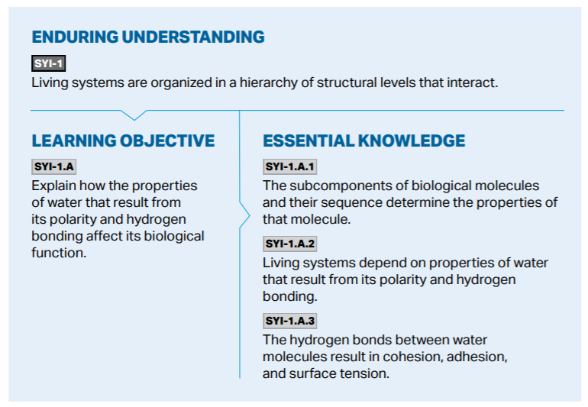 | ● Water contains 1 oxygen atom covalently bonded to 2 hydrogen atoms  ● Oxygen has a higher electronegativity compared to hydrogen resulting in a water molecule having polarity  ● Polarity allows molecules to form hydrogen bonds when oppositely charged regions of two molecules interact  ● The term cohesion refers to molecules of the same type forming hydrogen bonds with one another and adhesion referred to different types of molecules forming hydrogen bonds with one another  ● Living systems depend on waters properties like surface tension which is the tension of the surface film of a liquid caused by the attraction of the particles in the surface layer by the bulk of the liquid, which tends to minimize surface area. As well as capillary action the ability of a liquid to flow in narrow spaces without the assistance of, or even in opposition to, external forces like gravity and lastly waters high heat capacity.
1.2 Elements of Life  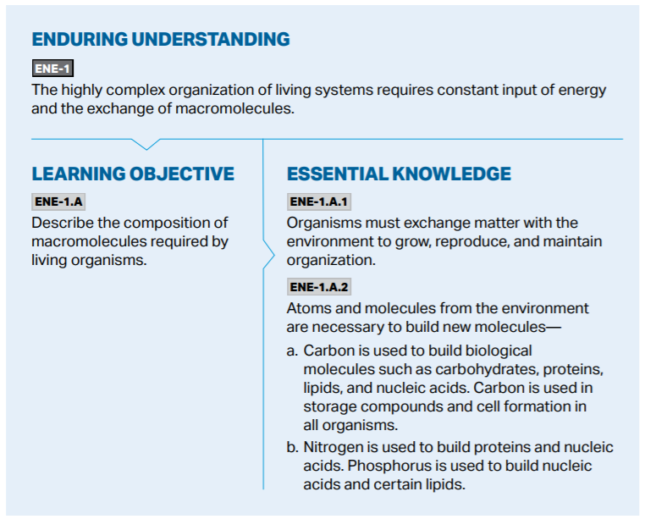 | ● living systems need a constant input of energy to grow, reproduce and maintain organization  ● Law of conservation of energy - energy can not be created or destroyed only transformed  ● Atoms and molecules from the environment are necessary to build new molecules  ● Carbon is used to build all macromolecules, store energy and form cells  ● Nitrogen is used to build proteins and nucleic acids  ● Phosphorus is used to build nucleic acids and certain lipids
1.3 Introduction to Biological Macromolecules  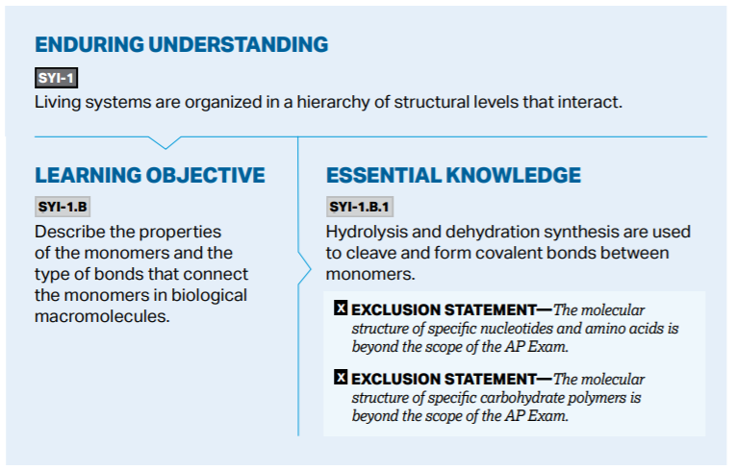 | ● all macromolecules contain carbon and are used to build biological macromolecules  ● Covalent bonds are used to connect monomers together  ● Dehydration synthesis reactions are used to create biological macromolecules and water is an additional product  ● Hydrolysis reactions use water to break down biological macromolecules
1.4 Properties of Biological Macromolecules  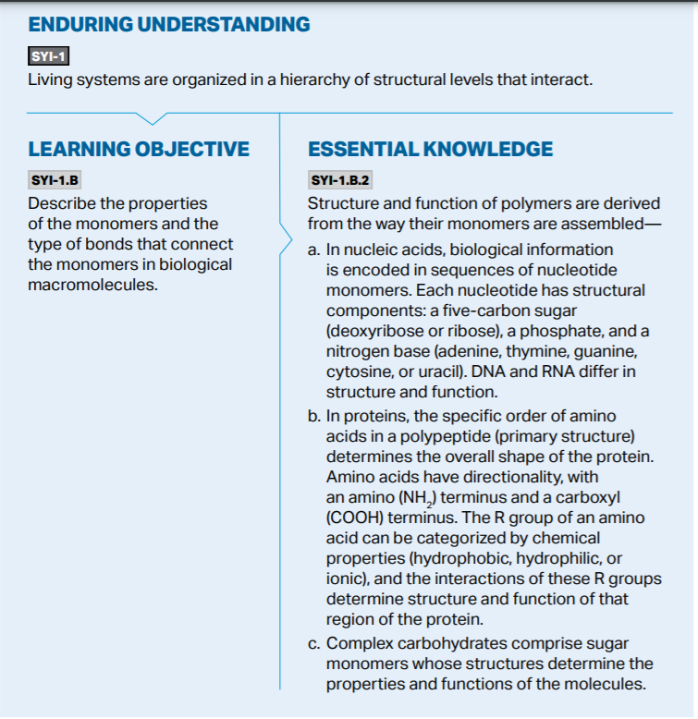  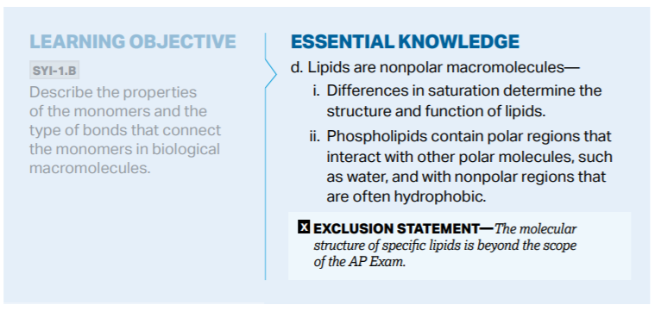 | ● nucleotides can vary in the sugar and base components resulting in nucleic acids with different structure and function  ● The amino terminus and carboxyl terminus give amino acids directionality and determine how amino acids assemble into protein polymers  ● R groups properties determine how amino acids interact with the polypeptide and determine the structure and function of the protein  ● Differences in the components of carbohydrate monomers determine how the monomers  assemble into complex carbohydrates and determine function  ● Lipids are nonpolar macromolecules and difference in saturation determine the structure and function of lipids  ● Phospholipids contain polar regions that interact with other polar molecules and nonpolar regions
1.5 Structure and Function of Biological Macromolecules  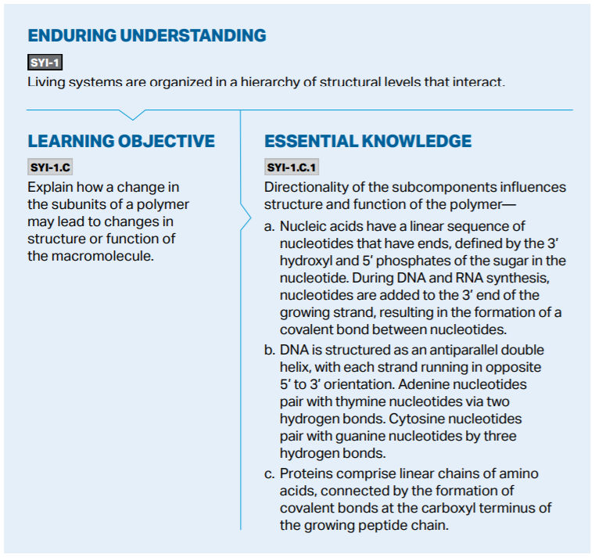  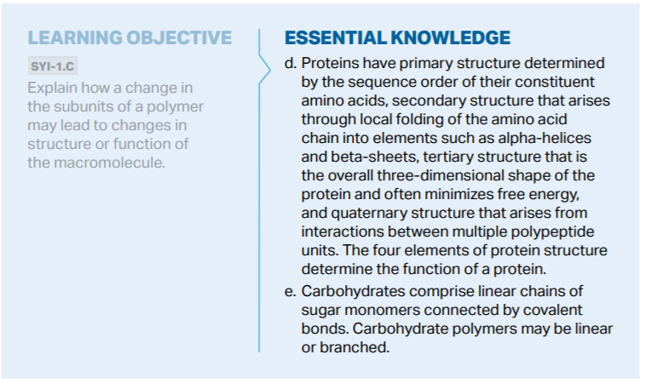 | ● The linear sequences of all nucleic acids is defined by the 3’ hydroxyl and 5’ phosphate of the sugar in the nucleotide  ● DNA is structured as an antiparallel double helix with two strands running in opposite 5’-3’ directions. This allows for the two strands of DNA to be held together by hydrogen bonds between base pairs. A-T held together by 2 hydrogen bonds; G-C held together by 3 hydrogen bonds.  ● During DNA and RNA synthesis, nucleotides can only be covalently added to the 3’ end of a growing nucleotide strand  ● Changes in the linear sequences of the nucleotide bases may lead to differences in the encoded biological information  ● Amino acids have directionality with an amino terminus (NH₂) and a carboxyl terminus (COOH) on the other. Amino acids are added to the carboxyl terminus of a growing peptide chain by the formation of covalent bonds  ● There are 4 elements of protein structure. Primary, secondary (alpha helices and beta sheets), tertiary, and quaternary. Levels of structure beyond the primary linear sequence of amino acids arise through the local folding and other chemical interactions among  amino acids. The resulting 3D shape gives rise to the protein's specific function.  ● A change in an amino acid subunit at the primary level of structure may lead to a change in the structure and function of the protein at subsequent levels.  ● Carbohydrates comprise linear chains of amino of sugar monomers connected by covalent bonds. Sugar monomers may vary in the direction of some of their components, such as the bond orientation of -OH groups linked to the carbon chain.  ● Depending on the type of sugar monomers used in its formation, a carbohydrate polymer may have a linear or branched structure and can differ in function
1.6 Nucleic Acids  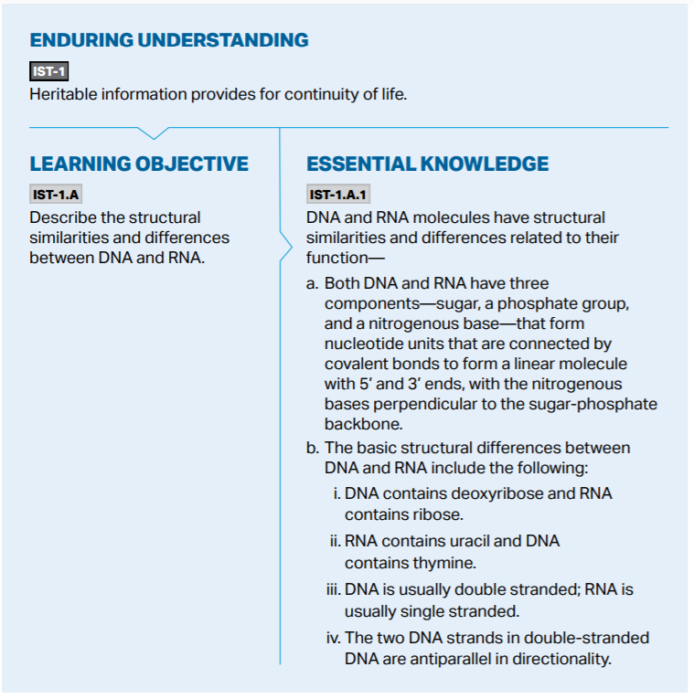 | ● Both DNA and RNA are formed from nucleotide subunits connected by covalent bonds to form linear molecules with 5’ and 3’ ends. Each nucleotide is comprised of a sugar, phosphate group and nitrogenous base.  ● Differences include the type of sugar, one of the nitrogenous bases (RNA contains uracil whereas DNA contains thymine), and number of strands. DNA has two nucleotide strands that are antiparallel

