Unit 2: Cell Structure and Function

Topic | Learning Objective(s)
2.1  Cell Structure:  Subcellular Components | SYI-1.D Describe the structure and/ or function of subcellular components and organelles.
2.2  Cell Structure and Function | SYI-1.E Explain how subcellular components and organelles contribute to the function of the cell.
 | SYI-1.F Describe the structural features of a cell that allow organisms to capture, store, and use energy
2.3  Cell Size | ENE-1.B Explain the effect of surface area-to-volume ratios on the exchange of materials between cells or organisms and the environment.
 | ENE-1.C Explain how specialized structures and strategies are used for the efficient exchange of molecules to the environment.
2.4  Plasma Membranes | ENE-2.A Describe the roles of each of the components of the cell membrane in maintaining the internal environment of the cell.
 | ENE-2.B Describe the Fluid Mosaic Model of cell membranes.
2.5  Membrane Permeability | ENE-2.C Explain how the structure of biological membranes influences selective permeability
 | ENE-2.D Describe the role of the cell wall in maintaining cell structure and function.
2.6  Membrane Transport | ENE-2.E Describe the mechanisms that organisms use to maintain solute and water balance.
 | ENE-2.F Describe the mechanisms that organisms use to transport large molecules across the plasma membrane.
2.7  Facilitated Diffusion | ENE-2.G Explain how the structure of a molecule affects its ability to pass through the plasma membrane.
2.8  Tonicity and Osmoregulation | ENE-2.H Explain how concentration gradients affect the movement of molecules across membranes.
 | ENE-2.I Explain how osmoregulatory mechanisms contribute to the health and survival of organisms.
2.9  Mechanisms of Transport | ENE-2.J Describe the processes that allow ions and other molecules to move across membranes.
2.10  Cell Compartmentalization | ENE-2.K Describe the membrane-bound structures of the eukaryotic cell.
 | ENE-2.L Explain how internal membranes and membrane-bound organelles contribute to compartmentalization of eukaryotic cell functions.
2.11  Origins of Cell Compartmentalization | EVO-1.A Describe similarities and/or differences in compartmentalization between prokaryotic and eukaryotic cells.
 | EVO-1.B Describe the relationship between the functions of endosymbiotic organelles and their free-living ancestral counterparts.

Free Response Practice
2019 #8
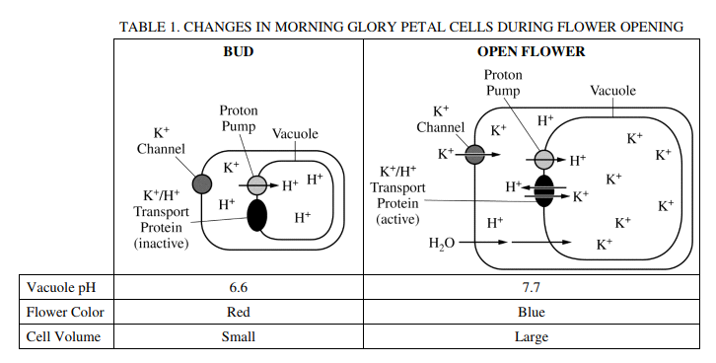
The petal color of the Mexican morning glory (Ipomoea tricolor) changes from red to blue, and the petal cells swell during flower opening. The pigment heavenly blue anthocyanin is found in the vacuole of petal cells. Petal color is determined by the pH of the vacuole. A model of a morning glory petal cell before and after flower opening is shown in Table 1.

(a) Identify the cellular component in the model that is responsible for the increase in the pH of the vacuole during flower opening AND describe the component’s role in changing the pH of the vacuole.

(b) A researcher claims that the activation of the K⁺/H⁺ transport protein causes the vacuole to swell with water. Provide reasoning to support the researcher’s claim.

2018 #6
Cystic fibrosis is a genetic condition that is associated with defects in the CFTR protein. The CFTR protein is a gated ion channel that requires ATP binding in order to allow chloride ions (Cl⁻) to diffuse across the membrane.

(a) In the provided model of a cell, draw arrows to describe the pathway for production of a normal CFTR protein from gene expression to final cellular location.

(b) Identify the most likely cellular location of the ribosomes that synthesize CFTR protein.

(c) Identify the most likely cellular location of a mutant CFTR protein that has an amino acid substitution in the ATP-binding site.
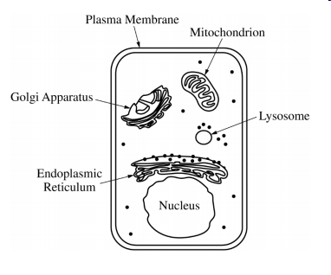

2017 #8
Estrogens are small hydrophobic lipid hormones that promote cell division and the development of reproductive structures in mammals. Estrogens passively diffuse across the plasma membrane and bind to their receptor proteins in the cytoplasm of target cells.

(a) Describe ONE characteristic of the plasma membrane that allows estrogens to passively cross the membrane.

(b) In a laboratory experiment, a researcher generates antibodies that bind to purified estrogen receptors extracted from cells. The researcher uses the antibodies in an attempt to treat estrogen-dependent cancers but finds that the treatment is ineffective. Explain the ineffectiveness of the antibodies for treating estrogen-dependent cancers.

2013 #6
The following data were collected by observing subcellular structures of three different types of eukaryotic cells.

RELATIVE AMOUNTS OF ORGANELLES IN THREE CELL TYPES
Cell Type | Smooth ER | Rough ER | Mitochondria | Cilia | Golgi Bodies
X | Small amount | Small amount | Large number | Present | Small amount
Y | Large amount | Large amount | Moderate number | Absent | Large amount
Z | Absent | Absent | Absent | Absent | Absent

Based on an analysis of the data, identify a likely primary function of each cell type and explain how the data support the identification.

Free Response Scoring Guidelines
2019 #8
Part | Scoring Guidelines | Topic
(a) | 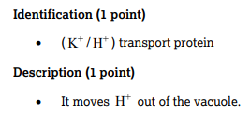 | 2.7  2.8
(b) | 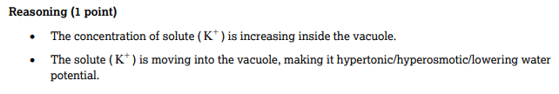 | 2.7  2.8

2018 #6
Part | Scoring Guidelines | Topic
(a) | 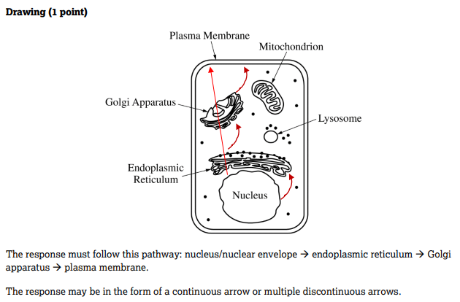 | 2.1
(b) | 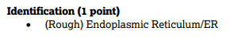 | 2.1
(c) | 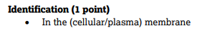 | 2.7

2017 #8
Part | Scoring Guidelines | Topic
(a) | 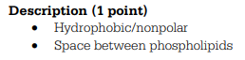
(b) | 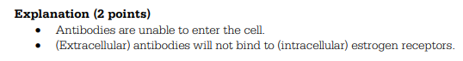

2013 #6
Part | Scoring Guidelines | Topic
 | 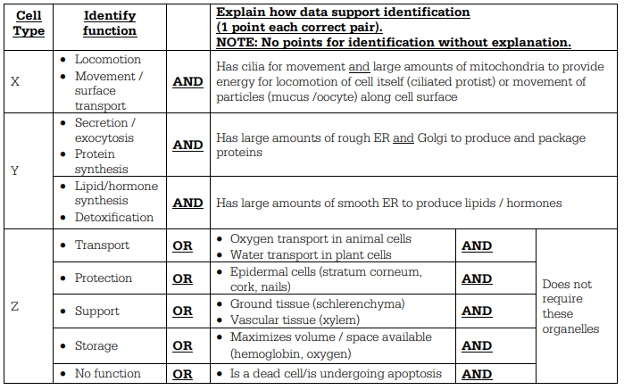 | 2.1

