Unit 3: Cellular Energetics

Topic | Learning Objective(s)
3.1  Enzyme Structure | ENE-1.D Describe the properties of enzymes.
3.2  Enzyme Catalysis | ENE-1.E Explain how enzymes affect the rate of biological reactions.
3.3  Environmental Impacts on Enzyme Function | ENE-1.F Explain how changes to the structure of an enzyme may affect its function.
 | ENE-1.G Explain how the cellular environment affects enzyme activity
3.4  Cellular Energy | ENE-1.H Describe the role of energy in living organisms.
3.5  Photosynthesis | ENE-1.I Describe the photosynthetic processes that allow organisms to capture and store energy.
 | ENE-1.J Explain how cells capture energy from light and transfer it to biological molecules for storage and use
3.6  Cellular Respiration | ENE-1.K Describe the processes that allow organisms to use energy stored in biological macromolecules.
 | ENE-1.L Explain how cells obtain energy from biological macromolecules in order to power cellular functions.
3.7  Fitness | SYI-3.A Explain the connection between variation in the number and types of molecules within cells to the ability of the organism to survive and/or reproduce in different environments.

Multiple Choice Practice
- The enzyme trypsin aids in protein digestion in the small intestine. The relative activity of trypsin at different pH values is shown in Figure 1.
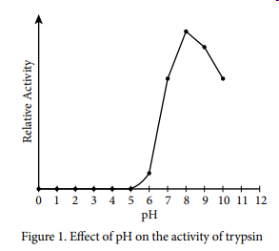
Which of the following statements best explains the activity levels of trypsin shown in Figure 1?
  - The small intestine releases inhibitor molecules that block the activity of trypsin unless it is at its optimum pH.
  - The number of effective collisions between trypsin and its substrate increase at higher pH values.
  - As pH values increase, the substrate concentration decreases, leading to an eventual decline in the rate of the trypsin-catalyzed reaction.
  - At extremely low pH values, trypsin is denatured and cannot function efficiently.

- It is estimated that oxygen production first evolved in photosynthetic prokaryotes approximately 2.7 billion years ago. The first photosynthetic prokaryotes are presumed to be similar to today’s cyanobacteria.

Which of the following best supports the claim that photosynthetic prokaryotes were responsible for the oxygen in Earth’s atmosphere?
  - The light reactions of photosynthesis split carbon dioxide into carbon and oxygen.
  - The light reactions of photosynthesis split water into hydrogen ions and oxygen.
  - The Calvin cycle splits glucose into carbon, hydrogen, and oxygen.
  - The Calvin cycle splits water into hydrogen ions and oxygen.

- Which of the following questions is most relevant to understanding the Calvin cycle?
  - How does chlorophyll capture light?
  - How is ATP used in the formation of 3-carbon carbohydrates?
  - How is NADP⁺ reduced to NADPH?
  - How is ATP produced in chemiosmosis?
Use the following information to answer questions 4 & 5:
A student placed 20 tobacco seeds of the same species on moist paper towels in each of two petri dishes. Dish A was wrapped completely in an opaque cover to exclude all light. Dish B was not wrapped. The dishes were placed equidistant from a light source set to a cycle of 14 hours of light and 10 hours of dark. All other conditions were the same for both dishes. The dishes were examined after 7 days and the opaque cover was permanently removed from dish A. Both dishes were returned to the light and examined again at 14 days. The following data were obtained.

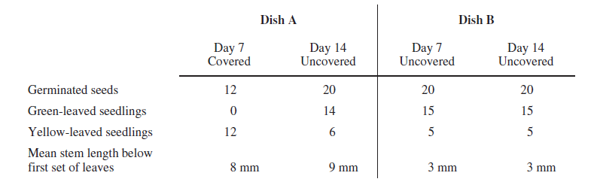
- According to the results of this experiment, germination of tobacco seeds during the first week is
  - increased by exposure to light
  - unaffected by light intensity
  - prevented by paper towels
  - accelerated in green-leaved seedlings

- Additional observations were made on day 21, and no yellow-leaved seedlings were found alive in either dish. This is most likely because
  - yellow-leaved seedlings were unable to absorb water from the paper towels
  - taller green-leaved seedlings blocked the light and prevented photosynthesis
  - yellow-leaved seedlings were unable to convert light energy to chemical energy
  - a higher rate of respiration in yellow-leaved seedlings depleted their stored nutrients

Use the following information to answer questions 6 – 10:
Photosynthetic activity can be measured using chloroplasts suspended in a buffered solution containing DCPIP, a dye that can accept electrons from the electron transport chain of photosynthesis. Transfer of electrons to DCPIP decreases the relative absorbance of a specific wavelength of light (605 nm) by a solution that contains the dye.
A buffered solution containing chloroplasts and DCPIP was divided equally among six identical samples. The samples were placed at various distances from a lamp, and then all samples were exposed to white light from the lamp for 60 minutes at room temperature. Sample 3 was wrapped in foil to prevent any light from reaching the solution. At 20-minute intervals, the photosynthetic activity in each sample was determined by measuring the relative absorbance of 605 nm light. The results of the experiment are provided below.
Relative Absorbance of 605 nm Light (arbitrary units)
Sample | Distance from Lamp (cm) | 0 min | 20 min | 40 min | 60 min
1 | 15 | 0.89 | 0.61 | 0.34 | 0.04
2 | 30 | 0.90 | 0.67 | 0.41 | 0.14
3* | 30 | 0.88 | 0.87 | 0.86 | 0.87
4 | 45 | 0.86 | 0.69 | 0.47 | 0.26
5 | 60 | 0.92 | 0.75 | 0.59 | 0.41
6 | 75 | 0.88 | 0.79 | 0.71 | 0.58
* Wrapped in foil

- Which of the following provides the best indication that light is required for the activation of electron transfer reactions in chloroplasts?
  - Calculating the rate of change of the absorbance for sample 1
  - Comparing the observed results for sample 2 and sample 3
  - Repeating the entire experimental procedure at night
  - Including multiple trials for all the samples

- Which of the following can be reasonably concluded from the experimental results?
  - Chloroplasts must be suspended in a buffer solution to function properly.
  - The optimal temperature for activation of electron transfer is 25°C.
  - DCPIP inhibits biochemical reactions in suspended chloroplasts.
  - Light from a lamp can substitute for sunlight in stimulating chloroplast processes

- If an additional sample containing the chloroplast/DCPIP solution was placed at a distance of 90 cm from the lamp, which of the following predictions would be most consistent with the experimental results?
  - The concentration of DCPIP in the solution will increase exponentially.
  - The absorbance at 60 minutes will be roughly equal to 1.4.
  - The change in absorbance over time in the solution will be less than that of the other samples.
  - The temperature of the solution will exceed 75°C.

- Which of the following descriptions of photosynthesis best explains the results of the experiment?
  - Availability of electrons for transfer to DCPIP depends on light energy.
  - Movement of DCPIP across chloroplast membranes occurs in less than 60 minutes.
  - Chlorophyll molecules degrade rapidly in the presence of DCPIP.
  - DCPIP can only be used to measure photosynthetic activity at low light levels.

- Which of the following scientific questions could be investigated using a similar experimental setup?
  - How much carbon dioxide is required by a plant cell to produce one molecule of glucose?
  - What wavelength of light best activates electron transfer reactions in chloroplasts?
  - Which molecule in chloroplasts accepts activated electrons from DCPIP during photosynthesis?
  - Are the same genes that are expressed in chloroplasts also expressed in mitochondria?

- What most likely causes the trends in oxygen concentration shown in the graph below?
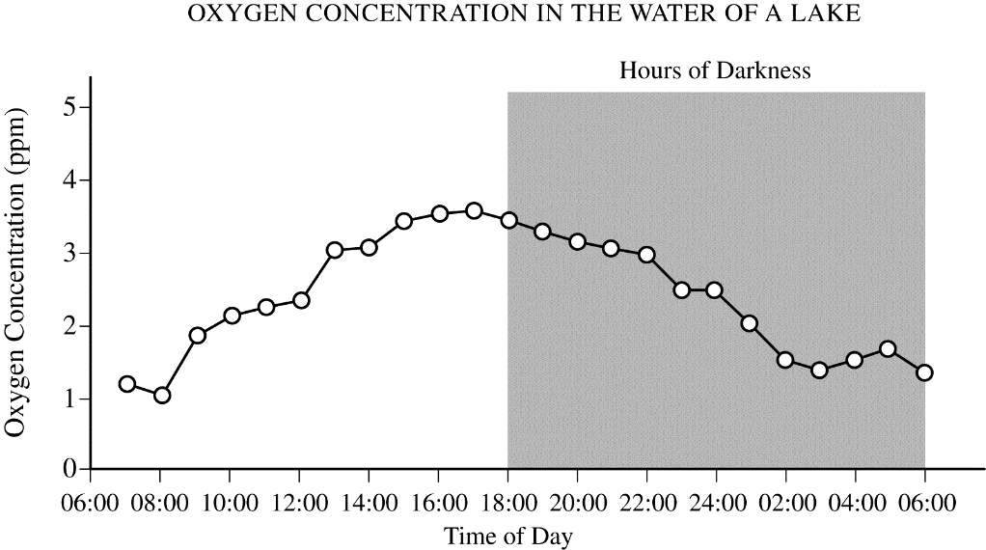

  - The water becomes colder at night and thus holds more oxygen.
  - Respiration in most organisms increases at night.
  - More organisms are respiring at night than during the day.
  - Photosynthesis produces more oxygen than is consumed by respiration during the day.

- The chemical reaction for photosynthesis is
6 CO₂ + 12 H₂O + light energy C₆H₁₂O₆ + 6 O₂ + 6 H₂O
If the input water is labeled with a radioactive isotope of oxygen, ¹⁸O, then the oxygen gas released as the reaction proceeds is also labeled with ¹⁸O. Which of the following is the most likely explanation?
  - During the light reactions of photosynthesis, water is split, the hydrogen atoms combine with the CO₂, and oxygen gas is released.
  - During the light reactions of photosynthesis, water is split, removing electrons and protons, and oxygen gas is released.
  - During the Calvin cycle, water is split, regenerating NADPH from NADP+, and oxygen gas is released.
  - During the Calvin cycle, water is split, the hydrogen atoms are added to intermediates of sugar synthesis, and oxygen gas is released.

- Students in a class measured the mass of various living organisms. They then kept the organisms in the dark for 24 hours before remeasuring them. None of the organisms were provided with nutrients during the 24-hour period. The data are as follows.
Organism | Starting Mass (g) | Final Mass (g)
Elodea (submerged aquatic plant) | 15.10 | 14.01
Goldfish | 10.10 | 9.84
Sea anemone | 25.60 | 24.98

Which of the following is the best explanation for the pattern of change in mass of the organisms over time?
  - Water loss due to evaporation
  - Cellular respiration
  - The law of conservation of matter
  - Growth and reproduction

Use the following information to answer questions 14 & 15:

An experiment to measure the rate of respiration in crickets and mice at 10°C and 25°C was performed using a respirometer, an apparatus that measures changes in gas volume. Respiration was measured in mL of O₂ consumed per gram of organism over several five-minute trials and the following data were obtained.

Organism | Temperature (°C) | Average respiration  (mL O₂/g/min)
Mouse | 10 | 0.0518
Mouse | 25 | 0.0321
Cricket | 10 | 0.0013
Cricket | 25 | 0.0038

- During aerobic cellular respiration, oxygen gas is consumed at the same rate as carbon dioxide gas is produced. In order to provide accurate volumetric measurements of oxygen gas consumption, the experimental setup should include which of the following?
  - A substance that removes carbon dioxide gas
  - A plant to produce oxygen
  - A glucose reserve
  - A valve to release excess water

- According to the data, the mice at 10°C demonstrated greater oxygen consumption per gram of tissue than did the mice at 25°C. This is most likely explained by which of the following statements?
  - The mice at 10°C had a higher rate of ATP production than the mice at 25°C.
  - The mice at 10°C had a lower metabolic rate than the mice at 25°C.
  - The mice at 25°C weighed less than the mice at 10°C.
  - The mice at 25°C were more active than the mice at 10°C.

Multiple Choice Key
Question | Correct Answer | Unit/Topic | Source
1 | D. At extremely low pH values, trypsin is denatured and cannot function  efficiently | 3.3 | 2020 CED
2 | B. The light reactions of photosynthesis split water into hydrogen ions and oxygen. | 3.5 | 2020 CED
3 | B. How is ATP used in the formation of 3-carbon carbohydrates? | 3.5 | 2013 #5
4 | A. increased by exposure to light | 3.5 | 2012  CED #13
5 | C. yellow-leaved seedlings were unable to convert light energy to chemical energy | 3.5 | 2012  CED #15
6 | B. Comparing the observed results for sample 2 and sample 3 | 3.5 | 2013 #41
7 | D. Light from a lamp can substitute for sunlight in stimulating chloroplast processes | 3.5 | 2013 #42
8 | C. The change in absorbance over time in the solution will be less than that of the other samples. | 3.5 | 2013 #43
9 | A. Availability of electrons for transfer to DCPIP depends on light energy. | 3.5 | 2013 #44
10 | B. What wavelength of light best activates electron transfer reactions in chloroplasts? | 3.5 | 2013 #45
11 | D. Photosynthesis produces more oxygen than is consumed by respiration during the day. | 3.5 | 2013 #17
12 | B. During the light reactions of photosynthesis, water is split, removing electrons and protons, and oxygen gas is released. | 3.5 | 2012  CED #36
13 | B. Cellular respiration | 3.6 | 2013 #47
14 | A. A substance that removes carbon dioxide gas | 3.6 | 2012  CED #8
15 | A. The mice at 10°C had a higher rate of ATP production than the mice at 25°C. | 3.6 | 2012  CED #9

Multiple Choice Explanations
Q |  | Explanation:
1 | A | The prompt nor figure give information about an inhibitor released by the small intestines.
 | B | pH does not affect the collisions of enzyme and substrate. When temperature is increased, there is an increase in collision as there is an increase in kinetic enzyme from the heat energy.
 | C | pH does not affect substrate concentration. In addition, there is no information given in the prompt nor figure about substrate concentration.
 | D | A change in pH outside of an enzyme optimal range will affect the bonding patterns. This change in bonding affects the structure of the enzyme which affects the function of the enzyme. The figure shows the maximum activity at pH ~8 with a drastic decrease moving towards the low pHs demonstrating this reduction in activity due to denaturation.
2 | A | The light reactions do not involve carbon dioxide. In addition, carbon dioxide is fixed in the Calvin cycle of photosynthesis and is not broken down to release oxygen.
 | B | The light reactions involve the process of photolysis which using solar energy to break a water molecule into hydrogen and oxygen.
 | C | The Calvin cycle fixes carbon dioxide to synthesize carbohydrates like G3P which is used to make glucose (not break it down releasing oxygen).
 | D | The Calvin cycle does not use water nor does it release oxygen.
3 | A | Chlorophyll capturing light involves the light reactions not the Cavin cycle.
 | B | The Calvin cycle results in the formation of a G3P molecule which is a 3-carbon carbohydrate.
 | C | NADP⁺ is reduced to NADPH during the light reactions not the Calvin cycle.
 | D | ATP is produced by chemiosmosis during the light reactions not the Calvin cycle.
4 | A | As seen by the germinated seeds, there are 12 in the covered dish A and 20 in the uncovered dish A. This shows that exposure of light increases the germination of the seeds.  This option is correct. Dish B, which was uncovered, had 20 seeds germinate, while the covered dish A had only 12 seeds germinate in the first week. (CollegeBoard)
 | B | The light intensity is not differed in this experimental design. There is a covered and uncovered which shows that covered has less germination than uncovered.  This option is incorrect because the only variable was light intensity, and dish B did have more seeds germinate when exposed to light versus only 12 seeds in dish A, which was not exposed to light. (CollegeBoard)
 | C | The paper towels constant and are moistened then placed into petri dishes for seeds (not wrapped around the seeds inhibiting light exposure).  This option is incorrect because both dishes had paper towels — the paper towels were a controlled variable (CollegeBoard)
 | D | The seedlings succeed the germinated seeds so the color of the seeds has no impact on the germination of the seeds.  This option is incorrect. Germination occurred more rapidly in the yellow-leaved seedlings in dish A and at the same rate in dish B, so the data do not support the claim that germination was accelerated in green-leaved seedlings. (CollegeBoard)
5 | A | The color of the leaf has no impact on the ability for the roots to absorb water.  This option is incorrect because there is no evidence that yellow seedlings were unable to absorb water between days 14–21. In addition, because the seedlings were capable of doing so during the first 14 days, there is no evidence to support this claim that they could not absorb water after day 14. (CollegeBoard)
 | B | The reduced light would lead to less photosynthesis not  This option is incorrect because there is no evidence that green seedlings were taller (CollegeBoard)
 | C | Leaves are traditionally green since they absorb all colors except for green. If the leaves are yellow, the plant is unable to absorb the light energy and convert to chemical energy. This absence of chemical energy reduces the amount of energy for the plant which can lead to dead.  This option is correct. The only difference between the two plants after day 14 was the leaf color. Without chlorophyll, the yellow seedlings could not absorb enough light energy to convert to chemical energy to sustain growth. Therefore, no yellow seedlings were found alive in either dish after day 21. (CollegeBoard)
 | D | There is no additional respiration need for the yellow-leaved seedling over the green-leaved seedlings.  This option is incorrect because there are no data supporting a higher rate of respiration in yellow seedlings compared to green seedlings (CollegeBoard)
6 | A | Calculating the rate of change in absorbance explains how light affects only Sample 1, but there was no comparison to the other samples.
 | B | Samples 2 and 3 are both 30 cm away from the lamp. Sample 2 is uncovered and sample 3 is covered, so you would be able to determine the requirement of light for electron transfer.
 | C | There is still light at night. In addition, you would not be able to maintain the experimental procedure at night.
 | D | Increasing the trials will give you more information about the samples you already have. The two samples that allow you to determine light requirement is Samples 2 and 3 as all conditions remain the same except the presence or absence of light.
7 | A | All of the samples were suspended, but sample 3 did not demonstrate the same level of absorbance as observed by sample 2 at the same distance (nor did it fit with the trend of increasing distance and absorbance)
 | B | All of the samples were at room temperature, so there shouldn’t be a difference due to temperature of the experiment.
 | C | If the biochemical processes were inhibited, there would be no data obtained regarding the changing of the DCPIP solution as it gains electrons from the light reactions.
 | D | Since the light came from the lamp and was able to produce the absorbance difference, it showed the lamp could be a substitute for sunlight.
8 | A | The DCPIP is being used as an electron acceptor. It will be added to the sample so the concentration will be the same as the other samples.
 | B | The absorbance of 75 cm is 0.56 and 60 cm is 0.41, so you would not expect the 90 cm to be 1.4. In addition, I do not believe you can have an absorbance greater than 1.
 | C | The absorbance of 75 cm is 0.56, 60 cm is 0.41, and 45 is 0.26. The amount of absorption will be greater than 0.56.
 | D | The temperature remains constant in the experimental design.
9 | A | The absorbance decreases the closer the light source gets to the sample. This demonstrates that the light energy has an impact on the amount of electrons released which means it has an effect on photosynthesis.
 | B | DCPIP is an electron acceptor and does not pass across the membrane. The absorbance data comes from the solution becomes more colorless as it accepts electrons.
 | C | Chlorophyll is the site of light absorbance which results in the electrons being donated. As electrons are accepted by the DCPIP, the solution will change color. Since the absorbance changed, the chlorophyll does not degrade the DCPIP
 | D | DCPIP was used throughout the entire experiment up to 75 cm recorded.
10 | A | This experiment does not measure carbon dioxide, thus it would not be an appropriate investigation with this set-up.
 | B | The experiment can be set-up in the same fashion except instead of different distances, it would be different wavelengths. This would provide quantitative data regarding how the wavelength affects the electrons generated.
 | C | This experiment does not investigate the components of photosynthesis to determine the molecule that accepts the activated electrons. In addition, the answer states the electrons are coming from the DCPIP which is opposite of the prompt.
 | D | This experiment does not investigate gene expression.
11 | A | Colder water does increase the amount of gas that can be held by a solution, but the figure shows that at night the concentration of oxygen steadily decreases.
 | B | Does it? I would think that it decreases as most organisms are diurnal (awake during the daytime and sleep at night).
 | C | The same number of organisms are present during the day and at night, so there wouldn’t be more organisms respirating.
 | D | The figure shows the difference between hours of light and hours of darkness. During the light, the graph increases and during the darkness the graph decreases. Photosynthesis will use the light to synthesize G3P with a byproduct of oxygen. At night, the plants are no longer producing the oxygen as a byproduct so the concentration decreases.
12 | A | Carbon dioxide is not used during the light reactions. The light reactions involve absorbing the light energy and storing the energy in ATP and removing the electrons from water and storing in NADPH. The ATP and NADPH has future usage in the Calvin cycle.  This option is incorrect because carbon dioxide fixation is not part of the light-dependent reactions. (CollegeBoard)
 | B | During the light reactions, the water is split using light energy to break a water molecule (photolysis) which removes electrons donating to the reaction center complex. The oxygen gas is released.  This option is correct. This choice correctly describes the events of the light dependent reactions and indicates that the student can justify the selection of data regarding the types of molecules that an organism will take up as necessary building blocks. (CollegeBoard)
 | C | Water is not split during the Calvin cycle. The Calvin cycle uses the ATP and NADPH from the light reactions to fix carbon from carbon dioxide in the form of carbohydrates. NADPH is oxidized to make NADP⁺ but no oxygen is released.  This option is incorrect because water is not split in the Calvin cycle. (CollegeBoard)
 | D | Water is not split during the Calvin cycle. The Calvin cycle uses the ATP and NADPH from the light reactions to fix carbon dioxide in the form of carbohydrates.  This option is incorrect because water is not split in the Calvin cycle (CollegeBoard)
13 | A | All of these organisms are surrounded by water and will not lose water to evaporation.
 | B | None of the organisms were provided with nutrients. All three organisms require ATP and thus undergo cellular respiration to make the ATP which reduces their mass as fuel is converted to carbon dioxide and water.
 | C | Law of conservation of matter is not demonstrated by this table as we only see the decrease in mass. There is no record of the gaseous components that could have been tested as well.
 | D | Without nutrients, the organism is probably not able to grow or reproduce. Thus the mass decrease is not due to solely the growth and reproduction of two organisms.
14 | A | If you did the cellular respiration respirometer lab, then you knew this information without looking into the question, KOH was used to bind to the carbon dioxide to remove it from the tube which decreases the pressure within the tube allowing the water to move up the pipette to allow for quantitative data regarding the volume of oxygen consumed.  This option is correct. There is no change in gas volume measured by the respirometer unless carbon dioxide is removed, because oxygen is consumed at the same rate that carbon dioxide is produced during cellular respiration (CollegeBoard)
 | B | If the plant is producing oxygen, you will be unable to determine the amount of oxygen consumed by the mouse or cricket.  This option is incorrect because the production of oxygen by plants is by the process of photosynthesis, which is not the focus of this experiment. The focus of this experiment is the consumption of oxygen during aerobic cellular respiration, not the production of oxygen gas during photosynthesis. (CollegeBoard)
 | C | A glucose reserve will allow for the starting material of cellular respiration. This is a solid and the oxygen is a gas, so this will not allow you to determine the oxygen consumed.  This option is incorrect because a glucose reserve would have no effect on the measurement of oxygen gas consumption because the oxidation of glucose via aerobic cellular respiration would still consume oxygen gas at the same rate as  carbon dioxide production (CollegeBoard)
 | D | The water is used to measure the oxygen consumption. As the organism consumes the oxygen and releases the carbon dioxide, there will an even exchange of gases so no change in the pressure which means the water level will not enter the tube.  This option is incorrect because the release of excess water would have no effect on the relative volumes of oxygen or carbon dioxide gas. There would not be enough water produced in this experiment to affect gas volume due to differences in solubility. (CollegeBoard)
15 | A | The process of cellular respiration produces heat as a byproduct, Endothermic organisms will perform cellular respiration at a higher rate in colder conditions to maintain their body temperature.  This option is correct. Mice are endotherms and at cold temperatures will increase their rate of ATP production in order to shiver. This increase in metabolism will produce heat according to the second law of thermodynamics. This heat production will help the mouse maintain a constant internal environment. (CollegeBoard)
 | B | A lower metabolic rate means there will be less cellular respiration performed. According to the data table, there is a greater oxygen consumption at colder temperatures. A greater oxygen consumption means that there is an higher rate of cellular respiration.  This option is incorrect because a lower metabolic rate would mean a lower consumption of oxygen. The data do not support this claim. The mouse consumed more oxygen at 10°C than at 25°C(CollegeBoard)
 | C | There is a relationship between metabolic rate per unit body mass and the size of  multicellular organisms—generally, the smaller the organism, the higher the metabolic rate. (ENE-1.M.1) The 25°C mice had a lower rate of oxygen consumption so it didn’t weigh less than the 10°C mice.  This option is incorrect because the data for oxygen consumption were controlled for by mass / weight. All numbers are mL/g (CollegeBoard)
 | D | An increase in activity means an increase in metabolism/cellular respiration. If there is an increase in cellular respiration, there is an increase in oxygen consumption. The 25°C mice had a lower rate of oxygen consumption then 10°C mice.  This option is incorrect because the data do not support this claim. If the mice were more active at the higher temperature, then they would have consumed more oxygen. More activity would require more ATP, which is produced by aerobic cellular respiration in mice. (CollegeBoard)

