Unit 5: Heredity

Topic | Learning Objective(s)
5.1  Meiosis | IST-1.F Explain how meiosis results in the transmission of chromosomes from one generation to the next.
 | IST-1.G Describe similarities and/ or differences between the phases and outcomes of mitosis and meiosis.
5.2  Meiosis and Genetic Diversity | IST-1.H Explain how the process of meiosis generates genetic diversity
5.3  Mendelian Genetics | EVO-2.A Explain how shared, conserved, fundamental processes and features support the concept of common ancestry for all organisms.
 | IST-1.I Explain the inheritance of genes and traits as described by Mendel’s laws
5.4  Non-Mendelian Genetics | IST-1.J Explain deviations from Mendel’s model of the inheritance of traits.
5.5  Environmental Effects on Phenotype | SYI-3.B Explain how the same genotype can result in multiple phenotypes under different environmental conditions.
5.6  Chromosomal Inheritance | SYI-3.C Explain how chromosomal inheritance generates genetic variation in sexual reproduction.

Free Response Practice
2022 #2
During meiosis, double-strand breaks occur in chromatids. The breaks are either repaired by the exchange of genetic material between homologous non-sister chromatids, which is the process known as crossing over (Figure 1A), or they are simply repaired without any crossing over (Figure 1B). Plant breeders developing new varieties of corn are interested in determining whether, in corn, a correlation exists between the number of meiotic double-strand chromatid breaks and the number of crossovers.
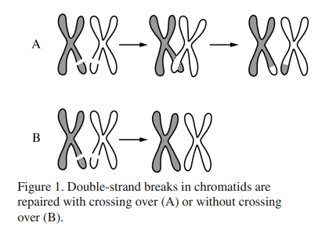
Using specialized staining and microscopy techniques, scientists counted the number of double-strand chromatid breaks and the number of crossovers in the same number of meiotic gamete-forming cells of six inbred strains of corn (Table 1).
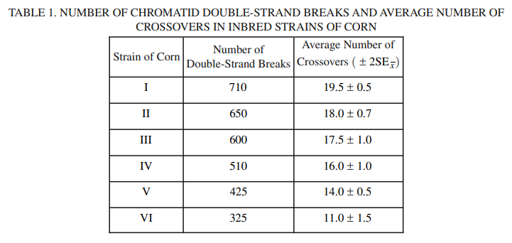
(a) The double-strand breaks occur along the DNA backbone. Describe the process by which the breaks occur.

(b) Using the template in the space provided for your response, construct an appropriately labeled graph that represents the data in Table 1 and allows examination of a possible correlation between double-strand breaks and crossovers. Based on the data, determine whether corn strains I, II, and III differ in their average number of crossovers.

(c) Based on the data, describe the relationship between the average number of double-strand breaks and the average number of crossovers in the strains of corn analyzed in the experiment.

(d) Crossing over (Figure 1A) creates physical connections that are required for proper separation of homologous chromosomes during meiosis. A diploid cell with four pairs of homologous chromosomes undergoes meiosis to produce four haploid cells. Crossing over occurs between only three of the pairs. Predict the number of chromosomes most likely present in each of the four haploid cells. Provide reasoning to justify your prediction. Explain how plant breeders can use the information in Table 1 to help develop new varieties of corn.

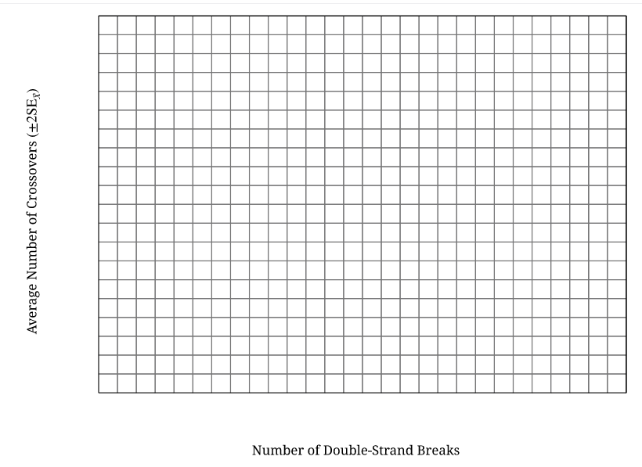

2019 #3
The pyruvate dehydrogenase complex (PDC) catalyzes the conversion of pyruvate to acetyl-CoA, a substrate for the Krebs (citric acid) cycle. The rate of pyruvate conversion is greatly reduced in individuals with PDC deficiency, a rare disorder.

(a) Identify the cellular location where PDC is most active.

(b) Make a claim about how PDC deficiency affects the amount of NADH produced by glycolysis AND the amount of NADH produced by the Krebs (citric acid) cycle in a cell. Provide reasoning to support your claims based on the position of the PDC-catalyzed reaction in the sequence of the cellular respiration pathway.

(c) PDC deficiency is caused by mutations in the PDHA1 gene, which is located on the X chromosome. A male with PDC deficiency and a homozygous female with no family history of PDC deficiency have a male offspring. Calculate the probability that the male offspring will have PDC deficiency.

2016 #7
In a certain species of plant, the diploid number of chromosomes is 4 (2n = 4). Flower color is controlled by a single gene in which the green allele (G) is dominant to the purple allele (g). Plant height is controlled by a different gene in which the dwarf allele (D) is dominant to the tall allele (d). Individuals of the parental (P) generation with the genotypes GGDD and ggdd were crossed to produce F₁ progeny.
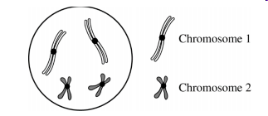
(a) Construct a diagram below to depict the four possible normal products of meiosis that would be produced by the F₁ progeny. Show the chromosomes and the allele(s) they carry. Assume the genes are located on different chromosomes and the gene for flow color is on chromosome 1.

(b) Predict the possible phenotypes and their ratios in the offspring of a testcross between an F₁ individual and a ggdd individual.

(c) If the two genes were genetically linked, describe how the proportions of phenotypes of the resulting offspring would most likely differ from those of the testcross between an F₁ individual and a ggdd individual.
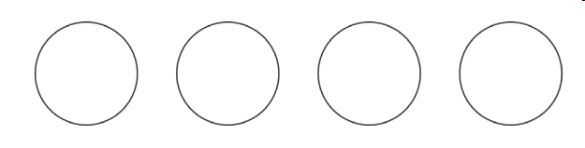

2015 #4
Both mitosis and meiosis are forms of cell division that produce daughter cells containing genetic information from the parent cell.

(a) Describe TWO events that are common to both mitosis and meiosis that ensure the resulting daughter cells inherit the appropriate number of chromosomes.

(b) The genetic composition of daughter cells produced by mitosis differs from that of the daughter cells produced by meiosis. Describe TWO features of the cell division processes that lead to these differences.

Free Response Scoring Guidelines
2022 #2
Part | Scoring Guidelines | Topic
(a) | 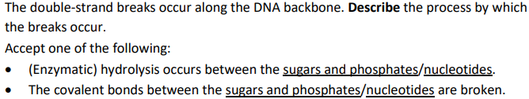 | 1.3
(b) | 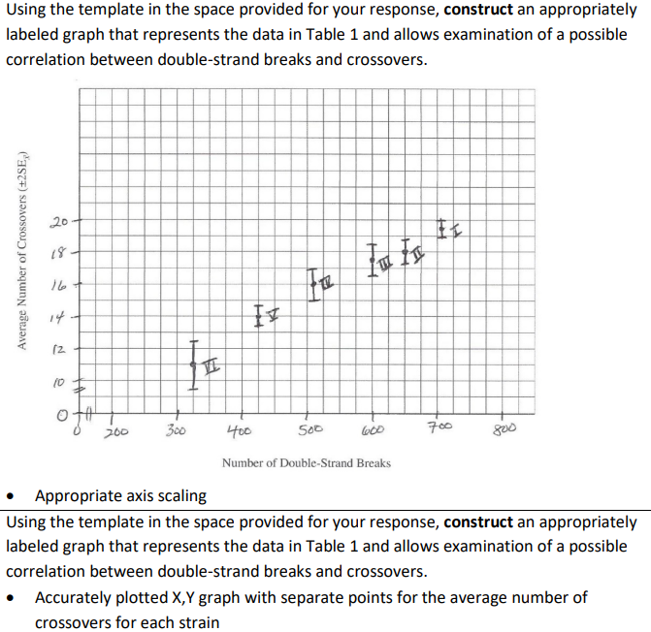  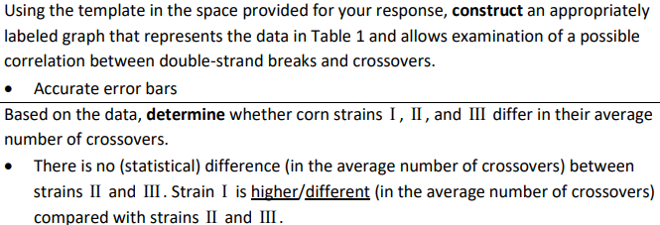
(c) | 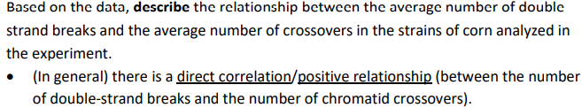
(d) | 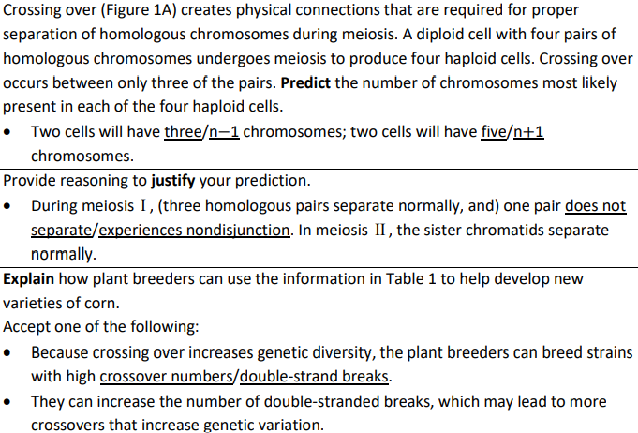 | 5.2  5.6

2019 #3
Part | Scoring Guidelines | Topic
(a) | 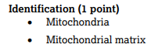 | 3.5
(b) | 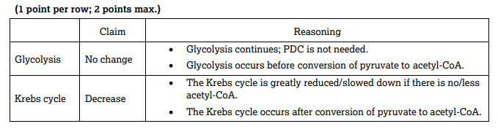 | 3.5
(c) | 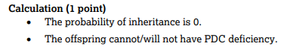 | 5.4

2016 #7
Part | Scoring Guidelines | Topic
(a) | 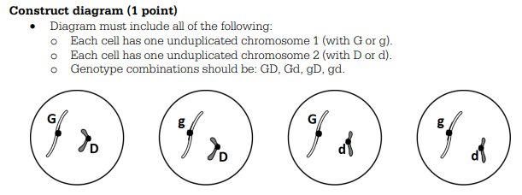 | 5.1
(b) | 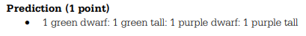 | 5.3
(c) | 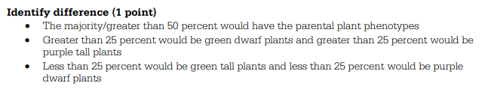 | 5.4

2015 #4
Part | Scoring Guidelines | Topic
(a) | 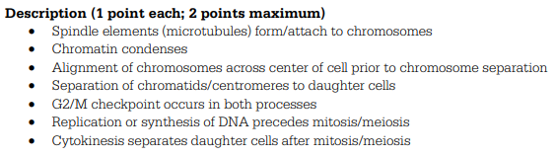 | 5.1
(b) | 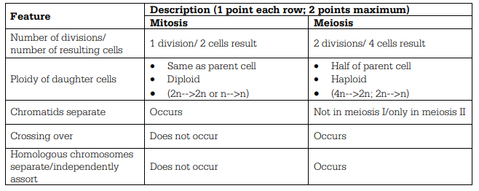 | 5.2

