Unit 5: Heredity

Topic | Learning Objective(s)
5.1  Meiosis | IST-1.F Explain how meiosis results in the transmission of chromosomes from one generation to the next.
 | IST-1.G Describe similarities and/ or differences between the phases and outcomes of mitosis and meiosis.
5.2  Meiosis and Genetic Diversity | IST-1.H Explain how the process of meiosis generates genetic diversity
5.3  Mendelian Genetics | EVO-2.A Explain how shared, conserved, fundamental processes and features support the concept of common ancestry for all organisms.
 | IST-1.I Explain the inheritance of genes and traits as described by Mendel’s laws
5.4  Non-Mendelian Genetics | IST-1.J Explain deviations from Mendel’s model of the inheritance of traits.
5.5  Environmental Effects on Phenotype | SYI-3.B Explain how the same genotype can result in multiple phenotypes under different environmental conditions.
5.6  Chromosomal Inheritance | SYI-3.C Explain how chromosomal inheritance generates genetic variation in sexual reproduction.

Multiple Choice Practice
- Humans have a diploid number (“2n”) of 46. Which of the following statements best predicts the consequence if meiosis did not occur during gametogenesis?
  - The gametes would get larger from one generation to the next.
  - The chromosome number would double with each generation.
  - The chromosome number would be halved with each generation.
  - The chromosome number would triple with each generation.

- The figure below shows several steps in the process of bacteriophage transduction in bacteria. Which of the following explains how genetic variation in a population of bacteria results from this process?
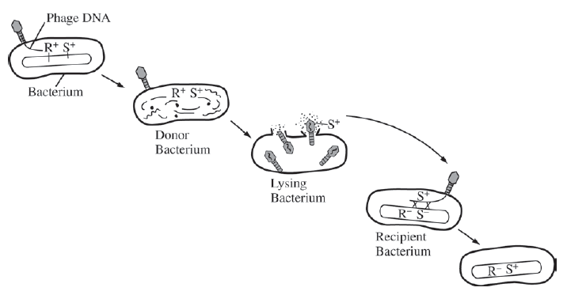
  - Bacterial proteins transferred from the donor bacterium by the phage to the recipient bacterium recombine with genes on the recipient’s chromosome.
  - The recipient bacterium incorporates the transduced genetic material coding for phage proteins into its chromosome and synthesizes the corresponding proteins.
  - The phage infection of the recipient bacterium and the introduction of DNA carried by the phage cause increased random point mutations of the bacterial chromosome.
  - DNA of the recipient bacterial chromosome undergoes recombination with DNA introduced by the phage from the donor bacterium, leading to a change in the recipient’s genotype.

- In 1944 Avery, MacLeod, and McCarty performed transformation experiments using live, harmless bacteria and extracts from virulent bacteria treated with various enzymes. Which of the following enzymes were used and why?
  - Proteases and RNases to rule out protein and RNA as the transforming factors
  - Lipase (an enzyme that facilitates the breakdown of lipids) to rule out lipoproteins as the transforming factor
  - Kinase (an enzyme that facilitates transfer of a phosphate group from ATP to a substrate molecule) to show that transformation is phosphorylation dependent
  - ATPase to show that transformation is not dependent on ATP

Use the following information to answer question 4:

The following figures display data collected while studying a family, some members of which have sickle-cell disease—a rare genetic disorder caused by a mutation in the hemoglobin beta gene (HBB). There are at least two alleles of the HBB gene: the HbA allele encodes wild-type hemoglobin and the HbS allele encodes the sickle-cell form of hemoglobin. Genetic testing provided insight into the inheritance pattern for sickle-cell disease.

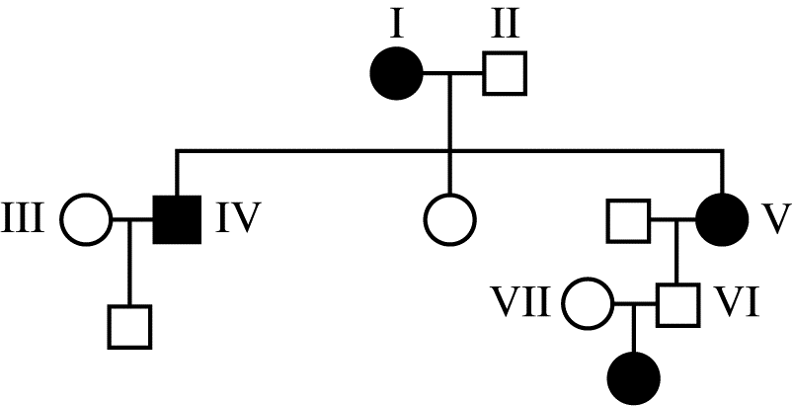
Figure 1. Pedigree of a family with affected individuals. Squares represent males, circles represent females, shaded symbols represent individuals with sickle-cell disease.

5' CTG ACT CCT GAG GAG AAG TCT 3' Non-template Strand
3' GAC TGA GGA CTC CTC TTC AGA 5' Template Strand

Figure 2. A portion of the DNA sequence from the wild-type hemoglobin allele (HbA) that codes for normal hemoglobin.

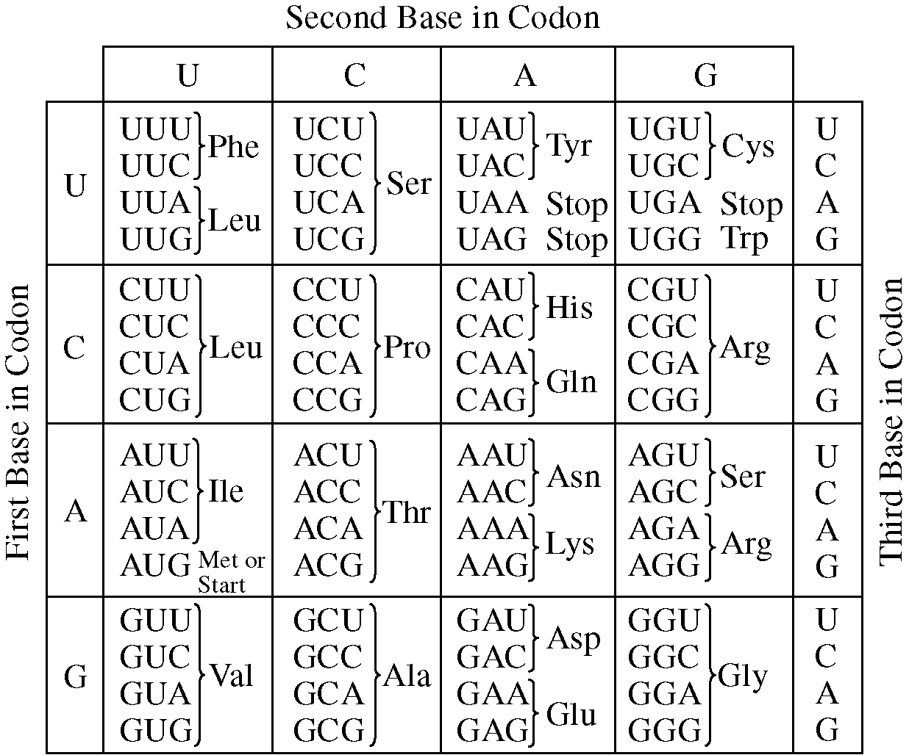
Figure 3. Codon table showing nucleotide sequences for each amino acid.

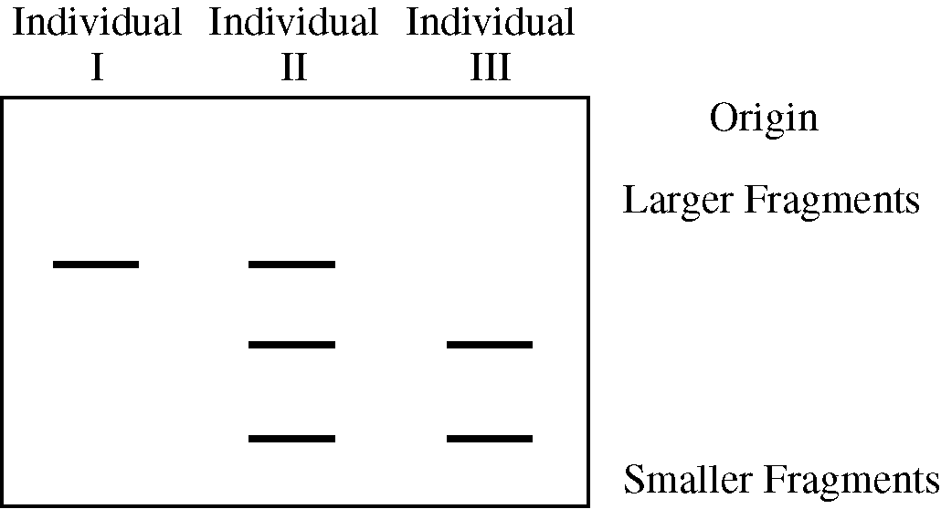
Figure 4. Image of a gel following electrophoretic separation of DNA fragments of the HBB gene from three individuals in the pedigree in Figure 1.

- Based on the data shown in Figure 1, which of the following best describes the genotypes of individual family members in the pedigree?
  - All affected individuals possess at least one dominant allele of the hemoglobin beta gene.
  - Healthy individuals may possess one mutant allele (HbS) of the hemoglobin beta gene.
  - Individuals IV and V must be heterozygous for the HbS (mutant) allele.
  - Individuals II and VI possess two copies of the HbA (wild-type) allele.

Use the following information to answer question 5:
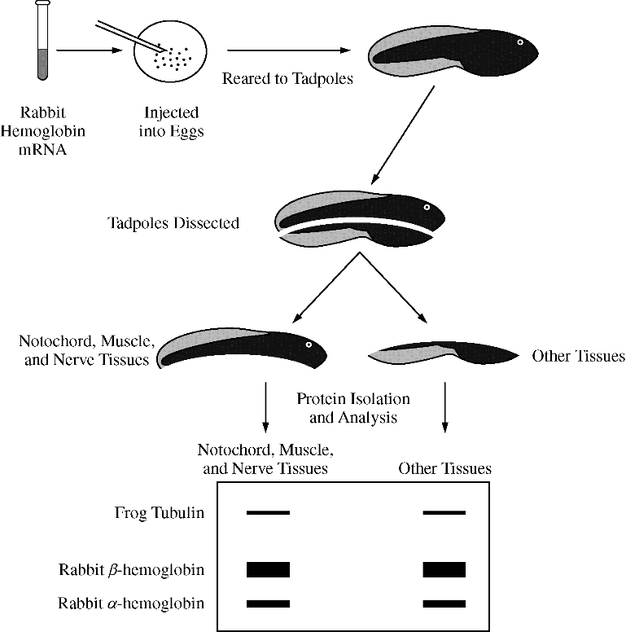
In a classic experiment from the 1970s investigating gene expression, a solution containing equal amounts of rabbit a-hemoglobin mRNA and b-hemoglobin mRNA, which encode subunits of a protein found in red blood cells, was injected into newly fertilized frog eggs. The injected mRNA was not degraded during the course of the experiment. Tadpoles that developed from the injected eggs were dissected into two fragments, one containing predominantly the notochord, muscle tissue, and nerve tissue and the other containing predominantly the other tissue types.

Equal amounts of total protein were analyzed after separation by electrophoresis to identify the relative amounts of the different proteins present in each sample. The thickness of the bands indicates the relative amounts of rabbit a-hemoglobin, rabbit b-hemoglobin, and frog tubulin (a cytoskeletal protein that is expressed at relatively constant levels in all tissues) present in each tadpole sample. The experimental protocol and results are summarized in the figure below.

- The observation that the rabbit mRNA was successfully translated in the frog tissues supports which of the following conclusions?
  - Frog cells are able to replace their own hemoglobin with rabbit hemoglobin.
  - Undeveloped frog eggs can be induced to form genetically identical copies of a rabbit.
  - Rabbit hemoglobin can induce an immune response in frogs.
  - Rabbits and frogs share a common genetic code for expressing heritable information.

- The tiny blue-eyed Mary flower is often one of the first flowers seen in the spring in some regions of the United States. The flower is normally blue, but sometimes a white or pink flower variation is found. The following data were obtained after several crosses.
Parents | F₁ | F₂
Blue x White | Blue | 196 Blue, 63 White
Blue x Pink | Blue | 149 Blue, 52 Pink
Pink x White | Blue | 226 Blue, 98 White, 77 Pink

Which of the following statements best explains the data?
  - The appearance of blue in the F1 generation of the pink and white cross demonstrates that flower color is not an inherited trait but is determined by the environment.
  - Flower color depends on stages of flower development, and young flowers are white, advancing to pink and then blue.
  - Since the F1 and F2 phenotypes of the pink and white cross do not fit the expected genotypic and phenotypic ratios, blue-eyed Mary must reproduce by vegetative propagation.
  - Flower color is an inherited trait, and the F1 and F2 phenotypes of the flowers arising from the pink and white cross can best be explained by another gene product that influences the phenotypic expression.

- A student in a biology class crossed a male Drosophila melanogaster having a gray body and long wings with a female D. melanogaster having a black body and apterous wings. The following distribution of traits was observed in the offspring.

Phenotype | Number of Offspring
Gray body, long wings | 42
Black body, apterous wings | 41
Gray body, apterous wings | 9
Black body, long wings | 8

Which of the following is supported by the data?
  - The alleles for gray body and long wings are dominant.
  - The alleles for gray body and long wings are recessive.
  - Genes for the two traits are located on two different chromosomes, and independent assortment occurred.
  - Genes for the two traits are located close together on the same chromosome and crossing over occurred between the two gene loci.

Use the following information for question 8:

A student placed 20 tobacco seeds of the same species on moist paper towels in each of two petri dishes. Dish A was wrapped completely in an opaque cover to exclude all light. Dish B was not wrapped. The dishes were placed equidistant from a light source set to a cycle of 14 hours of light and 10 hours of dark. All other conditions were the same for both dishes. The dishes were examined after 7 days and the opaque cover was permanently removed from dish A. Both dishes were returned to the light and examined again at 14 days. The following data were obtained.

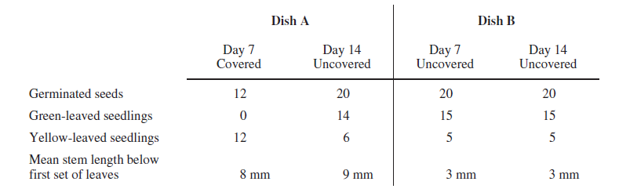

- Which of the following best supports the hypothesis that the difference in leaf color is genetically controlled?
  - The number of yellow-leaved seedlings in dish A on day 7
  - The number of germinated seeds in dish A on days 7 and 14
  - The death of all the yellow-leaved seedlings
  - The existence of yellow-leaved seedlings as well as green-leaved ones on day 14 in dish B

Multiple Choice Key
Question | Correct Answer | Unit/Topic | Source
1 | B. The chromosome number would double with each generation. | 5.1 | 2020 CED  #2
2 | D. DNA of the recipient bacterial chromosome undergoes recombination with DNA introduced by the phage from the donor bacterium, leading to a change in the recipient’s genotype. | 5.2 | 2012 CED #39
3 | A. Proteases and RNases to rule out protein and RNA as the transforming factors | 5.3 | 2013 #9
4 | B. Healthy individuals may possess one mutant allele (HbS) of the hemoglobin beta gene. | 5.3 | 2013 #48
5 | D. Rabbits and frogs share a common genetic code for expressing heritable information. | 5.3 | 2013 #27
6 | D. Flower color is an inherited trait, and the F1 and F2 phenotypes of the flowers arising from the pink and white cross can best be explained by another gene product that influences the phenotypic expression. | 5.4 | 2012 CED #32
7 | D. Genes for the two traits are located close together on the same chromosome and crossing over occurred between the two gene loci. | 5.4 | 2013 #33
8 | D. The existence of yellow-leaved seedlings as well as green-leaved ones on day 14 in dish B | 5.5 | 2012 CED #8

Multiple Choice Explanations
Q |  | Explanation:
1 | A | Gametes arise from germ cells within the gonads. These cells do not undergo serial divisions. The cells would not increase in size with each generation.
 | B | The function of meiosis is to create a cell with half of the chromosome number (gamete). By having half of the chromosome number, the organism will get a full set after the fusion of two gametes. If meiosis did not occur, there would be 2n in each of the cells. When these two cells fuse, there would be 4n which is double the original chromosome number. If meiosis again did not occur, there would be 4n in each of the cells. When these two cells fuse, there would be 8n which is double the previous generation.
 | C | The function of meiosis is to create a cell with half of the chromosome number. If meiosis does not occur, the chromosome number would not be reduced. This answer choice is describing what would happen if there was no fusion of gametes but the cell underwent meiosis each generation.
 | D | The function of meiosis is to create a cell with half of the chromosome number (gamete). This answer choice describes a triple with each generation which is not possible as there are two sets of chromosomes.
2 | A | As determined with the Hershey and Chase experiment, the proteins from the bacteriophage remain outside the bacteria. In addition, protein will not recombine with DNA.  This option is incorrect because bacterial DNA, not protein, is transferred by the phage (CollegeBoard)
 | B | This response feels correct, but it also feels like it is not detailed enough. How does transduced genetic material get incorporated into the bacteria DNA.  This option is incorrect because the recipient does not incorporate (add) the transduced DNA into its chromosome. The transduced DNA must recombine with the recipient DNA in order to become part of the chromosome (CollegeBoard)
 | C | Random point mutations would not explain why the gene from the bacteriophage is now incorporated in the bacteria DNA.  This option is incorrect because recombinant DNA does not cause point mutations (CollegeBoard)
 | D | Recombination involves when DNA from two different sources is incorporated together within one strand of DNA (traditionally discussed with crossing over). As seen in the diagram (4th bacteria image), there is crossing over taking place between the bacteriophage DNA and the bacteria DNA. The S⁺ from the bacteriophage gets incorporated into the bacteria DNA and the S⁻ from the bacteria gets incorporated into the bacteriophage DNA. This causes the bacteria to have a change in genotype from R⁻S⁻ to R⁻S⁺.  This option is correct. Transduction is the transfer of bacterial genes from one bacterium to another by bacteriophages (CollegeBoard)
3 | A | Proteases digests proteins. RNases digest RNA. The sample had DNA, RNA, and proteins. These enzymes remove the RNA and proteins to leave over DNA to determine if it was the transforming agent.
 | B | If you digest the lipids on the lipoproteins, there is still RNA and DNA in the sample. The scientists are unable to determine which is the transforming agent.
 | C | If you add kinase, it will allow for phosphorylation of the substrate but how does this help you to determine the transforming agent?
 | D | ATPase will synthesize dephosphorylate ADP to synthesize ATP. Again, how does this help you to determine the transforming agent?
4 | A | Based on the offspring between individual VII and VI, it can be determined that sickle cell disease is an autosomal recessive trait. An affected individual would have two of the HbS alleles which is recessive.
 | B | Based on the pedigree, Individual II and III are unaffected while individual I is affected. Based on the offspring between individual VII and VI, it can be determined that sickle cell disease is an autosomal recessive trait. Based on the gel electrophoresis, it can be determined that individual I is HbS HbS, individual II is HbS HbA, and individual III is HbA HbA. Since individual II is unaffected, we can state that healthy individuals may posses one mutant allele.
 | C | Based on the pedigree, both individuals IV and V are affected and have two HbS alleles, so they are not heterozygous.
 | D | Based on the pedigree, both individuals II and VI are heterozygous (both have an affected offspring), so they do not have two copies of the HbA allele.
5 | A | This is discussing that the frog replaces their hemoglobin with the rabbit hemoglobin but the frog still has its own mRNA for the frog hemoglobin,
 | B | The researchers only injected hemoglobin mRNA.
 | C | How does an immune response explain the frog making a rabbit protein?
 | D | The question is asking how was the frog tissues able to translate the rabbit mRNA. This is a homology that all organisms share their genetic code. You are able to place the mRNA into another organism to be translated.
6 | A | If it was caused by the environment, there would not be the “sometimes a white or pink flower variation is found” because the flowers are all in the same environment.  This option is incorrect because if the environment determined the flower color, then the occasional white and pink flower would not be seen in the original environment. (CollegeBoard)
 | B | The prompt gives no information about the flowers being observed at different times. Logically, all of the flowers in a generation would be observed and recorded at the same time.  This option is incorrect because there is no indication of the stages of flower development, and the 3:1 ratios in the first two crosses would not be seen if the stage of flower development were the controlling factor. (CollegeBoard)
 | C | Vegetative propagation is asexual reproduction. These ratios are appropriate ratios of a 3:1 of blue to white or blue to pink and 1:2:1 of white to blue to pink.  This option is incorrect because the crosses of blue and white and blue and pink do fit expected phenotypic ratios. Vegetative propagation would not result in the ratios indicated by the data. (CollegeBoard)
 | D | In the first cross, if you assume true-breeding parents, it is logical to get a heterozygous blue in F1 and a 3:1 ratio of blue to white in F2 generation. In the second cross, if you assume true-breeding parents, it is logical to get a heterozygous blue in F1 and a 3:1 ratio of blue to pink in F2 generation. In the third cross, the pink and white cross leads to blue in F1 and a 1:2:1 ratio of white to blue to pink in F2 generation similar to incomplete dominance or another gene product the influences expression.  This option is correct. The student is asked to evaluate the data given. The crosses between blue / white and blue / pink show expected 3:1 ratios in the F1 generation. The appearance of a majority of blue flowers in the F1 cross between pink and white indicate that there is another gene product affecting the outcome. (CollegeBoard)
7 | A | If the allele for gray and long were dominant, then you would expect to find most offspring to be gray/long.
 | B | If the allele for gray and long were recessive, then you would expect to find less offspring to be gray/long as they could be masked by the other phenotype.
 | C | If you were to observe independent assortment, then you would find that there would be a 1:1:1:1 ratio which is not observed in the data. There would be an equal number of each of the phenotypes.
 | D | You would expect to find a 1:1:1:1 ratio if the gray/long was heterozygous. Since you find most of the individuals look like the parentals this shows you that the two genes must be close together on one chromosome. The recombinants come from crossing over.
8 | A | Dish A was not exposed to light, so the yellow leaves could be a result of the absence of light.  This option is incorrect because the leaves in dish A could have been yellow because they had not been exposed to light yet and could have changed to green in response to light, which would not be a genetic difference. Some yellow leaves did change to green when exposed to light. (CollegeBoard)
 | B | The seed germination was a result of exposure to light. The germination is not genetically controlled and is based on the environment.  This option is incorrect because the only variable in this experiment was light. If genes responsible for leaf color also had an impact on germination rate, then germination should have been similar in each dish, which is not supported. (CollegeBoard)
 | C | All of the yellow-leaved seedlings did not die. There are 6 found on day 14 in Dish A and 5 found on day 14 in Dish B.  This option is incorrect because according to the data, no seedlings died. (CollegeBoard)
 | D | Dish B was never covered but there are green and yellow leaved seedlings.  This option is correct because both colors of leaves existed after 14 days and essentially in the same numbers. If the green color resulted from a response to light, then the yellow leaves would have changed to green by 14 days. (CollegeBoard)

