Unit 7: Natural Selection

Topic | Learning Objective(s)
7.1  Introduction to Natural Selection | EVO-1.C Describe the causes of natural selection.
 | EVO-1.D Explain how natural selection affects populations.
7.2  Natural Selection | EVO-1.E Describe the importance of phenotypic variation in a population.
7.3  Artificial Selection | EVO-1.F Explain how humans can affect diversity within a population.
 | EVO-1.G Explain the relationship between changes in the environment and evolutionary changes in the population.
7.4  Population Genetics | EVO-1.H Explain how random occurrences affect the genetic makeup of a population.
 | EVO-1.I Describe the role of random processes in the evolution of specific populations.
 | EVO-1.J Describe the change in the genetic makeup of a population over time.
7.5  Hardy-Weinberg Equilibrium | EVO-1.K Describe the conditions under which allele and genotype frequencies will change in populations.
 | EVO-1.L Explain the impacts on the population if any of the conditions of Hardy-Weinberg are not met.
7.6  Evidence of Evolution | EVO-1.M Describe the types of data that provide evidence for evolution.
 | EVO-1.N Explain how morphological, biochemical, and geological data provide evidence that organisms have changed over time.
 | EVO-2.B Describe the fundamental molecular and cellular features shared across all domains of life, which provide evidence of common ancestry.
7.7  Common Ancestry | EVO-2.C Describe structural and functional evidence on cellular and molecular levels that provides evidence for the common ancestry of all eukaryotes.
7.8  Continuing Evolution | EVO-3.A Explain how evolution is an ongoing process in all living organisms.
7.9  Phylogeny | EVO-3.B Describe the types of evidence that can be used to infer an evolutionary relationship.
 | EVO-3.C Explain how a phylogenetic tree and/or cladogram can be used to infer evolutionary relatedness.
7.10  Speciation | EVO-3.D Describe the conditions under which new species may arise.
 | EVO-3.E Describe the rate of evolution and speciation under different ecological conditions.
 | EVO-3.F Explain the processes and mechanisms that drive speciation.
7.11  Extinction | EVO-3.G Describe factors that lead to the extinction of a population.
 | EVO-3.H Explain how the risk of extinction is affected by changes in the environment.
 | EVO-3.I Explain species diversity in an ecosystem as a function of speciation and extinction rates.
 | EVO-3.J Explain how extinction can make new environments available for adaptive radiation.
7.12  Variations in Populations | SYI-3.D Explain how the genetic diversity of a species or population affects its ability to withstand environmental pressures.
7.13  Origin of Life on Earth | SYI-3.E Describe the scientific evidence that provides support for models of the origin of life on Earth.

Multiple Choice Practice
- In a hypothetical population of beetles, there is a wide variety of color, matching the range of coloration of the tree trunks on which the beetles hide from predators. The graphs below illustrate four possible changes to the beetle population as a result of a change in the environment due to pollution that darkened the tree trunks.
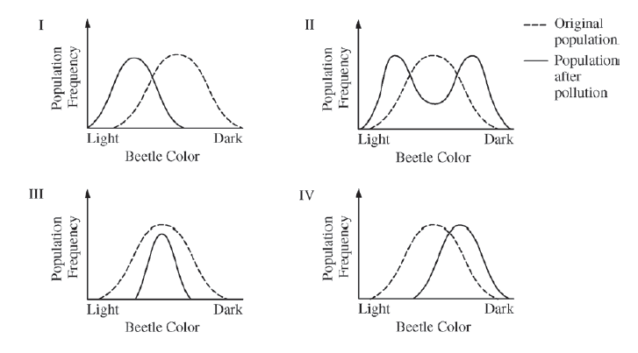
Which of the following includes the most likely change in the coloration of the beetle population after pollution and a correct rationale for the change?
  - The coloration range shifted toward more light-colored beetles, as in diagram I. The pollution helped the predators find the darkened tree trunks.
  - The coloration in the population split into two extremes, as in diagram II. Both the lighter-colored and the darker-colored beetles were able to hide on the darker tree trunks.
  - The coloration range became narrower, as in diagram III. The predators selected beetles at the color extremes.
  - The coloration in the population shifted toward more darker-colored beetles, as in diagram IV. The lighter- colored beetles were found more easily by the predators than were the darker-colored beetles.

- A group of mice was released into a large field to which no other mice had access. Immediately after the release, a representative sample of the mice was captured, and the fur color of each individual in the sample was observed and recorded. The mice were then returned to the field. After twenty years, another representative sample of the mice was captured, and the fur color of each individual in the sample was again recorded. Which of the following best explains the change in the frequency distribution of fur color phenotypes in the mouse population, as shown in the figures above?
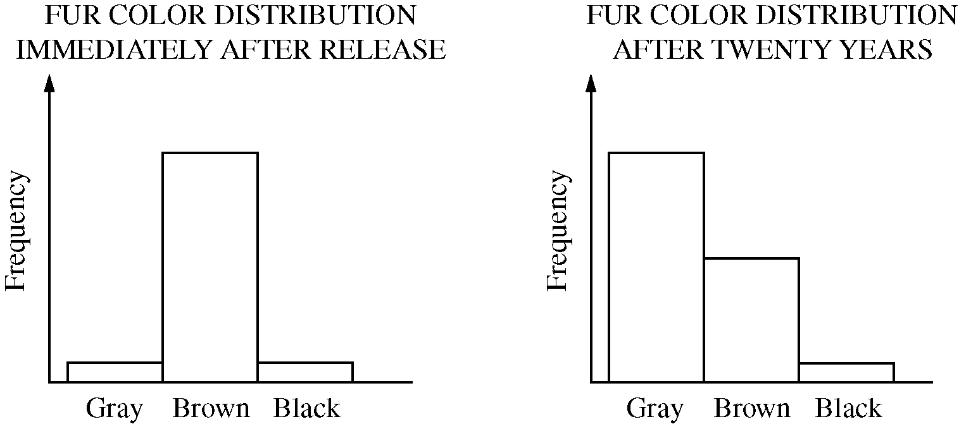
  - The allele for gray fur color is unstable, and over twenty years most of those alleles mutated to become alleles for black fur.
  - The field was composed primarily of light-colored soil and little vegetation, affording gray mice protection from predators.
  - Sexual selection led to increased mating frequency of black and brown versus gray and brown.
  - The gray mice were hardest to capture and so were underrepresented in the twenty-year sample.

Use the following information to answer question 3:

The following figures display data collected while studying a family, some members of which have sickle-cell disease—a rare genetic disorder caused by a mutation in the hemoglobin beta gene (HBB). There are at least two alleles of the HBB gene: the HbA allele encodes wild-type hemoglobin and the HbS allele encodes the sickle-cell form of hemoglobin. Genetic testing provided insight into the inheritance pattern for sickle-cell disease.
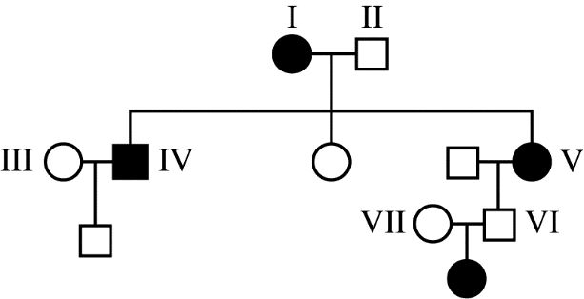
Figure 1. Pedigree of a family with affected individuals. Squares represent males, circles represent females, shaded symbols represent individuals with sickle-cell disease.

5' CTG ACT CCT GAG GAG AAG TCT 3' Non-template Strand
3' GAC TGA GGA CTC CTC TTC AGA 5' Template Strand
Figure 2. A portion of the DNA sequence from the wild-type hemoglobin allele (HbA) that codes for normal hemoglobin.

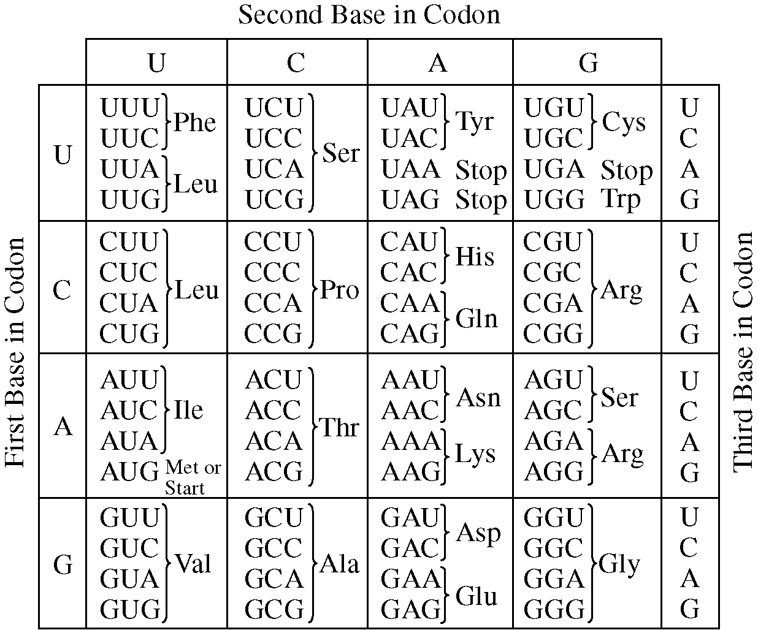
Figure 3. Codon table showing nucleotide sequences for each amino acid.

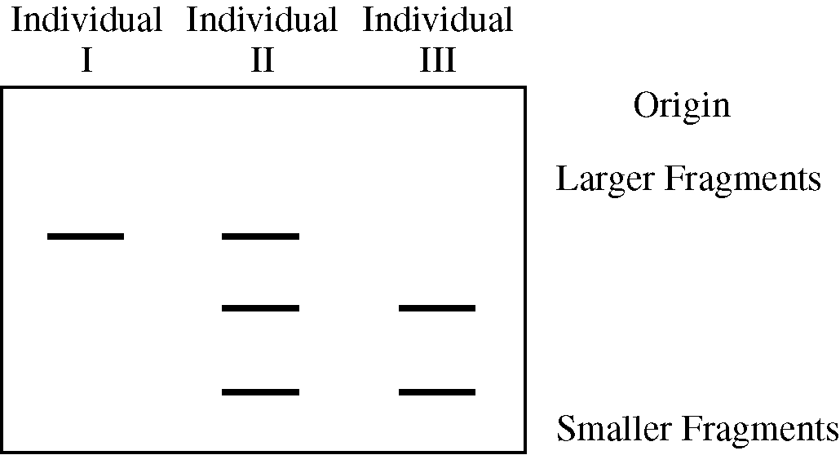
Figure 4. Image of a gel following electrophoretic separation of DNA fragments of the HBB gene from three individuals in the pedigree in Figure 1.

- Possessing a single copy of the HbS allele has been shown to provide some resistance to infection by Plasmodium falciparum, the parasite that causes malaria. Which of the following individuals represented in the pedigree would have the greatest selective advantage in an area where malaria is common?

  - I
  - II
  - III
  - V

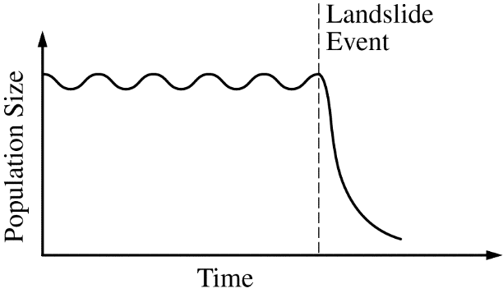
- Undersea landslides can disrupt marine habitats by burying organisms that live on the ocean floor. The graph above shows the size of a population of a certain organism that lives on the ocean floor. The population was affected by a recent landslide at the time indicated on the graph. Which of the following best predicts how the population will be affected by the landslide?

  - The surviving organisms will evolve into a new species.
  - The reduced population will likely have allelic frequencies that are different from the initial population.
  - The population will adapt to deeper waters to avoid future landslides.
  - The reduced population will have a greater number of different genes than the initial population.

- The data below demonstrate the frequency of tasters and non-tasters of a certain compound in four isolated populations that are in Hardy-Weinberg equilibrium. The allele for non-tasters is recessive. In which population is the frequency of the recessive allele highest?
Letter Choice | Populations | Tasters | Non-tasters | Size of Population
A | 1 | 110 | 32 | 142
B | 2 | 8,235 | 4,328 | 12,563
C | 3 | 215 | 500 | 715
D | 4 | 11,489 | 2,596 | 14,085

- Ellis-van Creveld syndrome is a recessive genetic disorder that includes the characteristics of short stature and extra fingers or toes. In the general population, this syndrome occurs in approximately 1 in 150,000 live births. In a particular isolated population, however, the incidence of this syndrome among live births is 1 in 500.

Assume that both the isolated population and the general population are in Hardy-Weinberg equilibrium with respect to this syndrome. Which of the following best describes the difference between the frequency of the allele that causes the syndrome in the general population and the frequency of the allele in the isolated population?
  - The frequency of the Ellis-van Creveld allele is 0.002 in the isolated population and 0.0000066 in the general population, which suggests that selection for this trait is occurring in both populations.
  - The frequency of the Ellis-van Creveld allele is 0.0447 in the isolated population and 0.0026 in the general population, showing that the rate of genetic mutation is highest among individuals in the isolated population.
  - The frequency of the Ellis-van Creveld allele is 0.002 in the isolated population and 0.0000066 in the general population, which demonstrates gametic incompatibility between the populations.
  - The frequency of the Ellis-van Creveld allele is 0.0447 in the isolated population and 0.0026 in the general population, which suggests that genetic drift has occurred in the isolated population.

Use the following information for question 7:

Different photosynthetic organisms have different types of chlorophyll molecules. The distribution of chlorophylls in several different groups of organisms is shown in Table 1. A plus sign (+) in the table indicates the presence of a chlorophyll, while a minus sign (-) indicates its absence.

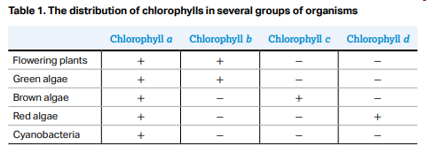

- Based on the data, which of the following most likely describes the evolutionary relationship among the organisms?
  - Because brown algae, red algae, and cyanobacteria lack chlorophyll b, they evolved before green algae and flowering plants did.
  - Because green algae and flowering plants contain chloroplasts, they evolved more recently than brown algae, red algae, and cyanobacteria did.
  - Because increasingly complex forms of chlorophyll are found in red algae, brown algae, green algae, and flowering plants, respectively, this reflects the order of their appearance.
  - Because all of the organisms contain chlorophyll a, the organisms share a common ancestor.

- Experimental evidence shows that the process of glycolysis is present and virtually identical in organisms from all three domains, Archaea, Bacteria, and Eukarya. Which of the following hypotheses could be best supported by this evidence?
  - All organisms carry out glycolysis in mitochondria.
  - Glycolysis is a universal energy-releasing process and therefore suggests a common ancestor for all forms of life.
  - Across the three domains, all organisms depend solely on the process of anaerobic respiration for ATP production.
  - The presence of glycolysis as an energy- releasing process in all organisms suggests that convergent evolution occurred.

- To determine the evolutionary history and relationships among organisms, scientists gather evidence from a wide variety of sources including paleontology, embryology, morphology, behavior, and molecular biology. A phylogenetic tree of vertebrates is shown.

Which of the following statements is most consistent with the phylogenetic tree shown?
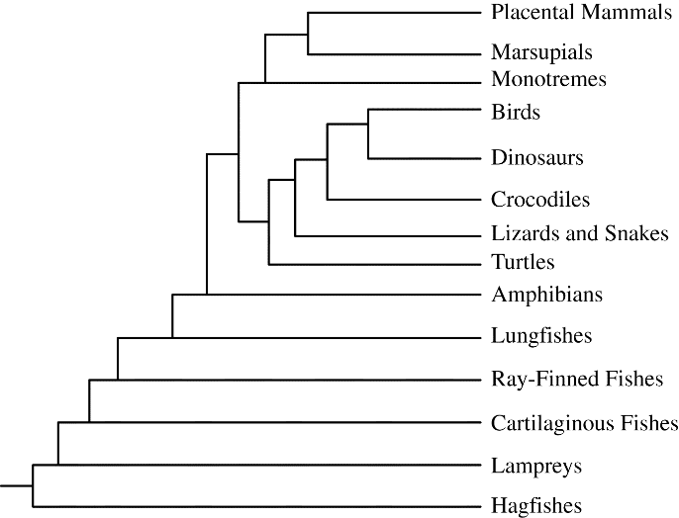
  - Birds and turtles evolved their own means of gas exchange independently of the other vertebrates.
  - Mammals are most closely related to birds because they share a direct common ancestor.
  - The common ancestor of reptiles, birds, and mammals produced amniotic eggs.
  - Crocodiles are direct descendants of ray-finned fishes since they live in the same environment.

- Data regarding the presence (+) or absence (-) of five derived traits in several different species are shown in the table below.
 | Trait
Species | 1 | 2 | 3 | 4 | 5
V | + | + | + | - | -
W | + | + | - | - | -
X | + | - | - | - | -
Y | - | - | - | - | -
Z | + | - | - | - | +

Which of the following cladograms provides the simplest and most accurate representation of the data in the table?

  - 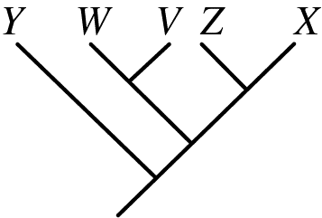
  - 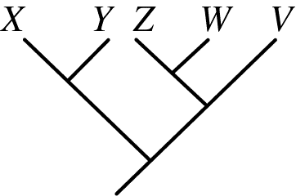
  - 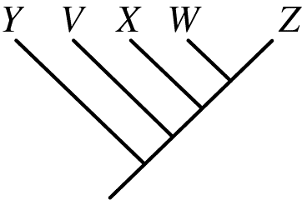
  - 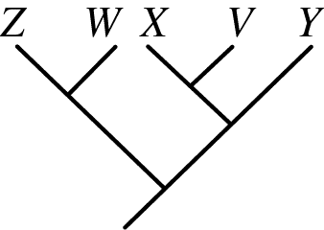

- Five new species of bacteria were discovered in Antarctic ice core samples. The nucleotide (base) sequences of rRNA subunits were determined for the new species. The table below shows the number of nucleotide differences between the species.
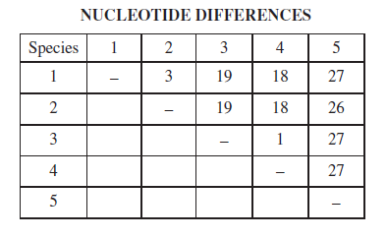
Which of the following phylogenetic trees is most consistent with the data?

  - 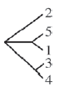
  - 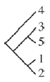
  - 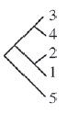
  - 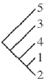

- The apple maggot fly, Rhagoletis pomonella, is native to North America and originally fed on fruit of the wild hawthorn. Since the mid-1800s, a population of flies has emerged that instead feed on domesticated apples. Apple maggot flies typically mate on or near the fruit of their host plants. Many varieties of apples ripen three to four weeks before the hawthorn fruits do.
The different fruit preferences of the two fly populations will most likely have which of the following effects?
  - The flies that eat hawthorn fruit will increase in number, while the flies that eat apples will decrease in number because of the use of insecticides on apple trees.
  - The single fly species will evolve into two distinct species because of the lack of gene flow between the two populations.
  - The ability to survive on a diet of two different fruits will help the flies learn to eat many more types of fruit.
  - The flies that eat hawthorn fruit will lay some of their eggs on the earlier ripening apples to minimize competition among the larvae.

Use the following information to answer questions 13 – 15:

Rhagoletis pomonella is a parasitic fly native to North America that infests fruit trees. The female fly lays her eggs in the fruit. The larvae hatch and burrow through the developing fruit. The next year, the adult flies emerge.

Prior to the European colonization of North America, the major host of Rhagoletis was a native species of hawthorn, Crataegus marshallii. The domestic apple tree, Malus domestica, is not native to North America, but was imported by European settlers in the late 1700s and early 1800s.

When apple trees were first imported into North America, there was no evidence that Rhagoletis could use them as hosts. Apples set fruit earlier in the season and develop faster, where hawthorns set later and develop more slowly.

Recent analysis of Rhagoletis populations has shown that two distinct populations of flies have evolved from the original ancestral population of flies that were parasitic on hawthorns. One population infests only apple trees, and the other infests only hawthorns. The life cycles of both fly populations are coordinated with those of their host trees. The flies of each population apparently can distinguish and select mates with similar host preferences and reject mates from the population specific to the other host tree. There is very little hybridization (only about 5 percent) between the two groups.

- The divergence between the two populations of Rhagoletis must have occurred very rapidly because
  - the apple tree was imported into North America with European settlement approximately 200 years ago
  - flies were imported into North America with European settlement approximately 200 years ago
  - long-distance rail transport of fruit increased only after the American Civil War (1861–1865)
  - heavy use of gunpowder during the American Civil War (1861–1865) led to increased mutation rates in many natural populations of plants and animals

- Initially, which of the following isolating mechanisms is likely to have been the most important in preventing gene flow between the two populations of Rhagoletis?
- Gamete incompatibility
- Temporal isolation
- Mechanical isolation
- Reduced hybrid viability

- Matings between individuals from the two populations of Rhagoletis produce hybrid flies that appear to be healthy and have normal life spans. The eggs laid by these hybrid flies, however, hatch less often than those of flies from either of the two populations. What isolating mechanism seems to be important in this hybrid population?
- Prezygotic isolation
- Mechanical isolation
- Reduced hybrid fertility
- Habitat isolation

- A group of students summarized information on five great extinction events.
Mass Extinction | Time of Extinction | Organisms Greatly Reduced or Made Extinct
End of the Ordovician period | 443 million years ago | Trilobites, brachiopods, echinoderms, and corals
End of the Devonian period | 354 million years ago | Marine families on tropical reefs, corals, brachiopods, and bivalves
End of the Permian period | 248 million years ago | Trilobites, mollusks, brachiopods, and many vertebrates
End of the Triassic period | 206 million years ago | Mollusks, sponges, marine vertebrates, and large amphibians
End of the Cretaceous period | 65 million years ago | Ammonites, dinosaurs, brachiopods, bivalves, and echinoderms

The students are sampling a site in search of fossils from the Devonian period. Based on the chart, which of the following would be the most reasonable plan for the students to follow?
- Searching horizontal rock layers in any class of rock and try to find those that contain the greatest number of fossils
- Collecting fossils from rock layers deposited prior to the Permian period that contain some early vertebrate bones
- Looking in sedimentary layers next to bodies of water in order to find marine fossils of bivalves and trilobites
- Using relative dating techniques to determine the geological ages of the fossils found so they can calculate the rate of speciation of early organisms

- By discharging electric sparks into a laboratory chamber atmosphere that consisted of water vapor, hydrogen gas, methane, and ammonia, Stanley Miller obtained data that showed that a number of organic molecules, including many amino acids, could be synthesized. Miller was attempting to model early Earth conditions as understood in the 1950s. The results of Miller’s experiments best support which of the following hypotheses?
- The molecules essential to life today did not exist at the time Earth was first formed.
- The molecules essential to life today could not have been carried to the primordial Earth by a comet or meteorite.
- The molecules essential to life today could have formed under early Earth conditions.
- The molecules essential to life today were initially self-replicating proteins that were synthesized approximately four billion years ago.

Multiple Choice Key
Question | Correct Answer | Unit/Topic | Source
1 | D. The coloration in the population shifted toward more darker-colored beetles, as in diagram IV. The lighter- colored beetles were found more easily by the predators than were the darker-colored beetles. | 7.1 | 2012 CED #21
2 | B. The field was composed primarily of light-colored soil and little vegetation, affording gray mice protection from predators. | 7.1 | 2012 #23
3 | B. II | 7.2 | 2013 #51
4 | B. The reduced population will likely have allelic frequencies that are different from the initial population. | 7.4 | 2013 #4
5 |  | 7.5 | 2013 #40
6 | D. The frequency of the Ellis-van Creveld allele is 0.0447 in the isolated population and 0.0026 in the general population, which suggests that genetic drift has occurred in the isolated population. | 7.5 | 2013 #53
7 | D. Because all of the organisms contain chlorophyll a, the organisms share a common ancestor. | 7.6 | 2020 CED #9
8 | B. Glycolysis is a universal energy-releasing process and therefore suggests a common ancestor for all forms of life. | 7.7 | 2012 CED #29
9 | C. The common ancestor of reptiles, birds, and mammals produced amniotic eggs. | 7.9 | 2013 #32
10 | A. | 7.9 | 2013 #18
11 | C. | 7.9 | 2012 CED #18
12 | B. The single fly species will evolve into two distinct species because of the lack of gene flow between the two populations. | 7.10 | 2020 CED #13
13 | A. the apple tree was imported into North America with European settlement approximately 200 years ago | 7.10 | 2013 #20
14 | B. Temporal isolation | 7.10 | 2013 #21
15 | C. Reduced hybrid fertility | 7.10 | 2013 #22
16 | B. Collecting fossils from rock layers deposited prior to the Permian period that contain some early vertebrate bones | 7.11 | 2012 CED #37
17 | C. The molecules essential to life today could have formed under early Earth conditions. | 7.13 | 2012 CED #1
18 | C. individuals with more favorable phenotypes are more likely to survive and produce more offspring, thus passing traits to subsequent generations | 7.1 | Self
19 | A. phenotype | 7.2 | Self
20 | B. similar selective pressures result in similar phenotypic adaptations in different populations or species | 7.3 | Self
21 | D. mutations | 7.4 | Self
22 | A. the reduction in population size could lead to fixation of an allele | 7.4 | Self
23 | B. absence of gene flow | 7.5 | Self
24 | C. absence of selection | 7.5 | Self
25 | D. 0.48 | 7.5 | Self
26 | A. small populations | 7.5 | Self
27 | A. DNA sequencing | 7.6 | Self
28 | B. homologous structures | 7.6 | Self
29 | D. presence of chloroplasts | 7.7 | Self
30 | B. Mutations in the HIV genome leads to reproductive success | 7.8 | Self
31 | A. least closely related to the remainder of the organisms in the cladogram | 7.9 | Self
32 | B. molecular | 7.9 | Self
33 | C. group capable of interbreeding and exchanging genetic information to produce viable, fertile offspring | 7.10 | Self
34 | D. punctuated equilibrium results in rapid evolution after long period of stasis while gradualism occurs slowly over hundreds of thousands of years | 7.10 | Self
35 | B. temporal | 7.10 | Self
36 | A. behavioral | 7.10 | Self
37 | A. rate of speciation and rate of extinction | 7.11 | Self
38 | B. transported to Earth by meteorite | 7.13 | Self
39 | B. RNA | 7.13 | Self

Multiple Choice Explanations
Q |  | Explanation:
1 | A | If the beetles were lighter, they would be more easily seen on the darkened tree trunks and less likely to survive to pass on their traits.  This option is incorrect. The population of beetles after pollution would not have shifted to a more light-colored beetle as indicated in diagram I because the tree trunks would have been darker, and the lighter colored beetles would have been eaten by predators more easily since they were light and the trees were dark. The suggestion that the predators would find the darker tree trunks more easily is irrelevant. (CollegeBoard)
 | B | The darker phenotypes were able to camouflage, but the lighter phenotypes will be more likely seen and eaten by predators.  This option is incorrect. After the pollution the coloration could not have split into two groups because the lighter colored beetles would not have been able to hide on the darker tree trunks and thus would have been preyed upon. (CollegeBoard)
 | C | As the tree trunks got darker, the darker phenotype would be more likely to camouflage so there would not be a decrease in the dark phenotypes as it is a favorable trait.  This option is incorrect. The coloration range after pollution would not have become narrower, as in diagram III, because predators were selecting those light-colored beetles that were distinguishable on the darker tree trunks. (CollegeBoard)
 | D | After pollution, the tree trunks were darker. The beetles that had darker phenotypes were able to camouflage and less likely to be eaten by predators. Over time, a directional selection should be observed to darker phenotypes.  This option is correct because it illustrates the change in the population that would occur with selection against the lighter colored beetles. The student is asked to justify and explain the process of biological evolution in this question. A change in coloration of the beetle population after pollution is shown in diagram IV because the original beetles (lighter colored beetles) were eaten by predators, and the darker colored beetles would have survived. (CollegeBoard)
2 | A | There is a decrease in the frequency of the black phenotype.
 | B | There is a directional selection observed. The gray phenotype was more favorable leading to an increase in surviving. If the environment was light, the gray mouse would be more likely to camouflage and not be caught by the predators.
 | C | Sexual selection increased mating of black and brown would lead to an increase in black and brown individuals, but both of these phenotypes decreased in frequency.
 | D | The gray phenotype has the highest frequency and could not be classified as “underrepresented”
3 | A | Using the pedigree, we can determine that individual I has a genotype of HbS HbS. They will not have a selective advantage as they are affected by sickle cell disease.
 | B | According to the prompt, an individual that is heterozygous (HbA HbS) will have a selective advantage. Using the pedigree, we can determine individual II is heterozygous because they are unaffected but have affected offspring.
 | C | Using the pedigree, we can determine that individual III has a genotype of HbA HbA. They do not have a HbS allele to provide a selective advantage.
 | D | Using the pedigree, we can determine that individual I has a genotype of HbS HbS. They will not have a selective advantage as they are affected by sickle cell disease.
4 | A | A new species results from an absence of gene flow. The landslide did not cause a restriction to reproduction between organisms.
 | B | The landslide event describes a bottleneck situation. During a bottleneck, there is a rapid decrease in the population and the remaining individuals do not represent the original population (the allele frequencies are different).
 | C | Adaptations are the result of traits that already exist to be more favorable. So, the population will not decide to bury deeper because of this landslide.
 | D | This is not logical. How can you reduce the population but have more of different genes?
5 | A | 32/142 = q² = 0.23 q = $√$0.23 = 0.47
 | B | 4328/12563 = q² = 0.34 q = $√$0.34 = 0.59
 | C | 500/715 = q² = 0.69 q = $√$0.69 = 0.84 This is the largest number for the recessive allele frequency
 | D | 2596/14085 = q² = 0.18 q = $√$0.18 = 0.43
6 | A | general population: 1/150,000 = q² = 0.0000067  isolated population: 1/500 = q² = 0.002  This answer choice is the genotypic frequency NOT the allele frequency
 | B | general population: 1/150,000 = q² = 0.0000067 q = $√$0.0000067 = 0.0026  isolated population: 1/500 = q² = 0.002 q = $√$0.002 = 0.0447  We do not have any data to support that the mutations occurred after the isolated population was isolated.
 | C | general population: 1/150,000 = q² = 0.0000067  isolated population: 1/500 = q² = 0.002  This answer choice is the genotypic frequency NOT the allele frequency
 | D | general population: 1/150,000 = q² = 0.0000067 q = $√$0.0000067 = 0.0026  isolated population: 1/500 = q² = 0.002 q = $√$0.002 = 0.0447  Genetic drift (specifically founders effect) the population is isolated and has a different allele frequency than the original population.
7 | A | There is no evidence to support this. The brown algae has chlorophyll c while others do not, red algae has chlorophyll d while others do not, and cyanobacteria has no additional chlorophyll aside from chlorophyll a.
 | B | The information about which organisms contained chloroplasts was not given in this data set.
 | C | Although the type of chlorophyll varies between these organisms, there is no consistency. In order to “gain” a trait, they all “lose” a trait which does not represent an order of appearance. The traits would be building upon one another if demonstrating order of appearance.
 | D | This would be considered an ancestral trait. All of the organisms have this trait before their common ancestor had the trait.
8 | A | Glycolysis takes place in the cytosol which is why it is able to be found in prokaryotes and eukaryotes.  This option is incorrect. Glycolysis does not occur in the mitochondria. Archaea and Bacteria do not contain mitochondria (CollegeBoard)
 | B | All organisms are able to undergo glycolysis demonstrating that it is an ancestral trait from a common ancestor.  This option is correct because it demonstrates understanding of the processes of evolution and glycolysis, which is common to both aerobic and anaerobic respiration (CollegeBoard)
 | C | Aerobic respiration provides more ATP so most organisms depend on aerobic respiration for ATP production.  This option is incorrect. Many organisms rely on aerobic respiration for ATP production. (CollegeBoard)
 | D | Convergent evolution does not show common ancestry. Convergent evolution is a similar solution to a similar problem.  This option is incorrect. There is no evidence for any other energy-producing process that substitutes for and predates glycolysis (CollegeBoard)
9 | A | Birds and turtles are not on a similar branch to represent this similarity of their gas exchange processes.
 | B | Mammals and birds have 4 branch points between them demonstrating that they do not share a direct common ancestor.
 | C | All of these organisms produce amniotic eggs, so it must have originated in the common ancestor.
 | D | The crocodile is 6 branches away from the ray-finned fishes. The crocodiles are not closely related to the ray-finned fishes.
10 | A | Y has no traits in common with the other organisms demonstrating its “outgroup” and first branched off status. All of the other organisms have trait 1, so that trait was gained after Y branched off. V and W share trait 2 in common so they will be branched together. X and Z share trait 1 so they will be branched together.
 | B | Y has no traits in common with the other organisms and should not be on a branch point with X as X has a trait in common with the other organisms.
 | C | V has 3 traits, X has 1 trait, W has 2 traits, and Z has 2 traits. This tree does not represent relatedness of organisms as their shared traits should allow them to be grouped together.
 | D | W and V should be branched together as they both share trait 2.
11 | A | Species 5 is an outgroup as it has 26 or 27 nucleotide differences with each of the other species.  This option is incorrect. The nucleotide differences between species 5 and 1 in the data set are high and do not represent a close relationship (CollegeBoard)
 | B | Species 5 is an outgroup as it has 26 or 27 nucleotide differences with each of the other species.  This option is incorrect. Even though the nucleotide differences between species 5 and 3 in the data set show a close relationship, species 3 and 4 have fewer differences and thus are closer in their evolutionary history (CollegeBoard)
 | C | There is 1 difference between Species 3 and Species 4. There is 3 differences between Species 1 and Species 2. This shows these should be branched together with 5 being an outgroup.  This option is correct. It demonstrates the ability to select the phylogenetic tree that correctly represents evolutionary history and speciation from the data set. The data indicate that species 5 is not closely related to the others and that 3 and 4 are very closely related. This cladogram incorporates those differences as well as the close relationship between 1 and 2. (CollegeBoard)
 | D | Species 3 and Species 4 have one nucleotide difference and should be found on the same branch together.  This option is incorrect. The nucleotide differences in species 2 are closer to species 1, and this representation indicates they are linked evolutionarily to all the other species. (CollegeBoard)
12 | A | There was no mention of insecticides on the plants
 | B | The prompt states that the flies will typically mate on or near the fruit of their host plants. The apple maggot fly feeds on the hawthorn. The emerging population of flies feeds on domesticated apples which ripen three to four weeks before the hawthorn. Due to this, the two flies will mate at different times. This temporal isolation will inhibit gene flow leading to different species of flies.
 | C | According to the prompt, the flies do not feed on both trees and instead will feed on a specific tree.
 | D | Hawthorn flies will reproduce later and will be unable to lay eggs on the earlier ripening apples.
13 | A | Originally when the domestic apple tree was imported in late 1700s/early 1800s, there was no evidence the flies could use them as hosts. Recent analysis shows one population of the flies infests the apple trees. This was rapid because the apple tree was imported recently (200 years ago)
 | B | The flies are native to North American. The trees were imported, but the flies were unable to use them as hosts initially.
 | C | The movement of the apples would allow for the flies to be dispersed. Divergence results from an absence of gene flow.
 | D | Mutations would allow for changes. Divergence results from an absence of gene flow so only if the mutation inhibited gene flow would it be the cause of the rapid divergence.
14 | A | Gamete incompatibility applies to the gametes not fusing for fertilization.
 | B | According to the prompt, apples set fruit earlier in the season and hawthorns set later. The life cycle of the fly populations coordinated with those of the host tree, so this means that the flies on the apple will mate earlier in the season and the flies on the hawthorn will mate later. Since they mate at different times, this is an example of temporal isolation.
 | C | Mechanical isolation applies to an inability to mate due to anatomical differences.
 | D | Reduced hybrid viability applies to the hybrids have reduced viability (less healthy).
15 | A | Prezygotic isolation occurs prior to the zygote being formed. This inhibits the reproductive event from taking place. There is a hybrid formed which eliminates this answer choice.
 | B | Mechanical isolation applies to an inability to mate due to anatomical differences. There is a hybrid formed which eliminates this answer choice.
 | C | The hybrids are healthy but the eggs hatch less often. This is the only postzygotic mechanism in the answer choices.
 | D | Habitat isolation applies to an inability to mate due to different habitats so less likely to come into contact with one another. There is a hybrid formed which eliminates this answer choice.
16 | A | Horizontal rock layers will be the same time period, but what time period are you searching? Investigating based on the number of fossils does not represent a geologic timeline.  This option is incorrect because the number of fossils is not directly related to any period. (CollegeBoard)
 | B | The Devonian period was 354 million years ago. If you are searching for fossils from that time period, then you can look for fossils BEFORE the Permian period (which occurred before Devonian 248 millions year ago).  This option is correct because it indicates that a student is able to design a plan for collecting data concerning speciation and extinction throughout the Earth’s history. The Devonian period prior to the Permian period did not contain vertebrates, which evolved later. Thus, an area prior to the Permian that contains a few early vertebrates would indicate the Devonian/Permian boundary, which would be an appropriate place for students to collect fossil data. (CollegeBoard)
 | C | Bivalves are found in Cretaceous period and Devonian so just their presence does not represent the fossils are from the Devonian.  This option is incorrect because trilobites existed in the Permian, not the  Devonian, period. (CollegeBoard)
 | D | This answer choice discusses radiometric dating then applying that information to speciation which does not provide information about the fossils in the Devonian.  This option is incorrect because the rate of speciation is not related to the location of Devonian fossils. (CollegeBoard)
17 | A | This was not supported by Stanley Miller’s experiment. He was able to produce organic molecules abiotically.  This option is incorrect. The Miller experiment did not model the formation of Earth but rather attempted to model the evolution of biological molecules on Earth. (CollegeBoard)
 | B | This was not tested by Stanley Miller. His experiment was determining if organic molecules could be produced abiotically.  This option is incorrect. The Miller experiment did not model the conditions on comets or meteorites but rather attempted to model the evolution of biological molecules on Earth. (CollegeBoard)
 | C | Stanley Miller was able to produce biological molecules through an abiotic process. He used inorganic gases and electric sparks, then was about to extract amino acids proving that life today could have formed until early Earth conditions.  This option is correct. It demonstrates the ability to evaluate scientific questions about the origin of life on Earth by recognizing that the Miller experiment modeled the presumed early atmospheric conditions and, under laboratory conditions, produced biological molecules, such as amino acids, that were required for early life. (CollegeBoard)
 | D | This was not supported by Stanley Miller’s experiment as he demonstrated that amino acids could be formed abiotically.  This option is incorrect. The molecules formed in the Miller experiment were not proteins. (CollegeBoard)

