Unit 8: Ecology

Topic | Learning Objective(s)
8.1  Responses to the Environment | ENE-3.D Explain how the behavioral and/or physiological response of an organism is related to changes in internal or external environment.
 | IST-5.A Explain how the behavioral responses of organisms affect their overall fitness and may contribute to the success of the population.
8.2  Energy Flow Through Ecosystems | ENE-1.M Describe the strategies organisms use to acquire and use energy
 | ENE-1.N Explain how changes in energy availability affect populations and ecosystems
 | ENE-1.O Explain how the activities of autotrophs and heterotrophs enable the flow of energy within an ecosystem.
8.3  Population Ecology | SYI-1.G Describe factors that influence growth dynamics of populations.
8.4  Effect of Density of Populations | SYI-1.H Explain how the density of a population affects and is determined by resource availability in the environment.
8.5  Community Ecology | ENE-4.A Describe the structure of a community according to its species composition and diversity
 | ENE-4.B Explain how interactions within and among populations influence community structure.
 | ENE-4.C Explain how community structure is related to energy availability in the environment.
8.6  Biodiversity | SYI-3.F Describe the relationship between ecosystem diversity and its resilience to changes in the environment.
 | SYI-3.G Explain how the addition or removal of any component of an ecosystem will affect its overall short-term and long-term structure.
8.7  Disruptions to Ecosystems | EVO-1.O Explain the interaction between the environment and random or preexisting variations in populations.
 | SYI-2.A Explain how invasive species affect ecosystem dynamics.
 | SYI-2.B Describe human activities that lead to changes in ecosystem structure and/ or dynamics.
 | SYI-2.C Explain how geological and meteorological activity leads to changes in ecosystem structure and/or dynamics

Multiple Choice Practice
- Testosterone oxido-reductase is a liver enzyme that regulates testosterone levels in alligators. One study compared testosterone oxido-reductase activity between male and female alligators from Lake Woodruff, a relatively pristine environment, and from Lake Apopka, an area that has suffered severe contamination. The graph above depicts the findings of that study.
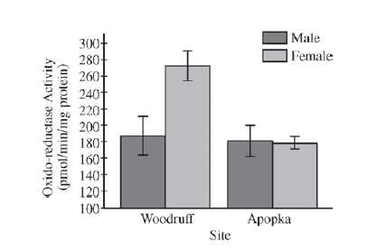
The data in the graph best support which of the following claims?
  - Environmental contamination elevates total testosterone oxido-reductase activity in females.
  - Environmental contamination reduces total testosterone oxido-reductase activity in females.
  - Environmental contamination elevates total testosterone oxido-reductase activity in males.
  - Environmental contamination reduces total testosterone oxido-reductase activity in males.

Use the following information to answer question 2.

A student placed 20 tobacco seeds of the same species on moist paper towels in each of two petri dishes. Dish A was wrapped completely in an opaque cover to exclude all light. Dish B was not wrapped. The dishes were placed equidistant from a light source set to a cycle of 14 hours of light and 10 hours of dark. All other conditions were the same for both dishes. The dishes were examined after 7 days and the opaque cover was permanently removed from dish A. Both dishes were returned to the light and examined again at 14 days. The following data were obtained.
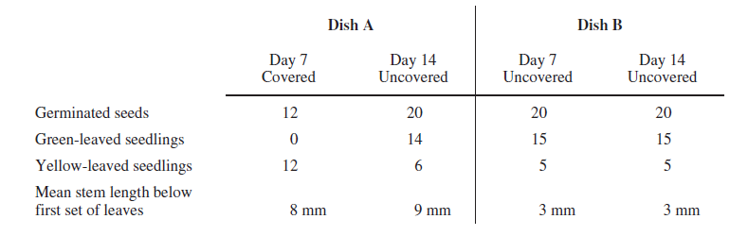

- The most probable cause for the difference in mean stem length between plants in dish A and plants in dish B is which of the following?
  - Shortening of cells in the stem in response to the lack of light
  - Elongation of seedlings in response to the lack of light
  - Enhancement of stem elongation by light
  - Genetic differences between the seeds

- Which of the following statements most directly supports the claim that different species of organisms use different metabolic strategies to meet their energy requirements for growth, reproduction, and homeostasis?
  - During cold periods pond-dwelling animals can increase the number of unsaturated fatty acids in their cell membranes while some plants make antifreeze proteins to prevent ice crystal formation in tissues.
  - Bacteria lack introns while many eukaryotic genes contain many of these intervening sequences.
  - Carnivores have more teeth that are specialized for ripping food while herbivores have more teeth that are specialized for grinding food.
  - Plants generally use starch molecules for storage while animals use glycogen and fats for storage.

- Figure I shows the growth of an algal species in a flask of sterilized pond water. If phosphate is added as indicated, the growth curve changes as shown in Figure II.
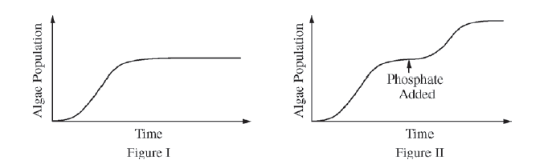
Which of the following is the best prediction of the algal growth if nitrate is added instead of phosphate?

  - 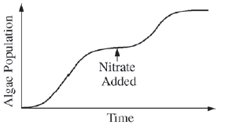
  - 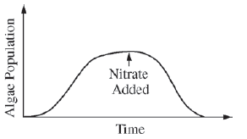
  - 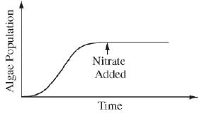
  - 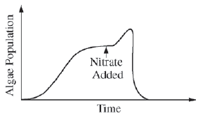

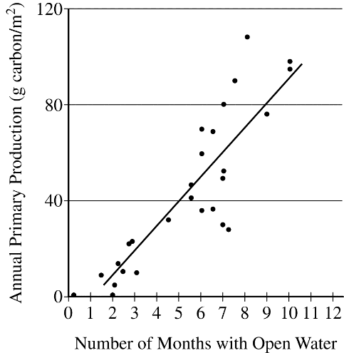
- In the Arctic Ocean, the predominant primary producers are phytoplankton. Phytoplankton are consumed by zooplankton, which in turn are eaten by codfish. In years when there is more open water (less ice coverage), there are more zooplankton and fish than in years with less open water (more ice coverage). Based on the graph above, the difference is most likely because

  - when there is less open water, light is blocked from the zooplankton, so they cannot produce as much food for the fish
  - when there is more open water, the temperature is warmer, so the zooplankton and fish populations increase in size
  - the ice blocks the light, so in years with more ice coverage, there is less photosynthesis by the phytoplankton
  - the ice increases the light available for photosynthesis, so primary production increases and zooplankton populations increase in size

Use the following information to answer question 6.

An experiment to measure the rate of respiration in crickets and mice at 10°C and 25°C was performed using a respirometer, an apparatus that measures changes in gas volume. Respiration was measured in mL of O₂ consumed per gram of organism over several five-minute trials and the following data were obtained.

Organism | Temperature (°C) | Average respiration  (mL O₂/g/min)
Mouse | 10 | 0.0518
Mouse | 25 | 0.0321
Cricket | 10 | 0.0013
Cricket | 25 | 0.0038

- According to the data, the crickets at 25°C have greater oxygen consumption per gram of tissue than do the crickets at 10°C. This trend in oxygen consumption is the opposite of that in the mice. The difference in trends in oxygen consumption among crickets and mice is due to their

  - relative size
  - mode of nutrition
  - mode of internal temperature regulation
  - mode of ATP production

- Beaked whales feed at various depths, but they defecate at the ocean’s surface. Nitrogen-rich whale feces deposited in surface waters supply nutrients for algae that are eaten by surface dwelling fish. Which of the following best predicts what would happen if the whale population decreased?
  - There would be a reduction in surface nitrogen concentration, which would cause an algal bloom.
  - The surface fish populations would decline due to reduced populations of algae.
  - The remaining whales would accumulate mutations at a faster rate.
  - The remaining whales would be forced to forage in the deepest parts of the ocean.

- The following is a food web for a meadow habitat that occupies 25.6 km². The primary producers’ biomass is uniformly distributed throughout the habitat and totals 1,500 kg/km².
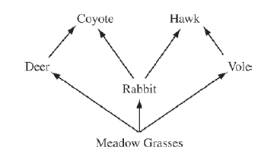
Developers have approved a project that will permanently reduce the primary producers’ biomass by 50 percent and remove all rabbits and deer.

Which of the following is the most likely result at the completion of the project?
  - The biomass of coyotes will be 6 kg, and the biomass of hawks will be 0.5 kg.
  - The biomass of coyotes will be dramatically reduced.
  - The coyotes will switch prey preferences and outcompete the hawks.
  - There will be 50 percent fewer voles and 90 percent fewer hawks.

Use the following information to answer questions 9-12.
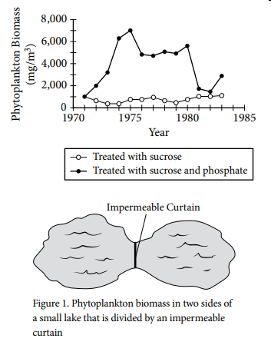
In the early 1970s, researchers hypothesized that carbon was the limiting nutrient in many aquatic ecosystems. To test this hypothesis, the researchers divided a small lake in two roughly equal halves with an impermeable curtain that was fastened and sealed to the bedrock of the lake. Beginning in 1971 the researchers treated one side of the lake with sucrose and the other side with both sucrose and phosphate. From 1971 to 1983 the researchers monitored the phytoplankton biomass in both parts of the lake. The results are shown in Figure 1.

- Which of the following claims is best supported by the data?
  - Carbon was a limiting factor for phytoplankton in the lake.
  - Phosphate was a limiting factor for phytoplankton in the lake.
  - Both carbon and phosphate were limiting factors for phytoplankton in the lake.
  - Neither carbon nor phosphate was a limiting factor for phytoplankton in the lake

- The average growth rate of the phytoplankton population from 1971 to 1975 in the side of the lake treated with sucrose and phosphate is closest to which of the following?

  - 125 (mg/m³)/year
  - 1,000 (mg/m³)/year
  - 1,500 (mg/m³)/year
  - 6,000 (mg/m³)/year

- Which of the following treatments would have been the best control treatment for the experiment?
  - An untreated section of the lake
  - A section of the lake that was treated with phosphate but not sucrose
  - A different lake that was treated with sucrose and phosphate
  - A small pool of the lake water maintained in a controlled laboratory environment

- Which of the following was most likely a direct consequence of the addition of phosphate to the lake?
  - The amount of biomass in the first trophic level decreased.
  - The amount of biomass in the second trophic level decreased.
  - The amount of energy available to producers in the lake increased.
  - The amount of energy available to consumers in the lake increased

- Thrips are insects that feed on rose pollen. Scientists noted that the thrips population increased in the spring and decreased dramatically during the summer. The researchers hypothesized that food abundance was the limiting factor for the population. Which of the following types of data would be most useful for the scientists to collect at regular intervals on a designated test plot of rose plants?
  - Amount of sunlight (hours/day)
  - Mean temperature (°C)
  - Density of rose pollen produced (g/m²)
  - Amount of pollen produced by each flower (g/flower)

- The diagram below shows the progression of ecological events after a fire in a particular ecosystem. Based on the diagram, which of the following best explains why the oak trees are later replaced by other trees?
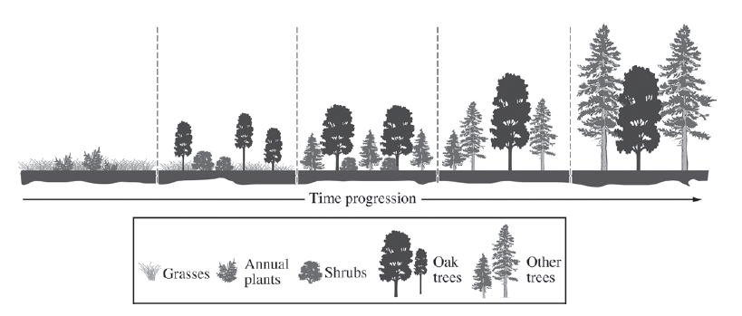
  - Eventually the other trees grow taller than the oak trees and form a dense canopy that shades the understory.
  - Oak trees alter the pH of the soil, making the forest better suited for shrubs and other trees.
  - Roots of shrubs proliferate in the soil of the forest and prevent the oak trees from obtaining water.
  - Oak trees succumb to environmental pollutants more readily than do either the shrubs or the other trees.

Use the following information to answer questions 15-17.

The figures below show the changes in populations of two species of flour beetles, Tribolium confusum (Figure I) and Tribolium castaneum (Figure II), in cultures without parasites (o) and in cultures infected with a parasite (•). Each data point represents the mean population size from ten culture dishes of equal size and food content.
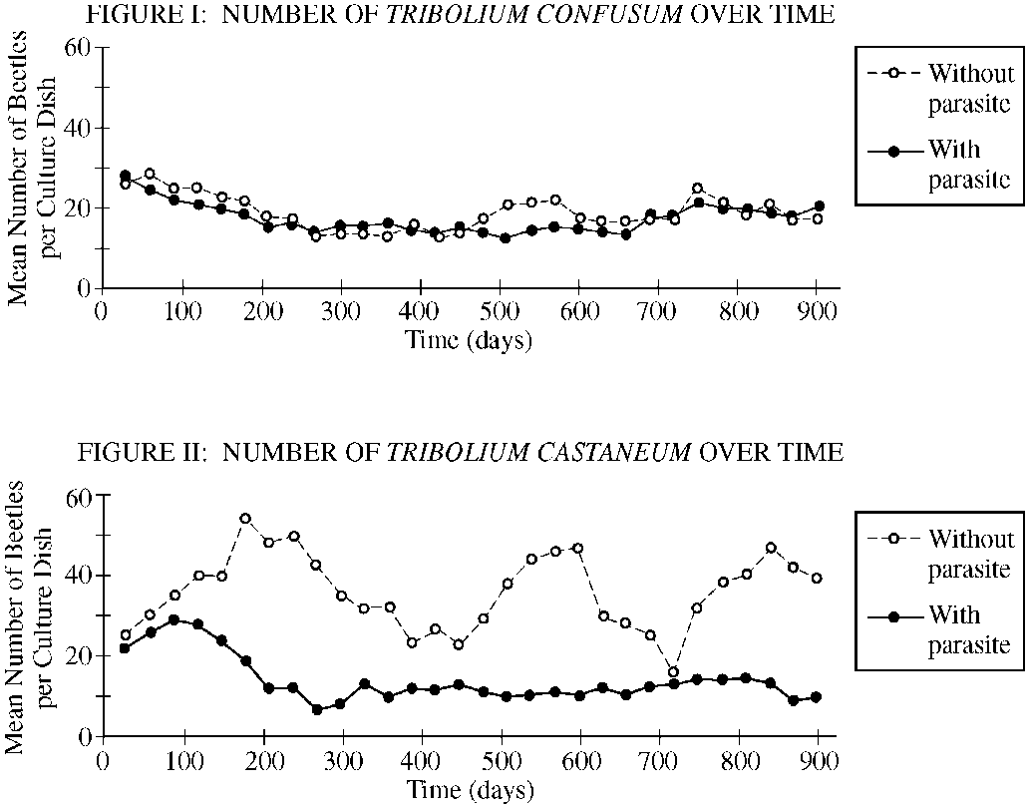

- Under which of the following conditions is the observed number of beetles per culture dish the greatest?
  - T. confusum with parasite at 500 days
  - T. confusum without parasite at 300 days
  - T. castaneum with parasite at 100 days
  - T. castaneum with parasite at 600 days

- The data over the duration of the experiment provide the strongest support for which of the following conclusions regarding the effect of the parasite on Tribolium populations?
  - T. confusum is adversely affected by the parasite, while T. castaneum is not.
  - T. castaneum is adversely affected by the parasite, while T. confusum is not.
  - Both T. confusum and T. castaneum are adversely affected by the parasite.
  - Both T. confusum and T. castaneum show increased fitness in the presence of the parasite.

- In Figure I, the difference between the two curves can best be attributed to which of the following?
  - The difference between controlled laboratory conditions and the natural environment
  - The effect of the host on its parasite
  - The influence of competition for limited resources
  - The natural variation among populations

- If the experiment was continued for an additional 500 days, the population density of T. castaneum with the parasite would most likely stabilize at a value closest to which of the following?
  - 5 beetles/culture dish
  - 10 beetles/culture dish
  - 20 beetles/culture dish
  - 25 beetles/culture dish

- A researcher is investigating the relationship between the existing species diversity in a community and the ability of an introduced nonnative species to destabilize the community.

Which of the following graphs is most consistent with the claim that communities with high diversity are more resistant to change than are communities with low diversity?

  - 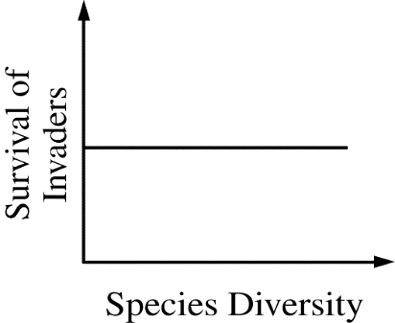
  - 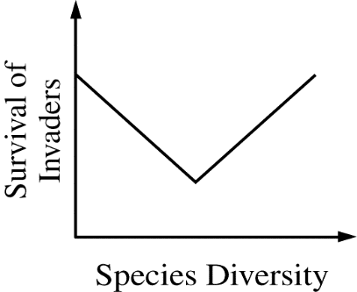
  - 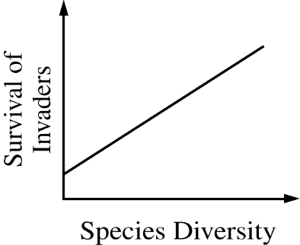
  - 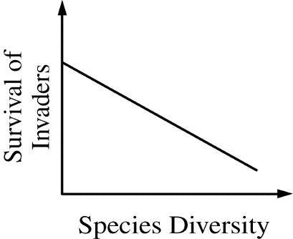

- Scientists have found that the existing populations of a certain species of amphibian are small in number, lacking in genetic diversity, and separated from each other by wide areas of dry land. Which of the following human actions is most likely to improve the long-term survival of the amphibians?
  - Cloning the largest individuals to counteract the effects of aggressive predation
  - Reducing the population size by one-fifth to decrease competition for limited resources
  - Constructing a dam and irrigation system to control flooding
  - Building ponds in the areas of dry land to promote interbreeding between the separated populations

Multiple Choice Key
Question | Correct Answer | Unit/Topic | Source
1 | B. Environmental contamination reduces total testosterone oxido-reductase activity in females. | 8.1 | 2012 CED #22
2 | B. Elongation of seedlings in response to the lack of light | 8.1 | 2012 CED #14
3 | D. Plants generally use starch molecules for storage while animals use glycogen and fats for storage. | 8.1 | 2012 CED #11
4 | C. | 8.1 | 2012 CED #40
5 | C. the ice blocks the light, so in years with more ice coverage, there is less photosynthesis by the phytoplankton | 8.2 | 2013 #37
6 | C. mode of internal temperature regulation | 8.2 | 2012 CED #10
7 | B. The surface fish populations would decline due to reduced populations of algae. | 8.2 | 2013 #14
8 | B. The biomass of coyotes will be dramatically reduced. | 8.2 | 2012 CED #4
9 | B. Phosphate was a limiting factor for phytoplankton in the lake. | 8.3 | 2020 CED #4
10 | C. 1,500 (mg/m³)/year | 8.3 | 2020 CED #5
11 | A. An untreated section of the lake | 8.3 | 2020 CED #6
12 | D. The amount of energy available to consumers in the lake increased | 8.2 | 2020 CED #7
13 | C. Density of rose pollen produced (g/m²) | 8.5 | 2012 #2
14 | A. Eventually the other trees grow taller than the oak trees and form a dense canopy that shades the understory. | 8.5 | 2012 CED #6
15 | C. T. castaneum with parasite at 100 days | 8.5 | 2013 #10
16 | B. T. castaneum is adversely affected by the parasite, while T. confusum is not. | 8.5 | 2013 #11
17 | D. The natural variation among populations | 8.5 | 2013 #12
18 | B. 10 beetles/culture dish | 8.3 | 2013 #13
19 | D. 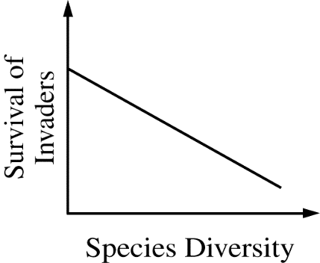 | 8.6 | 2013 #8
20 | D. Building ponds in the areas of dry land to promote interbreeding between the separated populations | 8.7 | 2013 #24

Multiple Choice Explanations
Q |  | Explanation:
1 | A | The environmental contamination was found in the Apopka. The mean activity of Woodruff is larger than the mean activity of Apopka.  This option is incorrect. Environmental contamination in Lake Apopka had a negative effect on the enzyme in females by decreasing the activity, not increasing the activity, as in Lake Woodruff, which was not contaminated. (CollegeBoard)
 | B | Using the error bars allows you to determine the statistically significant data. The error bars between the Woodruff males and Apopka males overlap so there is no difference meaning that the environmental contamination has no affect on the oxido-reductase activity in males. The error bars between the Woodruff females and Apopka females do not overlap so there is statistically significant difference. The mean value decreased showing the environmental contamination (found in the Apopka) reduces the oxido-reductase activity in females.  This option is correct. In Lake Woodruff, the lake that is relatively pristine, females had high levels of oxido-reductase enzyme activity, but in Lake Apopka, where environmental contamination conditions were severe, the enzyme activity was low, indicating that environmental factors had an influence on the organism. (CollegeBoard)
 | C | The male data is not statistically significant since the error bars overlap.  This option is incorrect. Environmental contamination in both lakes did not seem to influence the enzyme for activity for males. (CollegeBoard)
 | D | The male data is not statistically significant since the error bars overlap.  This option is incorrect. Environmental contamination in both lakes did not seem to influence the enzyme for activity for males (CollegeBoard)
2 | A | The seedlings in the absence of light were taller than those in the presence of light so the cells were not shortened in the absence of light.  This option is incorrect. Shortening of cells in response to a lack of light would result in slower growth, but this claim is not supported by the data. (CollegeBoard)
 | B | The seedlings in Dish A were covered until Day 7 while Dish B seedlings were uncovered. The dish A seedlings have a mean height of 8 mm and dish B seedlings have a mean height of 3 mm. The elongation seen was in response to the lack of light. Logically, the seedlings “think” they are deeper in the soil and are reaching for the sunlight to begin photosynthesis with their cotyledons.  This option is correct. In response to the lack of light, the plant elongates cells in an attempt to reach light necessary for photosynthesis at the expense of leaf development. (CollegeBoard)
 | C | The seedlings in the absence of light were taller than those in the presence of light so the light did not enhance stem elongation.  This option is incorrect. In the seeds that were exposed to light, the plants actually grew more slowly, so enhancement of stem elongation is not supported by the data. (CollegeBoard)
 | D | This is not plausible. The chances of this happening are low that you would just happened to pick the 20 seedlings that had the “tall” genes and the 20 seedlings that had “short” genes)  This option is incorrect because genetic differences were accounted for by using 20 seeds each from the same species. (CollegeBoard)
3 | A | This does not apply to metabolic strategies. The organisms are demonstrating the processes to maintain homeostasis in cold environments.  This option is incorrect despite being a correct statement. These strategies help the different organisms to survive cold periods but are not metabolic strategies for meeting their energy needs. (CollegeBoard)
 | B | This does not apply to metabolic strategies. The prokaryotes do not have introns and the eukaryotes do have introns.  This option is incorrect because this fact comparing bacterial and eukaryotic genomes and the presence of introns has nothing to do with these organisms meeting their energy needs by varying metabolic strategies. (CollegeBoard)
 | C | This does not apply to metabolic strategies. The carnivores have different dentition than the herbivores.  This option is incorrect. Metabolism is defined as the totality of an organism’s chemical reactions. The type of teeth organisms have would not be considered a metabolic strategy but rather a structural strategy (CollegeBoard)
 | D | Starch is the (glucose) energy storage for plants while glycogen and fats are the (glucose) energy storage for animals. This demonstrates that plants vs animals use different strategies for energy requirements.  This option is correct. Starch, glycogen, and fat are all molecules used for energy storage, yet plants have evolved to use starch while animals have evolved to use fat for long-term energy storage and glycogen for short-term energy storage. (CollegeBoard)
4 | A | Nucleic acids need both phosphate and nitrogen (nitrate). In the absence of phosphate, the algal would not see an increase of the algae population.  This option is incorrect because the phosphate is limiting; thus, additional nutrients would have no effect. (CollegeBoard)
 | B | In the absence of both nitrate and phosphate, the algal population did not decrease so it wouldn’t decrease when you added the nutrient.  This option is incorrect because the addition of nitrogen, an essential plant nutrient, would not decrease the algal growth (CollegeBoard)
 | C | Nucleic acids need both phosphate and nitrogen (nitrate). With the nitrate being added instead of the phosphate, the algal population will stop growing and level out.  This option is correct because the limiting nutrient is phosphate, not nitrogen. (CollegeBoard)
 | D | In the absence of both nitrate and phosphate, the algal population did not decrease so it wouldn’t decrease when you added the nutrient.  This option is incorrect because adding nitrogen, an essential plant nutrient, would not increase then decrease the algal growth (CollegeBoard)
5 | A | Zooplankton consume phytoplankton. The amount of sunlight does not affect zooplankton’s production of food for the fish.
 | B | We do not have any data to support this statement.
 | C | Primary Production is the quantitative measurement for photosynthesis. As the months with open waters increases, the primary production increases. This is logical as the photosynthetic organisms have more access to sunlight for primary production. The more sunlight, the more phytoplankton. Since the food of the zooplankton increased, the zooplankton’s population increased. Since the food of codfish increased, the codfish’s population increased.
 | D | Ice covering decreases the light available for photosynthesis.
6 | A | The data is per gram of tissue, so it has been adjusted for the size difference.  This option is incorrect because the rate of oxygen consumption is due to  metabolic rates since oxygen is necessary for ATP production. Though size does  affect heat gain and loss due to surface area to volume ratios, this physical trait  would have the same effect in both organisms, not the opposite. (CollegeBoard)
 | B | Both organisms are herbivores.  This option is incorrect because both crickets and mice are chemoheterotrophs. (CollegeBoard)
 | C | Crickets are ectotherms. Their internal temperature is dependent on their environment. Mice are endotherms. Their internal temperature is dependent on metabolism. As the temperature decreases, the mice will undergo more cellular respiration to generate heat to warm the organism’s bodies. As increase in cellular respiration is represented by an increase in respiration (oxygen is needed as the final electron acceptor).  This option is correct because crickets are ectotherms. Ectotherms have very low metabolic rates, so they depend on the environment to help regulate their internal temperature. Therefore, crickets would have a higher metabolic rate at the higher temperature due to kinetics or more frequent molecular collisions. (CollegeBoard)
 | D | Both organisms undergo cellular respiration to synthesize ATP.  This option is incorrect because both organisms produce ATP via aerobic cellular respiration when oxygen is not a limiting reactant. (CollegeBoard)
7 | A | Nitrogen is needed for proteins and nucleic acids, so there would be a decrease in the algae population due to limiting nutrients.
 | B | There was a decrease in the whale population which led to a decrease in the nitrogen (reduction in feces deposited). This decrease in nitrogen leads to a decrease in the algae. A decrease in algae is a decrease in food for the fish. This leads to a decrease in fish population.
 | C | The whale population decreasing does not cause mutations.
 | D | This is logical, but the question asks for the ‘best predicts”. Due to the decrease in nitrogen there is a decrease in the algae population which decreased the fish population. There is no information that states the whales are unable to forage in the upper regions of the ocean.
8 | A | There is no information to allow this to be determined.  This option is incorrect. The quantitative data provided in the scenario do not support this conclusion regarding changes in biomass for coyotes and hawks. (CollegeBoard)
 | B | All of the rabbits and deer are removed which is all of the food for the coyote. Due to this loss of prey, the coyote will die which reduces their (dramatically) reduces their biomass.  This option is correct. It demonstrates an understanding of the components of a food web and interactions between all of the participants. Coyotes prey on deer and rabbits, and if developers remove them, coyotes will lose their primary source of nutrition/energy. With this loss of nutrition/energy they will experience a decrease in reproductive success and therefore a significant decline in their population. (CollegeBoard)
 | C | There is no information about that coyotes would out complete hawks.  This option is incorrect. The data do not provide evidence to support the conclusion that with the removal of deer and rabbits the coyotes will switch to preying on voles and outcompeting hawks for the energy source. (CollegeBoard)
 | D | There is no information to calculate the effect on the 50% biomass decrease.  This option is incorrect. The vole population may not suffer because there is no longer competition from rabbits and deer for the grass. With the removal of rabbits, hawks will lose a source of energy. However, because hawks also prey on voles whereas coyotes do not, hawks still will have a source of energy. (CollegeBoard)
9 | A | Carbon was added in the form of sucrose. Both samples got the sucrose, but only one sample demonstrated an increase in growth demonstrating that carbon was not a limiting nutrient.
 | B | There are two lines on the graph. The line with sucrose has a low amount of phytoplankton biomass but the line with sucrose and phosphate has a large amount of phytoplankton biomass. This demonstrates that phosphate is a limiting nutrient and is required for growth of the phytoplankton.
 | C | Carbon was added in the form of sucrose. Both samples got the sucrose, but only one sample demonstrated an increase in growth demonstrating that carbon was not a limiting nutrient. When phosphate was added to one group, that group showed an increase demonstrating that phosphate was a limiting nutrient.
 | D | There was low growth with the sucrose only sample demonstrating there is a limiting nutrient.
10 | A | You made a math error, but I can’t think of what math would produce this answer to re-direct you.
 | B | You made a math error, but I can’t think of what math would produce this answer to re-direct you.
 | C | (1971, 1000) and (1975, 7000)  Rate = (y₂ – y₁) / (x₂ – x₁) = (7000 – 1000)/(1975 – 1971) = 6000/4 = 1500
 | D | Rate involves dividing by the change in time. This answer choice is the phytoplankton biomass difference (7000 – 1000 = 6000)
11 | A | Provides a point of comparison of these two samples to determine how sucrose and phosphate affect the phytoplankton.
 | B | This helps you to determine the affect of phosphate alone, but it is still a treatment group.
 | C | This allows you to compare your treatment to increase your sample size.
 | D | This does not include the same constants as the environmental lake so it cannot be used as a point of comparison.
12 | A | The phosphate leads to an increase in phytoplankton biomass so the biomass in the first trophic level would increase.
 | B | If there is an increase in phytoplankton, there would be an increase of the consumers of phytoplankton (second trophic level).
 | C | The phosphate does not provide energy nor does it assist the phytoplankton in obtaining sunlight.
 | D | The phosphate provided the nutrient for the phytoplankton to grow. The increase in phytoplankton would increase the food supply for the consumers and thus an increase in energy available to consumers.
13 | A | The sunlight although provides energy to the plant does not answer the researchers question regarding if food abundance was the cause.
 | B | The temperature although could affect the plants. It does not answer the researchers question regarding if food abundance was the cause.
 | C | The rose pollen is the food resource for the thrips. This information would tell you how much rose pollen there is in how much space to ensure there is enough food for the thrips.
 | D | This tells you how much food is available from a flower, but there is no information about the number of flowers to be able to determine if the thrips didn’t have enough food.
14 | A | As ecological succession continues, the trees get larger. Their height is an evolutionary advantage to obtain more sunlight. Since the trees obtain the sunlight and shade the shrubs, they are unable to compete and do not receive enough sunlight so they die.  This option is correct. The other trees shade out the oak trees. Oak seedlings are relatively intolerant to shade. Oak trees need sunlight for photosynthesis, and although they do survive in poor sunlight, they do not proliferate enough to be the dominant plant in the forest. Some oak species need sunlight for full development (CollegeBoard)
 | B | This information cannot be obtained from the diagram.  This option is incorrect for two reasons: First, the shrubs disappear in this progression, so there is no evidence that any change would enhance shrub growth. Second, oak trees do not significantly alter the pH of the soil. (CollegeBoard)
 | C | If the oak trees are unable to obtain water, they will be unable to replace the shrubs.  This option is incorrect because shrubs have relatively small root balls and would not out-compete an oak tree with a deep tap root. When the shrubs disappear, the success of the oak tree does not improve (CollegeBoard)
 | D | If the oak trees are less favorable in the presence of environmental pollutants, they would be unable replacing the shrubs.  This option is incorrect because there is no evidence in this data of environmental pollutants. Although pollutants do affect oak tree growth, oaks are not considered more sensitive to them than other trees. (CollegeBoard)
15 | A | T. confusum with parasite at 500 days = 10 beetles
 | B | T. confusum without parasite at 300 days = 15 beetles
 | C | T. castaneum with parasite at 100 days = 30 beetles
 | D | T. castaneum with parasite at 600 days = 10 beetles
16 | A | In the graph of T. confusum the two lines are very close demonstrating that the parasite had little to no effect on the number of beetles.
 | B | In the graph of T. confusum the two lines are very close demonstrating that the parasite had little to no effect on the number of beetles. In the graph of T. castaneum, the without parasite line was higher than the with parasite line. This shows that the parasite has a negative effect on the number of beetles.
 | C | In the graph of T. confusum the two lines are very close demonstrating that the parasite had little to no effect on the number of beetles.
 | D | In the graph of T. castaneum, the without parasite line was higher than the with parasite line. This shows that the parasite has a negative effect on the number of beetles.
17 | A | They were tested in the same environment with the only difference of whether there is a parasite present.
 | B | Figure 1 shows very little difference between the presence of parasite and the absence of the parasite.
 | C | If there was competition, you would see a decrease in both populations.
 | D | There will be a natural variation in the population. This is why the statistical analysis is important for data interpretation.
18 | A | It is at 10 beetles/culture dish, and it will stabilize not drop to 5.
 | B | It is already at 10 beetles/culture dish.
 | C | It is at 10 beetles/culture dish, and it will stabilize not increase to 20.
 | D | It is at 10 beetles/culture dish, and it will stabilize not increase to 25.
19 | A | This graph shows there is no difference in survival of invaders as the species diversity increases.
 | B | This graph shows an initial decrease in survival of invaders as species diversity increased, but then the graph increases.
 | C | This shows as the species diversity increases, the survival of invaders also increases. This does not show that it will resist change.
 | D | As the species diversity increases, the survival of invaders decreases. The community with a high diversity will inhibit change (hence the decreased survivability of invaders)
20 | A | Cloning would provide genetically identical individuals. This does not increase genetic diversity.
 | B | Reducing the population size could decrease the genetic diversity if a trait/allele is removed.
 | C | Decreasing the water inhibits the amphibian movement which restricts gene flow (which does not allow the populations to increase genetic diversity).
 | D | The amphibians lack genetic diversity. In order to increase the genetic diversity, there needs to be an increase in gene flow. There is wide areas of dry land between the ponds which would inhibit the mating of amphibians from different ponds. If humans build ponds between them, this would increase the amphibians mating and provide the genetic diversity needed.

